**Harriers Victorious at Newick**

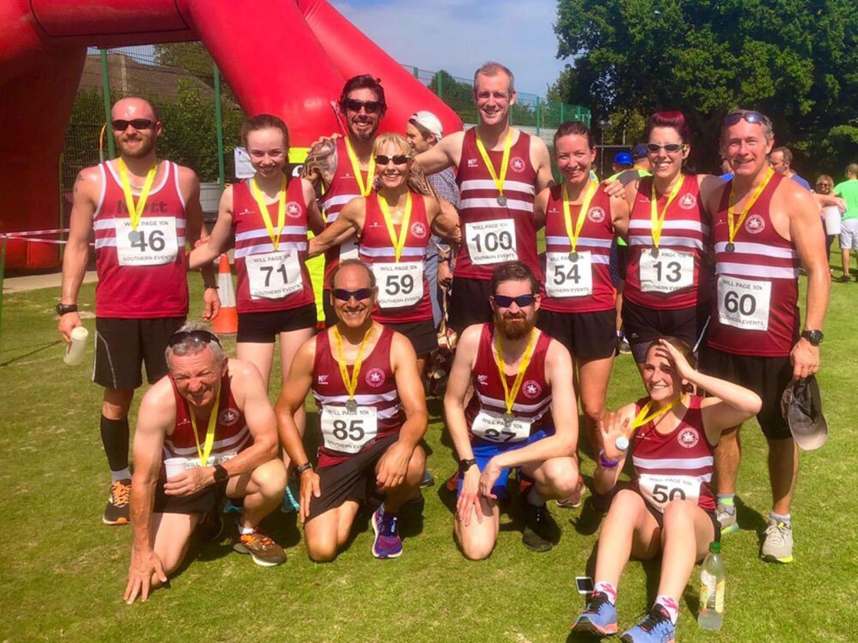

**Harriers at Newick 10km**.

**Road Racing:**

On Sunday the 25th August, the Harriers were dominant at the Newick 10 kilometres road race. This race is held in memory of Will Page who was a member of Haywards Heath Harriers who was tragically killed in road accident.

The Harriers took first place in the men’s and women’s team races. Also, individual honours went to Tim Miller, Sam Ridley and Mark Sykes, each first in their respective age categories.

Results were as follows:

4th Matt King 39:37, 5th Tim Miller 41:51, 8th Andy Hind 42:34, 9th Jack Chivers 42:51, 17th Sam Ridley 45:37, 20th Matt Quinton 47:04, 29th Mark Sykes 49:21, 35th Ian Dumbrell 50:39, 37th Isobel Russell 51:06, 43rd Lydia Levy 51:42, 54th Gemma Morgan 54:41, 100th Carys Hind 65:42.

**Track & Field**

The Southern Athletics League final event of the year was held on 17 August at Tooting Bec athletics stadium in London. A rather depleted team took part, which was combined with Lewes Athletics Club but a huge effort was played out by the few who took part scoring may valuable points for the team.

Results were:

Jenny Denyer: 100m 4th ‘A’ 20.0 secs, Long Jump 3rd ‘B’ 2.19m, Shot Putt 4th ‘A’ 5.33m, Discus 4th ‘A’ 14.44m, Hammer 3rd ‘A’ 14.41m, Javelin Throw 3rd ‘A’ 12.39m.

Martin Dawson: 400m 4th ‘A’ 56.1 secs, High Jump 2nd ‘A’ 1.55m, Long Jump 4th ‘A’ 4.71m, Triple Jump 3rd ‘A’ 11.00m, Javelin Throw 4th ‘A’ 22.45m.

Paul Cousins: 5000m 3rd ‘A’ race 18.30.2 secs.

Mike Bale: Shot Putt 4th ‘A’ 6.60m, Discus 4th ‘A’ 17.44m, Hammer 3rd ‘A’ 26.30m, Javelin Throw 3rd ‘B’ 18.53m.

At the Birthday Boys 5000m on 22 August which is an annual race held at the Withdean Stadium, Brighton. A number of personal bests were attained at this event last week. Ben Gibson ducking under the sixteen minutes barrier that has been alluding him for the last year and a half, smashed his best with a super 15 minutes and 45.2 seconds. Tim Miller smashing 19 minutes and Sam Ridley running a stunning race with arguably her best ever race!

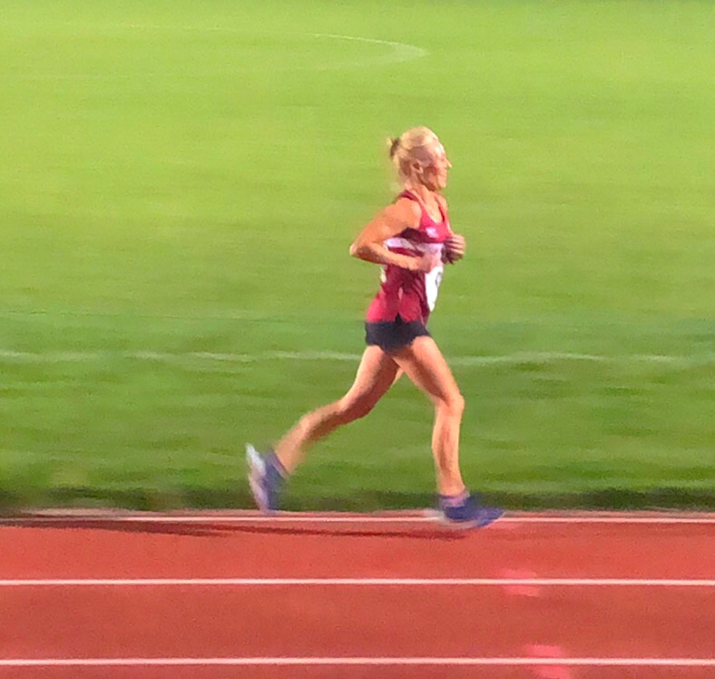Birthday Boys results:

James Skinner 15:44.9 secs, Ben Gibson 15:45.2 secs, Russ Mullen 16:51.7 secs, Matt King 17:20.6 secs, Paul Cousins 18:01.1 secs, Tim Miller 18:44.0 secs, Darja Knotkova-Hanley 18:55.6 secs, Barry Tullett 20:31.9 secs, Sam Ridley 20:32.8 secs, Carl Bicknell 21:44.5 secs.

**Fun run League**

Windlesham Whip

On 25 August was the West Sussex Fun Run League event called the “Windlesham Whip”. Five Harriers ventured to this trail race of about four miles at Worthing. The results were as follows:

36th Barry Tullett 31:06, 54th Phil Scott 33:13, 115th Carl Bicknell 36:24, 116th Kath Buckeridge 36:28, 258th Linda Tullett 51:09.

**Sam Ridley.**

The Highdown Hike on August 7th which is part of the West Sussex Fun Run League Harriers taking part in this race were Carys Hind and Richard Bates. Carys beating rival Richard. Cary’s time was 39:21 to Richard’s 42:36.

**Other Harrier results:**

Oli Farr ran his fortieth marathon at Marden Park. In sweltering conditions. He finished in a time of five hours and fifty-four minutes and twenty-seven seconds.

Tim Hicks ran in the Canterbury half marathon on Bank Holiday Monday. Finished as second Vet 60 in his age category in a time of one hour forty-seven minutes and forty-nine seconds.

On 18 August at the Henfield Half Marathon Carl Bicknell finished in 62nd place in a time of 1 hour 55 mins 59 secs.