Harriers set new Vet Records.

At the Sussex Vets League on 10 June, on a very wet evening at Lewes, Haywards Heath Harriers had a great turnout from the club at this league event. The Harriers compete as a joint team with Lewes Athletics Club. Notable performances were from Harriers Karen Thompson and Tim Hicks who set new Harrier vet club records.

Karen set a vet records in the Women’s Vet 50 age group in the 800m with a fine run of 3 minutes 9.2 seconds whilst in the Vet 60 category Tim Hicks set new club records in the 800m in 2 minutes 37.2 seconds and in the 3000m in 11 minutes and 35.5 seconds.

Emma Navesey had a brilliant race at the British 10,000 metres Track Championships held at Walthamstow on 7 June and set a club record of 36 min 48.47 secs and finished in ninth place against top level competition. The race was held in the evening and in the rain! The race provided Emma with good competition and has encouraged her to set her sights high. We look forwards to seeing what Emma will achieve in the future!

Sussex schools Track & Field Champs:
There were several Harriers taking part in the Sussex School Track and Field Championships were held at K2 Sports Centre at Crawley on 8 June. This event comes at a time when many of the competitors are taking their exams, so turn-out at this event was quite low.
In the Senior Girls 3000 metres race, Darja Knotkova-Hanley finished in first place in 10 minutes 45.39 seconds.
Lara Berzins finished in fourth place in the Intermediate Girls 1500 metres in a time of 5 minutes 29.34 seconds.
In the Junior Girls 800 metres race Harriet Dray finished in seventh place in 2 minutes and 36.36 seconds and Amy Rutherford finished in tenth place in 2 minutes 41.82 seconds.

Harriers at the Downland Challenge.

Race report by Michael Parish.

Last Sunday was the Downland Challenge, which is a 5 miles race (or slightly under) and is part of the West Sussex Fun Run League and was organised at Downland Community College, Hassocks by the Burgess Hill Runners. The harriers had a great turnout in the senior’s event with 13 runners. There were 18 clubs taking part in the league race.
As we lined up at the start it was clear it was going to be a hot day. There were three distinct parts to the route starting with a run around the school sports fields before being directed out into open fields that run along the foot of the South Downs. The run was quite difficult with the heat and the fields having very recently been mown with a lot of loose grass underfoot.
There were a lot of obstacles to navigate with a bridge, couple of stiles, kissing-gates and single track footpaths. Pedestrians out for their Saturday walk were rudely awakened by members of eighteen running clubs looming towards them. We managed to get everyone through the small gaps without any major problems.
After the extreme heat running across open fields, the next stage of the run through woodland was extremely welcome. The trees gave a lot of shade and the opportunity to cool down a little. This led to the next obstacle as with great trees come great roots which means you have to spend a lot of time keeping an eye on where your feet fall and not end up head down in a bush. With the recent rain there were also some slippery muddy parts.
Coming out of the woodland and back into open sunshine you could see the finish line. Running alongside the hedgerows you start checking the distance between you and the runners in front and feeling how much energy you still have in your muscles. You start the final sprint with the finish line firmly in your sights trying to reduce the gap and overtake other runners.
In the junior one mile race, it was a Harriers family affair with Bethany Hilton finishing in a super thirteenth place overall (and second girl) in a time of 7 minutes and 21 seconds. Her sister’s Emily came sixteenth in 7 minutes and 58 seconds and sister Evie finished in twenty fifth position in 10 minutes and 1 seconds.
Thanks go to the Burgess Hill runners for an amazing course especially Jay for his sense of humour and little prank at the finish line!
Harriers results in the adults 5 mile race were: 3rd Marcus Kimmins 29:26, 9th Andy Hind 31:04, 11th Nicholas Skov 31:24, 17th Paul Cousins 32:12, 21st Tim Miller 32:35, 32nd Greg Hilton 34:02, 40th Barry Tullett 34:40, 64th Steve McNulty 37:04, 67th Phil Scott 37:20, 117th Gemma Morgan 41:52, 181st Michael Parish 48:36, 199th Carys Hind 50:27, 200th Richard Bates 51:08.

Also, there was another West Sussex Fun Run League at Hove Park on the 16 June. The Harriers youngsters led the way home at this event in Hove Park. Sam Fernley had a stormer of a race to finish in first place in a time of 5 minutes and 21 seconds, winning by 1 second from Charlie Leedham (Worthing Harriers) and with Finley Hawkins (Phoenix AC) in third place a further 28 seconds behind. In the girl’s race, Harrier, Evie Miller had a great race to finish in third place in a time of 7 minutes and 26 seconds. She was beaten by Ines James-Fitzgerald (Unattached) who finished in a time of 6 minutes and 45 seconds and Amelia Wakeham (Worthing Harriers) in a time of 7 minutes and 20 seconds. Evie’s younger brother, Laurie finished in 16th place in a time of 7 minutes and 27 seconds.
In the adult’s race, Julian Boyer led the pack home in 20th place in 20:59. The Harriers results were as follows:
22nd Ryan Armstrong 21:08, 33rd Tim Miller 21:46, 74th Barry Tullett 23:34, 98th Sam Ridley 24:42, 149th Mike Scholes 26:43, 178th Kath Buckeridge 27:57, 231st Marion Hemsworth 30:51, 255th Deborah Day 31:55, 296th Richard Bates 34:55.

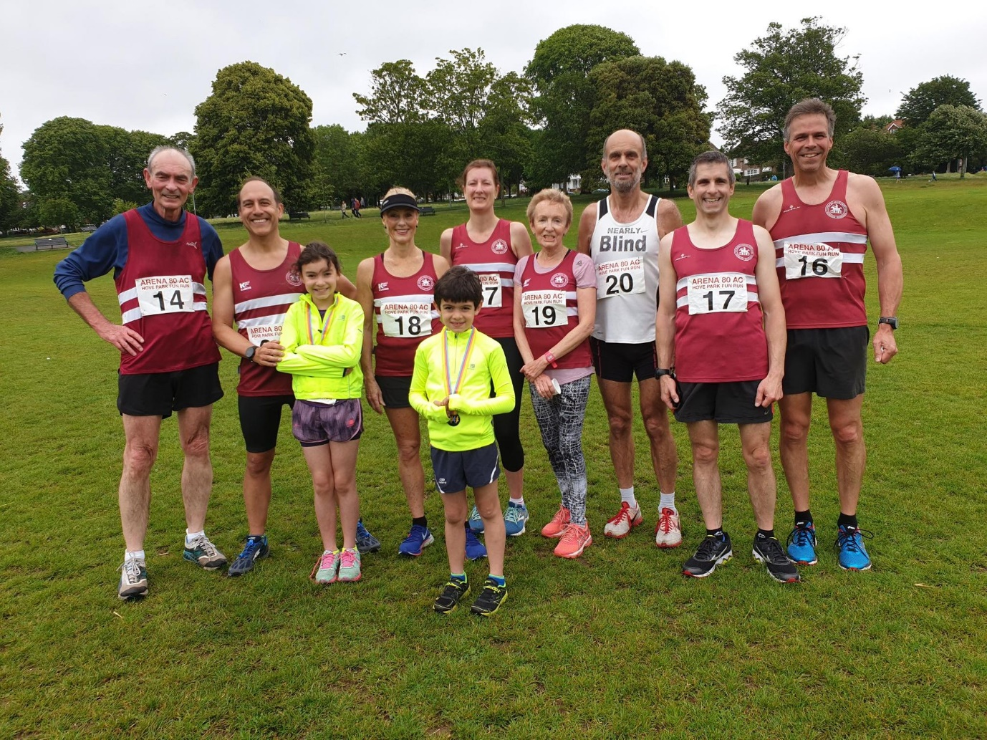
Harriers at Hove Park.

At the Sussex Under 13 League last week on 13 June at K2, Crawley, the Harriers had a great meeting finishing as third team out of six teams competing. It was really good to see again a huge turn-out by the club at this age level and the athletes competing in a good county level competition.
Results were as follows:

Boys:
Jonathan Parkin: 4th 75m 11.6 secs, 3rd LJ 4.05m.
Thomas Pearce: 3rd 75m 11.7 secs.
Philip Williamson: 6th 150m 22.4 secs, 2nd JT 19.07.
Calum Crowe: 1st 150m 23.3 secs, 3rd DT 11.05m.
Arlo Merchant: 5th 600m 2:02.4 secs.
Finlay Blythe: 3rd 600m 2:02.6 secs.
Arun Khursheed: 1st 1000m 3:12.5 secs, 3rd 75mH 16.0 secs.
Jonathan Beckett: 3rd 1000m 3:36.0 secs, 4th HJ 1.15m.
Thomas Pearce: 4th 75mH 16.5 secs.
C. Crouch: 3rd HJ 1.05m.
Oscar French: 4th LJ 3.24m, 4th SP 4.08m.
Jack Bannister: 4th SP 4.69m.
Johnny Rutherford: 4th DT 11.28m, 3rd JT 21.28m.
4 x 100m Relay: 2nd HHH 58.5 secs.

Girls:
Siobhan McMahon: 3rd 75m 11.3 secs, 2nd LJ 3.80m.
Mae Robinson: 4th 75m 12.0 secs, 4th HJ 1.10m.
Ella Crudginton: 5th 150m 25.2 secs, 4th 70mH 14.6 secs.
Holly Wilkinson: 3rd 150m 23.8 secs, 3rd 1000m 4:21.6 secs.
Ella Chatfield: 6th 600m 2:10.8 secs, 4th SP 2.83m.
B. Crouch: 4th 600m 2:12.1 secs.
Maya Dell’Aira Bromley: 3rd 1000m 3:49.4 secs.
Erin Gaston: 4th SP 4.79m, 3rd DT 11.90m.
Bethany Hilton: 2nd DT 6.92m.
4 x 100m Relay: 4th HHH 62.8 secs.

Non-scorers:
Boys:
75m: Jack Bannister 12.5 secs, Noah Perrett: 13.1 secs, Nye Sim: 12.2 secs, Oliver Cooper: 13.0 secs.
LJ: C. Crouch 3.21m, Nye Sim 3.20m, Oliver Cooper 2.55m.
4 x 100 Relay: HHH B team 64.s secs, HHH C team 66.5 secs.
Girls:
1000m: Bethany Hilton 4:23.2 secs.
4 x 100m Relay: HHH B team 66.1 secs, HHH C team 69.3 secs.

Other Harrier results:

At the Madehurst South Downs 10 km on the 16 June, Phil Scott finished in 51st place in a time of 51 minutes and 18 seconds.

At the Heathfield 10 km race on 23rd June, six Harriers took part in this race. Results were: 14th Rob Watts 40:03, 42nd Jack Chivers 43:52, 66th Matt Quinton 46:19, 146th Amanda Soper 54:03, 211th Peter Cobbett 1:00:45, 308th Jenny Denyer 1:22:43.

