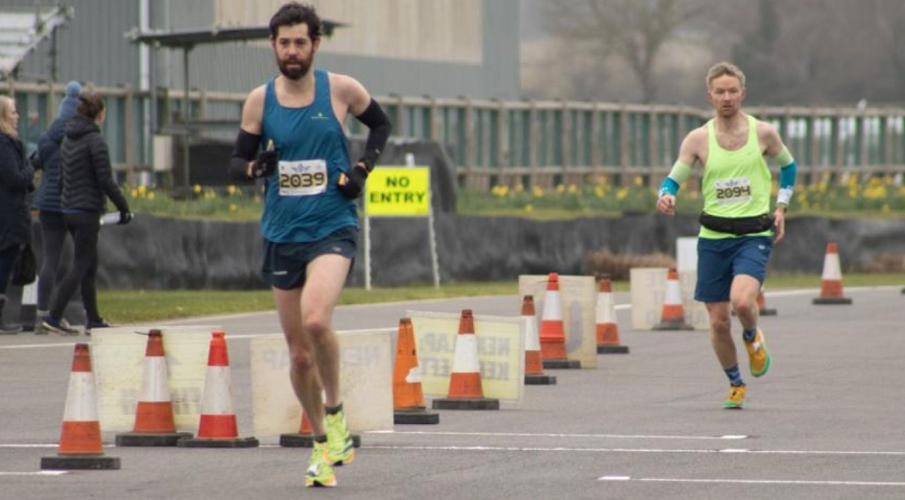
Ian Kenton in marathon form
At the Running Grand Prix at Goodwood Motor Circuit on Sunday 12 February, Ian Kenton ran a marathon effectively as a training run in preparation as a qualifying race for the Two Oceans Ultra he is planning to run in April. Ian came a super fifth place in 2 hour 50 minutes and 32 seconds which was four seconds outside his personal best time.
Sean Duff ran at the London Winter Run on 5 October. Finishing in a season’s best of 37 minutes and 38 eight seconds. Sean said that he was happy with the run after coming back from injury. Recording his run on the Strava app showing a map of the route the race took in central London. Sean is an experienced runner still yet to achieve his full potential as a distance runner.

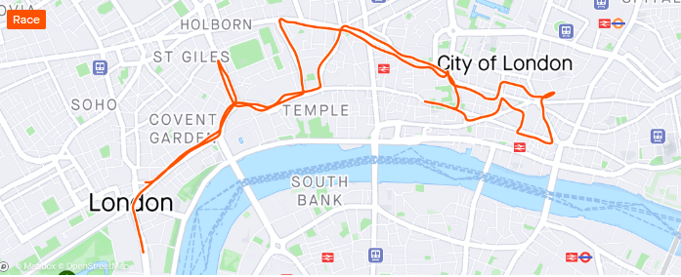
Sam Ridley recently ran in the Funchal Half Marathon in Portugal on the 22 January. She finished in a time of one hour 44 minutes and 41 seconds and finished second in her age category.

Haywards Heath Harriers
Parkrun roundup

Clair parkrun: 4th David Adams 20:01; 8th Pete Francis 21:05; 15th Patrick Kenward 22:00; 19th Andy Dray 22:37; 23rd Simon Robinson 23:18; 44th Bob Adams 25:46; 49th Ian Dumbrell 26:19; 66th Shelagh Robinson 27:37; 89th Michael Parish 29:08; 104th Emma Pryor 30:14; 120th Marion Hemsworth 32:08

Brighton & Hove parkrun: 6th Paul Cousins 19:34; 16th Julian Boyer 20:16; 87th Ian Tomkins 24:19.

Bedfont Lakes parkrun: 63rd Carl Bicknell 29:18.

Coventry parkun: 7th Will Grey 17:45

Tilgate parkrun: 53rd Oliver Farr 22:43; 82nd Chris Glanfield 24:14; 203rd Jack Chivers 28:33; 369th Kath Buckeridge 39:26.

Worthing parkrun: 14th Sean Duff 17:48 (pb).

Wepre parkrun: 28th Eric Hepburn 26:22.

Bethlem Royal Hospital parkrun: 82nd Lucy Anderson 28:41.

Ifield Mill Pond parkrun: 3rd Steven Heath 20:28.

Wollaton Hall parkrun: 76th Ewan Kemsley 23:41.

