Harriers Middy Report

South Downs Way Relay
Report by Tim Hicks

It was a long time coming but after being cancelled in 2020, pushed back to the first Saturday in July and then another 3 weeks delay in order to reach the first post lockdown Saturday, the South Downs Way Relay took place on 24th July. Due to the short notice of the last 3 week delay, there were only 33 teams from the original 57 that could make it. Haywards Heath Harriers were reduced from 3 teams to one and then with a few days to go we had to call on our last reserve to replace a runner who tested positive for COVID, resolve a last minute mix up over drivers before finally arriving in the middle of Haywards Heath at 4:30 in the morning with lightning flashing all around ready for the drive to Beachy Head.

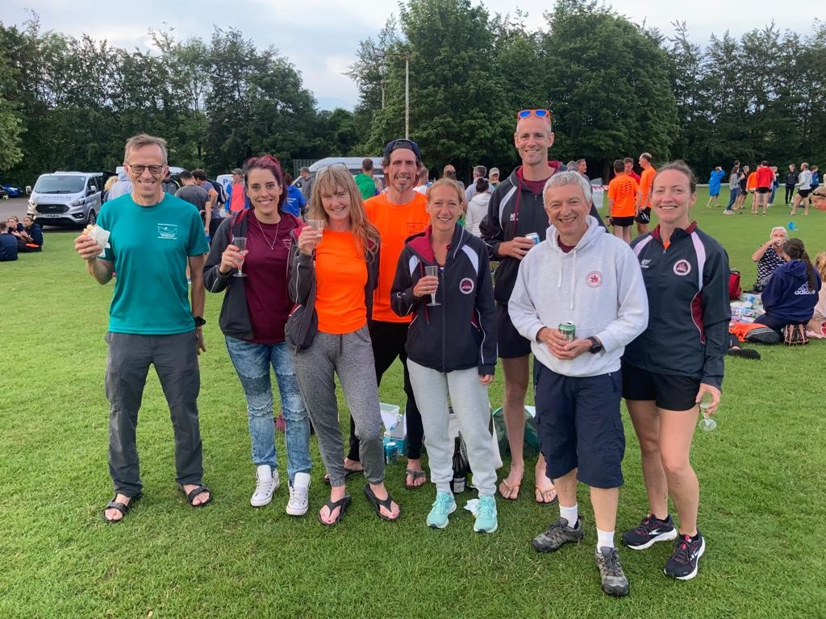
Harriers team: (L-R), Tim Hicks, Carys Hind, Karen Thompson, Andy Hind, Georgina Mugridge, Matt King, Mark Sykes and Gemma Morgan.

The start was cool and damp but the worst of the storm was over as Matt started off along the cliffs off Beachy Head towards the Seven Sisters. A few hours later, the sun was out, everyone had completed their first leg and we had settled in to a relaxed day out on the Downs. As the day progressed, we started on the chocolate ginger, date balls, seed bars and various other energy foods to keep us all going. The heat and humidity was starting to take its toll and the team lost a few minutes helping with a runner who had fallen in the heat. Carys did a splendid job in keeping us all hydrated and as the temperature began to fall, we had plenty of time spare to meet the final 14 hour cut-off. We finished in 13 hours 41 minutes and 50 seconds after another enjoyable day out with a great team of runners and drivers and celebrated with prosecco and bacon rolls with everyone looking forward to doing it all over again next year!

Thanks to the organisers (Richard and Jonathan) for persevering with this event and making sure we could go ahead in 2021 after the disappointment of 2020. And a special mention to our drivers (Mark and Carys) for driving from Haywards Heath to Beachy Head so early, negotiating numerous narrow lanes and obscure parking spots along the South Downs Way, and then driving us back from Winchester to Haywards Heath (at 11 in the evening!).

Out of the 33 teams that started we finished 23rd overall and 5th out of 10 in the 'mixed' team category. Team statistics were:

Matt King (legs 1, 8, 13) 19.0 miles, 3087 feet up and 2848 feet down in 2:28:38; Andy Hind (legs 2, 7, 17) 19.2 miles, 2421 feet up and 2533 feet down in 2:22:56; Karen Thompson (legs 3, 12, 16) 13.5 miles, 1263 feet up and 1886 feet down in 1:55:21; Georgina Mugridge (legs 4, 9, 15) 15.1 miles, 2106 feet up and 1499 feet down in 2:17:34; Gemma Morgan (legs 5, 10, 14) 14.6 miles, 1742 feet up and 2034 feet down in 2:15:00; Tim Hicks (legs 6, 11, 18) 16.0 miles, 1991 feet up and 2103 feet down in 2:22:21. Total distance 95.5 miles climbing 12612 feet and descending 12904 feet!

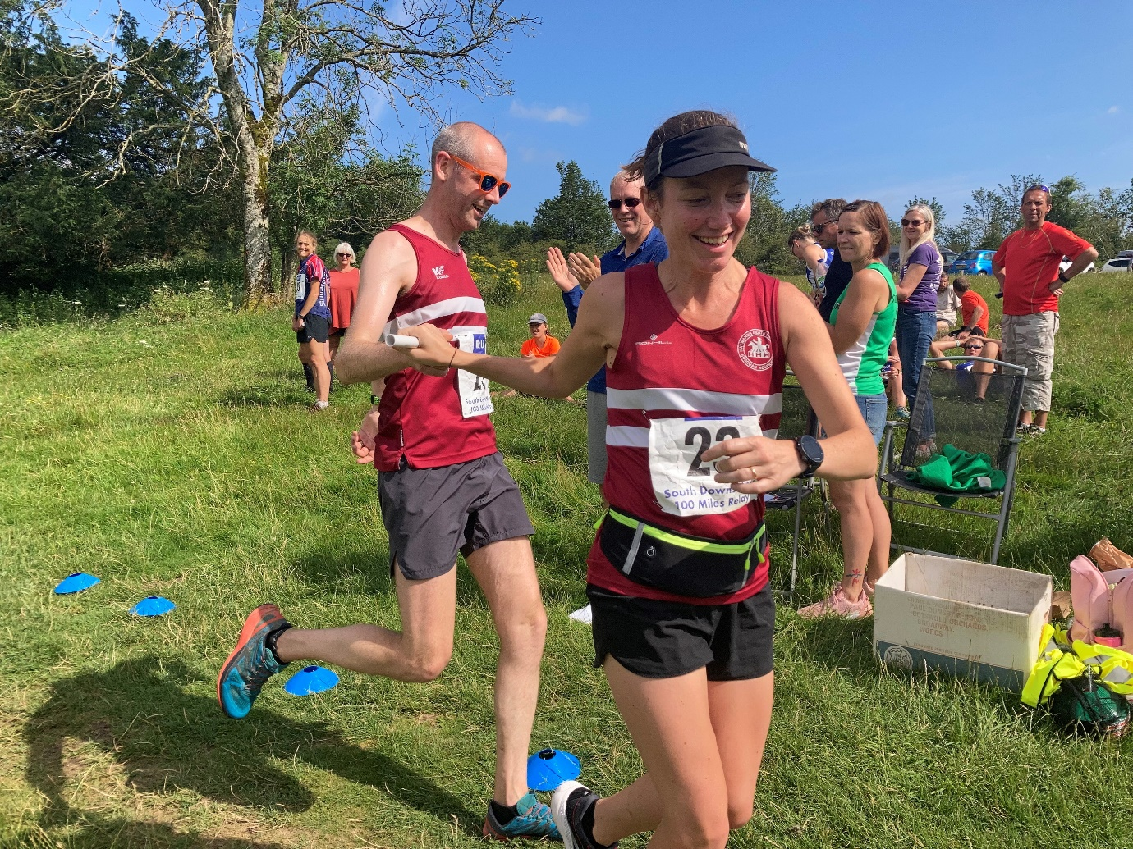
Matt passing the baton to Gemma at the end of leg 13

Other Harriers Results:

The Southern Athletics League took place on 11 July at Lewes. On a very hot and sunny afternoon at the Lewes track, the combined Haywards Heath Harriers team linked up with Lewes Athletics Club.

It was good to see new younger athletes taking part from the Harriers. With Ewan Kemsley trying out the eight hundred metres race and Harvey Alcock in the three thousand metres races.

Great performances by all the regulars taking part. Now looking forwards to the final league meeting at Hastings on Saturday 14 August.

Individual Harries results as follows:

Martin Dawson: 400m 60.3 seconds.
John Palmer: 400m 74.2 secs.
Ewan Kemsley: 800m 2 mins 15.7 secs.
James Skinner: 3000m 9 mins 30.5 secs.
Harvey Alcock: 3000m 10 mins 10.2 secs.
Lucie Venables: 100mH 21.1 secs, 400mH 83.8 secs, Long Jump 4.07m, Triple Jump 8.77m.
Tim Popkin: 3000m s/c 15 mins 08.6 secs.
Mike Bale: Shot Putt 6.84m, Discus 18.96m, Hammer 26.17m

Mike Bale also competed in the BMAF Southern Challenge on 1 August (formally called the South of England Championships). Mike’s results were as follows:

Hammer: 1st 31.09m
Discus: 2nd 27.11m
Weight: 1st 12.95m pb/club record

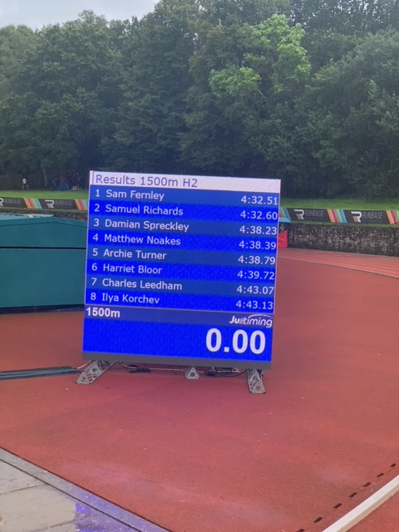

Sam Fernley ran a super personal best at the K2 Summer Open at Crawley on 31st July. winning his 1500 metres race in a time of 4 minutes 32.51 seconds. Sam improving with each race. He’s hoping to go quicker before the track season finishes. Watch this space!

Oliver Farr

Oliver Farr ran his 57th marathon at the Thames Meander Marathon on 7 August. On his way to his one hundred marathon challenge. It took Oliver 4 hours and 5 minutes and 34 seconds.

