**Lindfield Fun Run on 27 May**

**by Michael Parish**

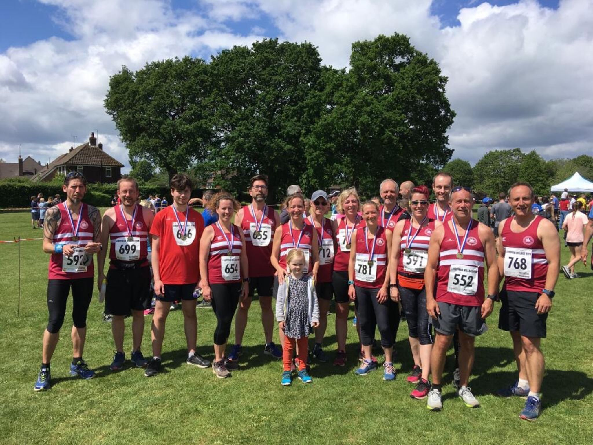

**Harriers at Lindfield Fun Run.**

Bank holiday Monday saw the Lindfield Village run organised by a dedicated team of volunteers. It’s one of the largest fundraising events for the registered charity: Lindfield’s King Edward Hall.

The run is a real old fashioned cross country run, multi- terrained with some slippery surfaces and the odd cow in a field!  Starting and finishing at Hickmans Lane Recreation Ground and going out to Ardingly Reservoir it has some beautiful scenery including Balcome viaduct which you can see in the distance.

To complete the course successfully runners need to race over roads, footpaths and across fields. They have to run down wooden steps, cross hurdles and down single track footpaths surrounded by nettles. This is what makes the Lindfield run. The sense of achievement you get at the end of it.

This year the weather was much cooler with a slight breeze. 293 runners took part in the 10 km race and 372 in the 5 km race.

Harriers were prominent in both races. In the 5km race Ryan Armstrong finished in second place overall in 19 minutes and 46 seconds. He was backed up with Jacob Roderick in 4th place, Sam Fernley in fifth and Oscar French in sixth place. In the 10 km event, James Yule was first home for the club in firth place in 44 minutes and six seconds, followed closely by Andy Hind in sixth place, Tom Mullen in thirteenth place and George Adams in fourteenth place.

With a number of races taking place over the Bank Holiday including the Rye 10 miles in East Sussex and the Vitality 10km in London the Harriers still managed to get a good team together. The run ended with a Harriers debrief in the Bent Arms public house.

Harriers team results were: James Yule 44:06, Andy Hind 44:14; Tom Mullen 46:50; George Adams 47:29, Dave Warren 49:59, Harvey Alcock 50:13, Sebastion Dell’Aira-Bromley 51:59, Kai Robinson 53:46, Jason Robinson 54:57, Ian Dumbrell 55:04; Daniel Blain 55:41, Phil Scott 56:32, Gemma Morgan 57:56; Georgina Mugridge 59:57, Jonathan Bromley 1:01:03, Carl Bicknell 1:01:51, Shelagh Robinson 1:05:18; Sarah Hamilton 1:07:12; Michael Parish 1:10:39; Carys Hind 1:11:44.

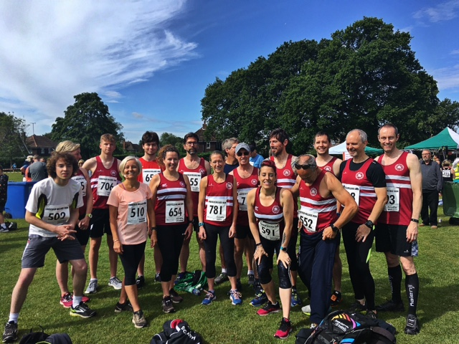

**Haywards Heath Harriers at Lindfield 10km fun run.**

**15 May Vets Track & Field League – Eastbourne.**

The first of the Vets League held on 15 May at Eastbourne. Haywards Heath Harriers compete as a joint team with Lewes AC in this league. Lots of great performances on the night by the Harriers

**Men’s results:**

Andy Dray: 3rd HJ 1.40m, 3rd 400m 61.7 secs, 1st 100m 13.1 secs.

John Morgan; 3rd HJ 1.15m.

Mike Bale: 3rd Javelin 19.72m, 2nd Hammer 30.94m

Paul Cousins: 1st 1500m 5:27.7 secs.

John Palmer: 4th 400m 69.0 secs, 4th 100m 14.9 secs.

**Women’s result:**

Helen Diack: 4th Shot Putt 5.56m, 3rd HJ 1.20m, 3rd TJ 7.95m, 4th Hammer 12.14m.

Jenny Denyer: 2nd Shot Putt 6.12m, 1st HJ 0.90m, 2nd 1000m walk 7:18.2 secs, 3rd 100m 20.1 secs, 3rd Hammer 18.93m.

Karen Thompson: 1st HJ 1.15m, 5th 100m 17.2 secs.

Abigail Redd: 1st 1000m Walk 5:55.6 secs, 5th 1500m Abigail Redd 6:25.8 secs, 5th 400m 86.3 secs.

Linda Tullett: 4th 1500m 7:53.5 secs, 3rd 400m 91.7 secs.

**19 May SAL Wimbledon.**

A number of Harriers took park in the second of this season’s Southern Athletics League at Wimbledon om 19 May.

Simeon Cousins: 2nd 100m ‘A’ string 12.0 secs, 2nd 200m ‘B’ string 24.3 secs.

Jenny Denyer: 2nd ‘100m B’ string 20.1 secs, 3rd SP ‘A’ string 5.29m, 2nd DT ‘A’ string 14.71m, 2nd HT ‘A’ string 19.49m, 2nd JT ‘A’ string 12.12m.

Tim Popkin: 3rd 400m ‘B’ string 68.6 secs, 4th 800m ‘A’ string 2:35.0 secs; 1st 1500m ‘B’ string 5:51.3 secs, 3rd 3000m ‘B’ string 13:04.3 secs.

Paul Cousins: 3rd 1500m ‘A’ string 4:58.1 secs, 3rd 3000m ‘A’ string 10:45.9 secs, 4th HJ ‘A’ 1.00m, 3rd SP ‘A’ string 4.96m, 2nd JT ’B’ string 18.38m.

**3 June Sussex Masters Track & field championships.**

At the Surrey & Sussex Masters Track & Field Championships held at Kingston, London on Sunday 2nd June, Harriers Carl Bicknell and Karen Thompson both took part.

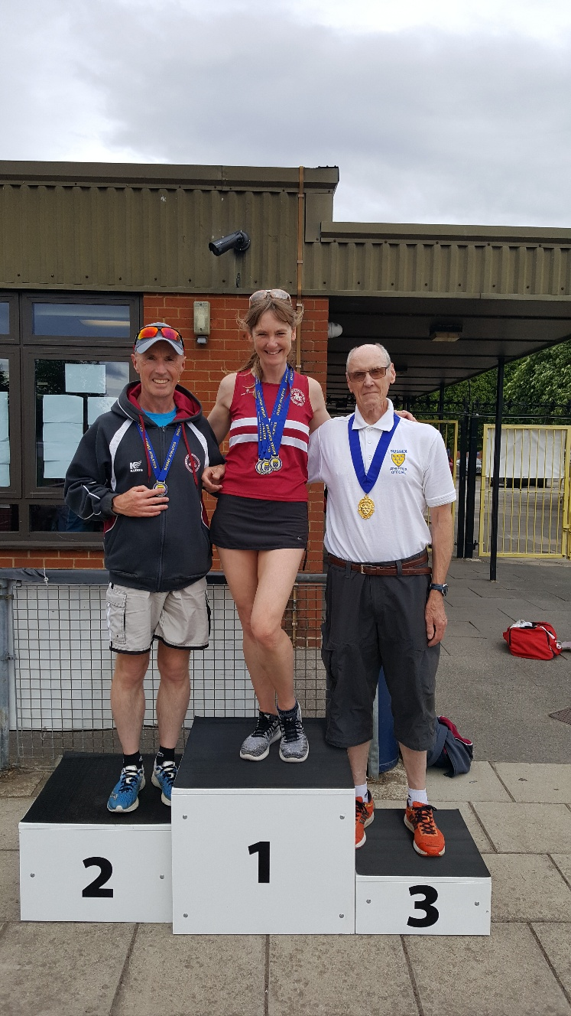

Karen was first Sussex lady in her age category (VW55) in the 200m, 400m and High Jump, improving on her own club high jump club record by an impressive 12cm.

Carl picked up age category gold in the men's VM55 5000m.

Mike Bale took gold honours in the Hammer, Discus and Shot and also won the javelin in the VM60 age group.

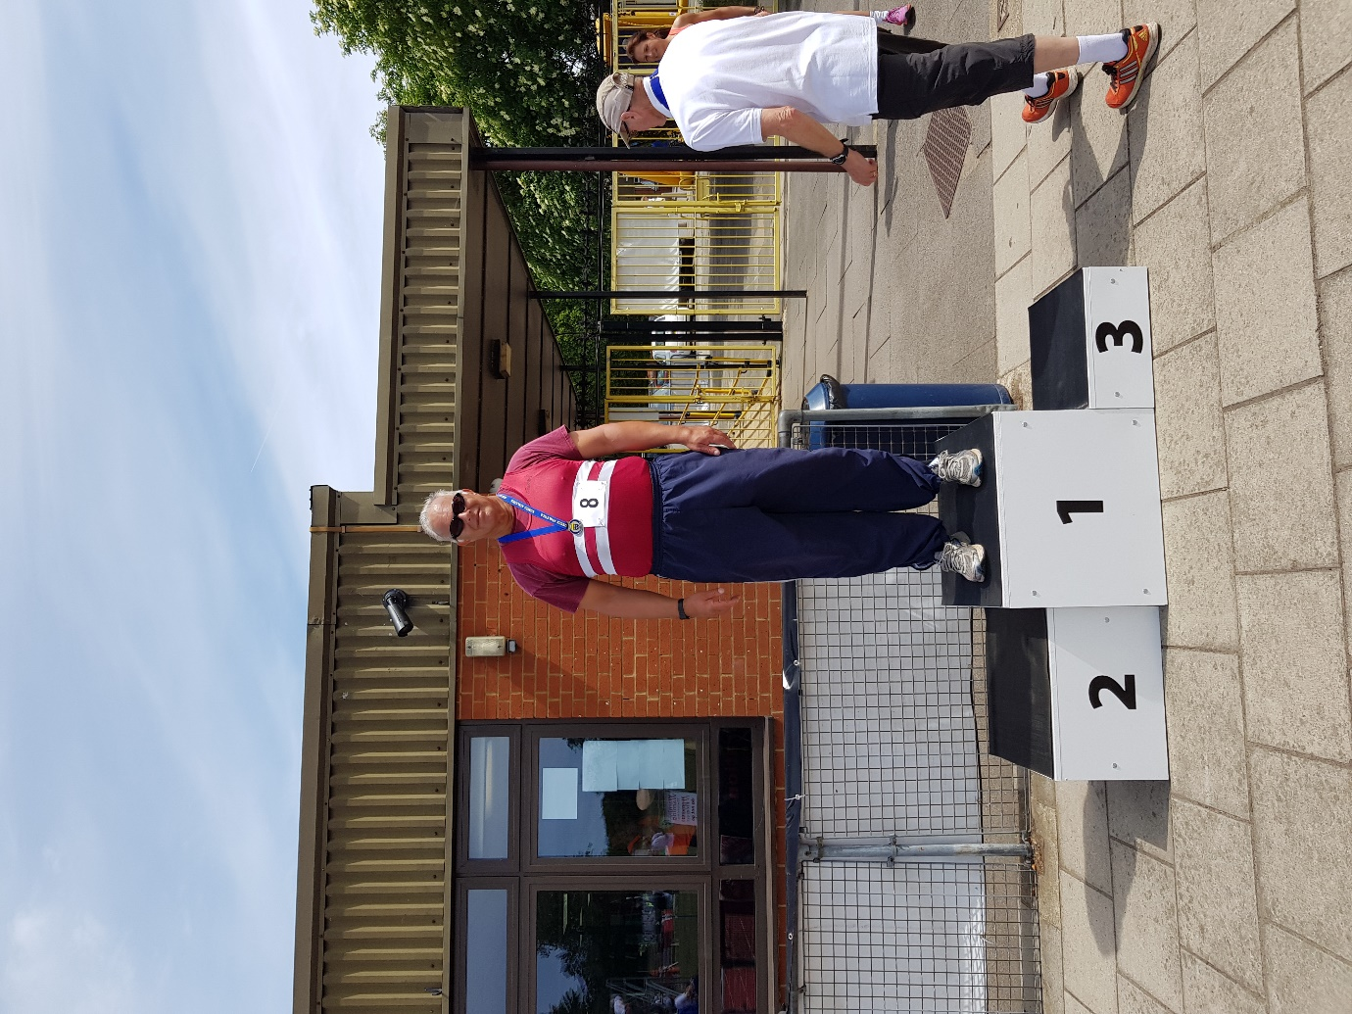

**Mike Bale.**

Results:

Mike Bale (V60): 1st DT 28.13m, 1st HT 32.37m, 1st JT 19.65m, 1st SP 8.31m.

Karen Thompson: 1st HJ 1.27m, 1st 200m 35.18 secs, 1st 400m 1:22.47 secs.

Carl Bicknell: 1st 5000m 22:20.16 secs.