Middy Report for 21.01.18

Darja Is Back In Form Of Her Life
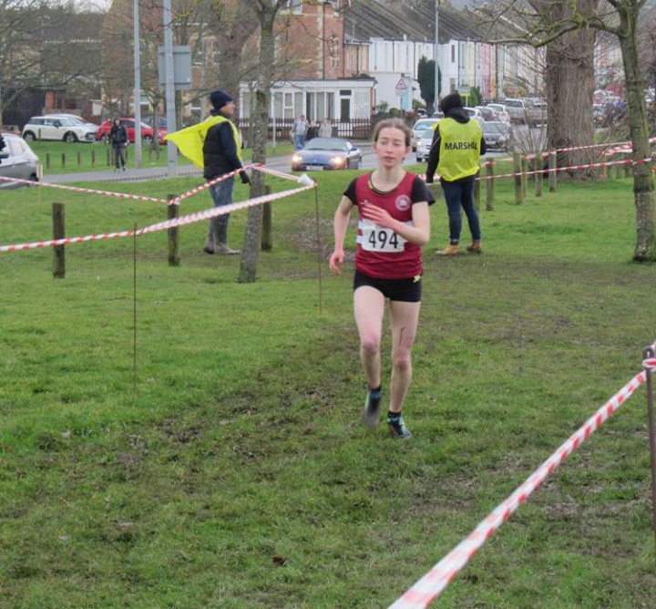
Darja Knotkova-Hanley.
Last Wednesday 17th January, Darja Knotkova-Hanley (Collyers) had a stormer of a run as she came a super 3rd in the Senior Girl’s race at the Sussex Schools Cross Country Championships at Waterhall in Brighton. Darja, who had been lacking some form for the past year had a super run finishing with the bronze medal only 2 seconds behind the winner!

Also, last weekend at Lancing Manor the Sussex Masters’ Cross-Country Championships were held on a very challenging muddy and hilly course. The Harriers who have been concentrating on cross-country development within the club for the last few years (coached by Martin Delbridge) sent out a team of veterans who don’t just run cross-country but enjoy the toughness of the event and have great fun at the same time. If you are interested in running cross-country then why not give it a try!

The men’s Vet 40 team were rewarded as they managed to sneak in and come home with a bronze team medal with 69 points and were not far off silver won by Lewes AC with 66 points. The Over 50’s men’s team just missed 3rd team by coming 4th with 36 points to Lewes AC 32 points as did the Women’s Over 35’s who also came 4th with 21 points to Brighton & Hove’s 3rd with 15 points.

In the individual races, Paul Cousins was the highest finisher in 4th place in O50’s race. The highest position for the ladies were Karen Thompson (O45’s) and Marion Hemsworth (O55’s) both in 13th place.

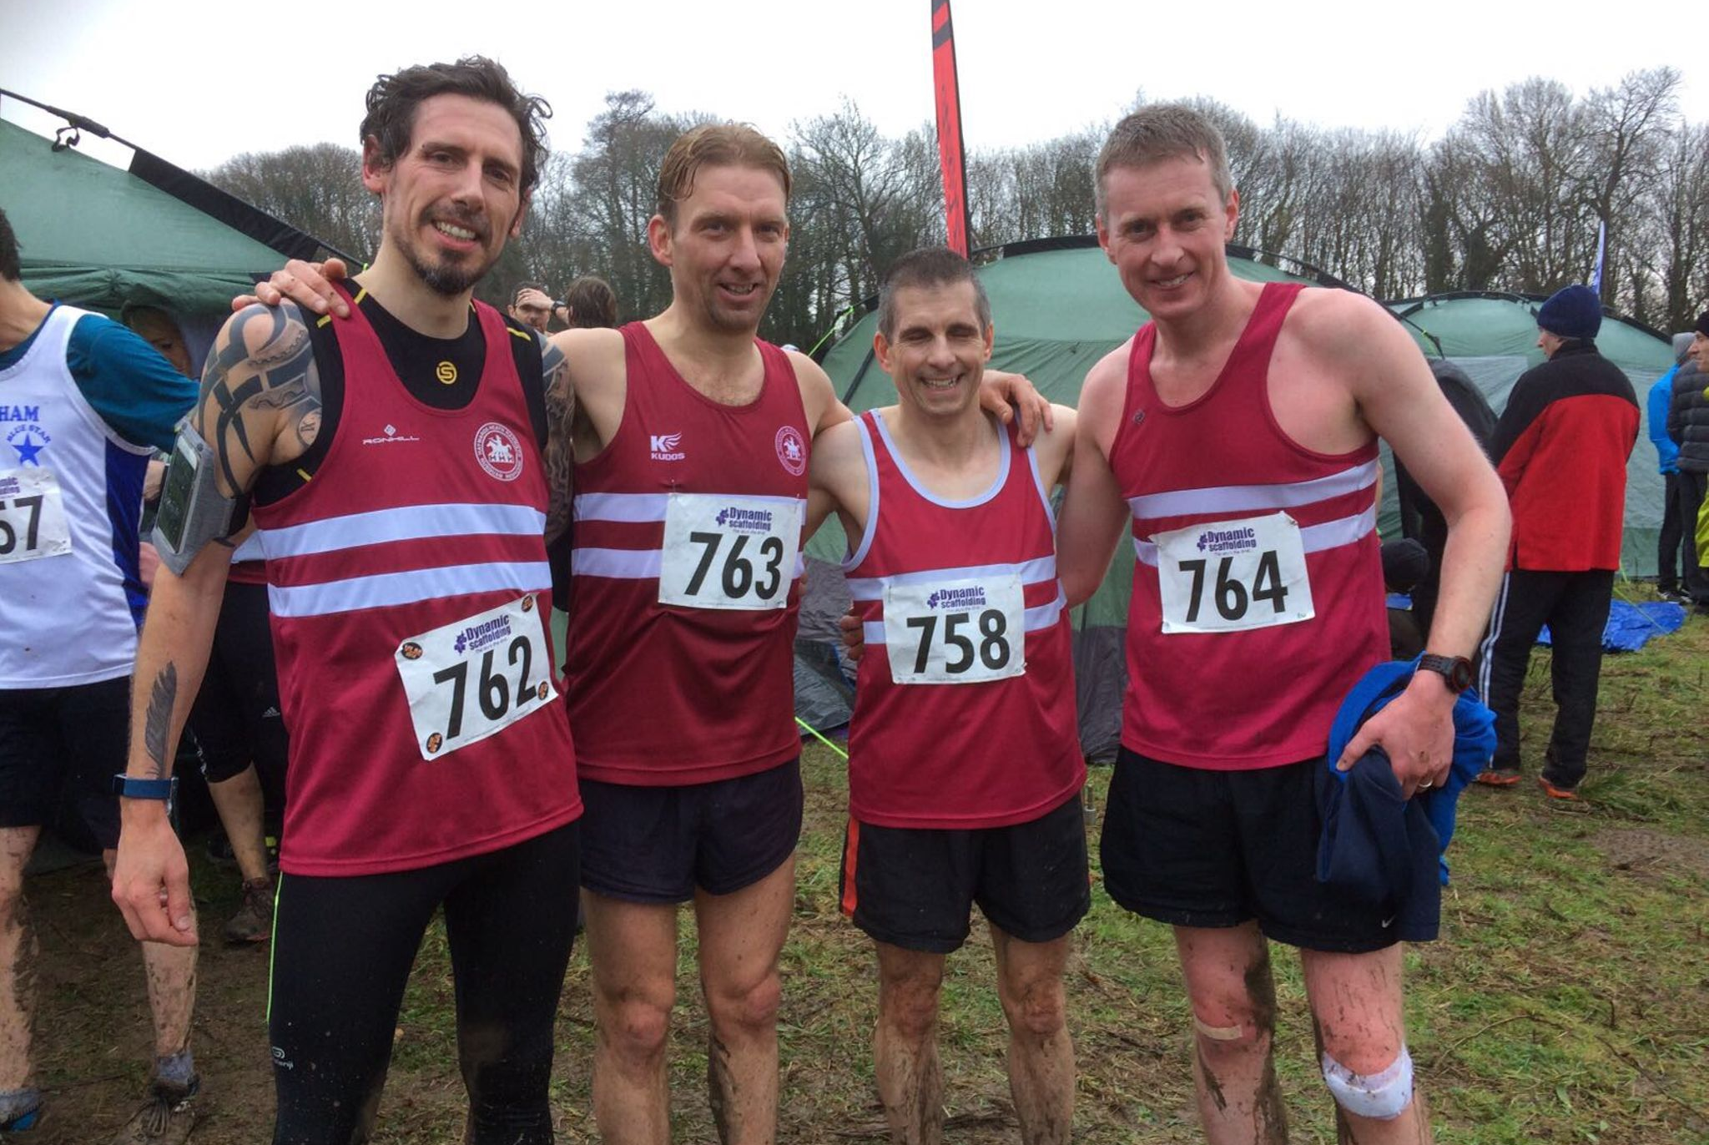Team Bronze: Men’s V40 medallists were (left to right): Andy Hind, Marcus Kimmins, , Julian Boyer and Rob Watts.

Full results from Lancing were as follows:
Women Over 35: 20th Gillian Forrest 33:46, 34th Claire Annesley 42:04, 35th Justine Tanner 42:35.
HHH 7th Team.

Women Over 45: 13th Karen Thompson 34:40, 16th Katherine Buckeridge 35:26, 21st Sarah Hamilton 39:54, 22nd Jacqueline Barnes 40:06, 28th Alison Shore 54:57.
HHH 4th team.

Women Over 55: 13th Marion Hemsworth 41:54, 21st Jenny Denyer 56:11.

Men Over 40: 7th Marcus Kimmins 40:01, 11th Rob Watts 41:11, 24th Julian Boyer 43:46, 27th Andy Hind 44:24, 37th Andy Dray 49:04, 45th Michael Essex 56:53.

Men Over 50: 4th Paul Cousins 32:55, 14th Barry Tullett 36:35, 18th Tim Hicks 37:17, 33rd Phil Scott 41:23, 38th Ian Dumbrell 44:28, 39th Graham Kenward 44:56.
HHH A team 4th. HHH B team 10th.

Men Over 60: 26^{h} Richard Bates 55:04.

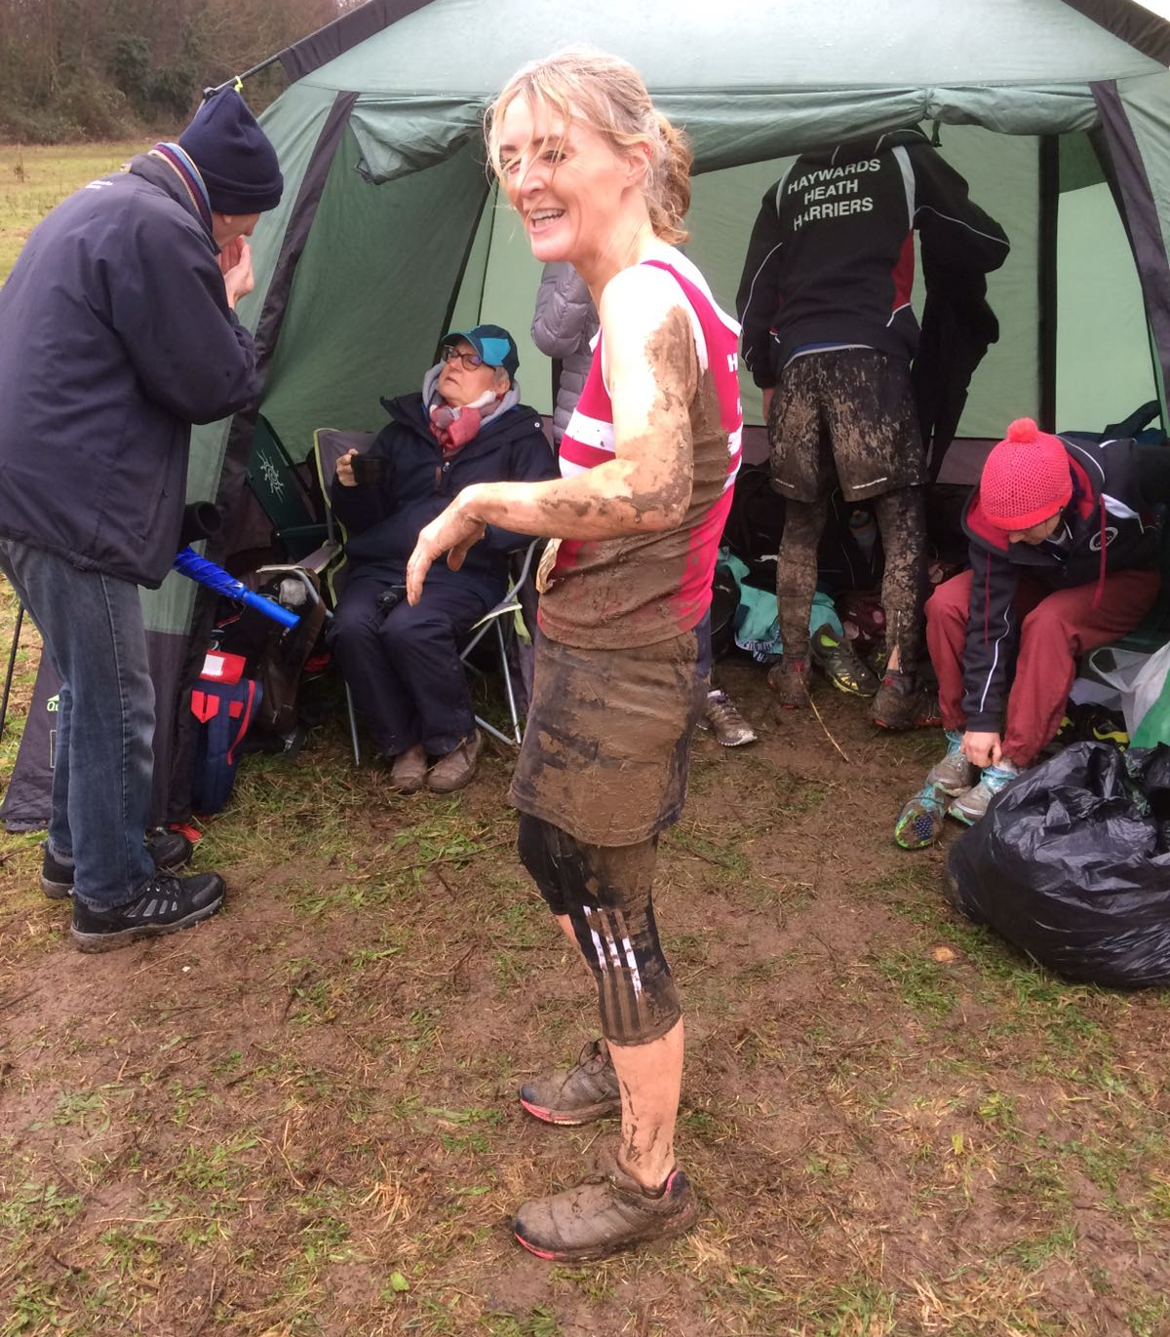
Alison Shore covered in mud.

As the mud took its toll on the runners, some runners decided the mud-bath was the best way around the course. As Harriers Alison found that without spikes the course was a very slippery place to be.

Other Harriers results were:
Phil Payne and Kim Lo completed the Farnborough Half Marathon on Sunday. Phil running a new personal best time of 1 hour 23 minutes and 8 seconds. Kim ran 1 hour 30 minutes and 26 seconds.

Sussex Sports Hall League results at Horsham on 14th January at Tandridge House School.

Girls u/11. DONE
2 Lap Sprint: ‘A’ race: 3rd Mae Robinson 25.7 secs, ‘B’ race: 4th Maia Bliss-Tomlinson 26.8 secs
Standing Long Jump: ‘A’ 2nd Mae Robinson 1m91, ‘B’ 3rd Maia Bliss-Tomlinson 1m79.
Speed Bounce: ‘A’ 4th Mae Robinson 51; ‘B’ 3rd Maia Bliss-Tomlinson 47.
4 x 1 Lap Relay:5th Haywards Heath 54.1 secs.
Girls u/13. DONE
2 Lap Sprint: ‘A’ race: 5th Isobelle Deeble 25.1 secs; B’ race: 4th Millie Somerville 26.2 secs.
4 Lap race: ‘A’: 4th May Stevenson 59.9 secs; B’ race: 4th Jessica Bashford-Dickens 64.1secs.
6 Lap race ‘A’: 5th Jessica Bashford-Dickens 1min 44.2 secs.
Speed Bounce: ‘A’ 3rd Millie Sommerville 74; ‘B’ 4th Jessica Bashford-Dickens 62.
Standing Long Jump: ‘A’ 5th Isobelle Deeble 1m83; ‘B’ 4th Millie Somerville 1m71.
Shot Putt: ‘A’ 4th Millie Francis 5m61; ‘B’ 4th Poppy Stapley: 4m28.
Vertical Jump: ‘A’ 5th Isobelle Deeble: 42, ‘B’ 4th Poppy Stapley: 42.
8 Lap Parlauf: 5th ^{th} Haywards Heath 1min 56.9 secs.
4 x 2 Lap Relay: 4th Haywards Heath 1min 38.9 secs.
Girls u/15: DONE
2 Lap Sprint: ‘A’ race: 5th Emma Vince 26.6 secs.
Shot Putt: ‘A’ 4th Emma Vince 3m99.
Vertical Jump: ‘A’ 5th Emma Vince 41.
Boys u/11: DONE
2 Lap Sprint: ‘A’ race: 2nd Thomas Pearce 24.7 secs; ‘B’ race: 4th Jack Twibell 25.3 secs.
Standing Long Jump: ‘A’ 4th Thomas Pearce 1m95; ‘B’ 4th Jack Twibell 1m77.
Speed Bounce: ‘A’ 3rd Harry Krombas: 52, ‘B’ 4th Oscar Clark 44.
4 x 1 Lap Relay:4th Haywards Heath 51.0 secs.
Boys u/13: DONE
2 Lap Sprint: ‘A’ race: 3rd Alexs Booth 24.5 secs; ‘B’ race: 4th George Bonwick-Adams 26.4 secs.
4 Lap race: ‘A’ 3rd Charlie Bonwick-Adams 52.7 secs; ‘B’ race’: 3rd Louis Henry 53.7 secs.
Speed Bounce: ‘A’ 2nd George Bonwick-Adams 76, ‘B’ 2nd Charlie Bonwick-Adams: 72.
Standing Long Jump: ‘A’ 4th Alexs Booth 1m84; ‘B’ 4th Louis Henry 1m83.
Shot Putt: ‘A’ 4th George Bonwick-Adams 3m48.
Vertical Jump: ‘A’ 3rd Alexs Booth:50, ‘B’ 2nd Loius Henry: 41.
4 x 2 Lap Relay:3rd Haywards Heath 1min 39.6 secs.
Boys u/15: DONE
2 Lap Sprint: ‘A’ race: 4th Ethan Lambert 22.8 secs; ‘B’ race: 3rd Alfie Geere 23.2 secs.
4 Lap Race: ‘A’ race: 4th Harvey Bashford-Dickens 50.9 secs.
Speed Bounce: ‘A’ 2nd Ethan Lambert 87; ‘B’ 2nd Alfie Geere 72.
Vertical Jump: ‘A’ 3rd Ethan Lambert: 56, ‘B’ 4th Harvey Bashford-Dickens: 47.
Standing Long Jump: ‘A’ 4th Alfie Geere 2m02.
Shot Putt: ‘A’ 4th Harvey Bashford-Dickens 5m03.
8 Lap Parlauf: 2nd Haywards Heath 1min 42.7 secs.

Non-Scoring:
2 Lap Race: Charlie Bonwick-Adams 24.2 secs, Oliver Cooper 27.1 secs, Seamus Cannon 27.0 secs, Harry Krombas 26.0 secs, Oscar Clark 28.7 secs, Millie Fairbrother 27.9 secs, Brooke Bashford 30.2 secs, Bethany Hilton 29.1 secs.
.
Speed Bounce: Oliver Cooper 33, Seamus Cannon 44, Jack Twibell 41, Millie Fairbrother 39, Brooke Bashford 33, Erin Gaston 44, Bethany Hilton 34.

Standing Long Jump: Oliver Cooper 1m46, Seamus Cannon 1m39, Oscar Clark 1m62, Harry Krombas 1m61, Erin Gaston 1m39, Bethany Hilton 1m06, Brooke Bashford 1m15, Millie Fairbrother 1m43.

Match result: Girls 4TH 77 points; Boys 4th 129 points.

