Carl Achieves South Downs Way 100 Feat.
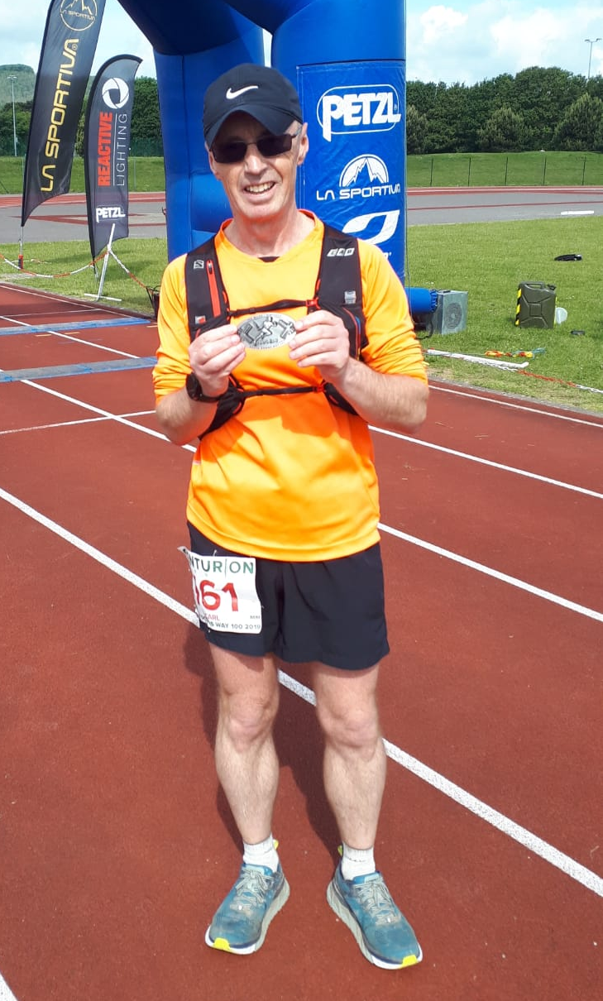
Carl Bicknell.

Cark Bicknell completed the South Downs Way 100 mile ultra on Saturday/Sunday 8th and 9th of June in 27 hours 42 minutes.

This event organised by Centurion Running started at Matterley Bowl near Winchester and finished at Eastbourne Athletics track, almost entirely following the South Downs Way. The weather was cool and mainly dry with a helping breeze.

The race allows runners to be accompanied by pacers during the last 50 miles and Carl was very grateful to fellow Harriers Katherine Buckeridge, Michael Burke, Karen Thompson and Lydia Levy for helping him through the night and the difficult later stages.

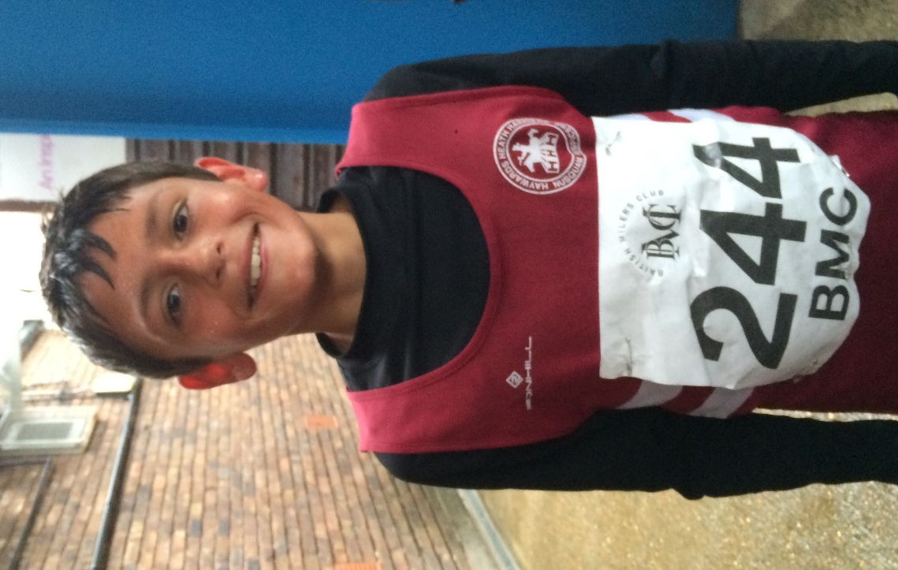
Arun Khursheed.

At the Phoenix Open/BMC races Wed 29 May, there were great performances by all the Harriers taking part. Young Arun Khursheed continuing his successful season by winning his 800 metres race in a fine time and a personal best of 2 minutes and 24.16 seconds.
Harriet Dray finished fourth in her 800m race in 2 mins 30.75 secs. Adam Dray finished third in his 1500 metres race with 4 minutes 11.12 seconds (a personal best time). In the women’s 3000 metres race, Emma Navesey finished in tenth place in 10 minutes 21.6 seconds and Darja Knotkova-Hanley not too far behind finished in thirteenth place in 10 minutes 37.7 seconds.

The Under 15 Track & Field League took place on Thursday 30th May at K2, Crawley.
The Harrier results were as follows:

Boys results:
Rory Dalgliesh: 2nd ‘A’ string 300m 44.5 secs, 3rd ‘A’ string Long Jump 4.40m.
Louis Henry: 2nd ‘B’ string 300m 53.0 secs, 6th ‘A’ string Shot Putt 4.80m.
Sam Fernley: 4th ‘A’ string 1500m 4:53.7 secs.
Alex Booth: 3rd ‘B’ string Long Jump 3.70m, 2nd ‘A’ string Javelin 23.25m.
4 x 100m relay: 4th HHH 59.0 secs.

Girls results:
Amy Rutherford: 2nd ‘A’ string 1500m 5:31.8 secs.

Parkrun Report by Michael Parish.

Parkrun organise free weekly 5km timed runs around the world. They are free to everyone and safe and easy to take part in. Parkruns are held every Saturday at 9am in local parks and attended by 263,937 runners with 23,169 volunteers. There are 270 junior Parkruns attended by 22,005 under 14s with 4,960 volunteers worldwide.

Saturday 8th June saw Haywards Heath Harriers take over Clair Park Parkrun in Mid Sussex. The Harriers covered all volunteer roles and a large team of Harriers took part in the event alongside runners from other clubs and unaffiliated runners.

Ian Dumbrell took on the role of race director giving the pre-race briefing with health and safety advice. Once this was completed the runners moved to the start line. The course requires four and a half laps of Clair Park which is one of the more difficult parkruns to complete as just under 50% of it is uphill. The timers were Marian Hemsworth and Michael Parish with Michael Essex taking on the role of tail walker ensuring that everybody crossed the finish line safely.

Volunteers were: Andy Hind, Ann Savidge, Ben Gibson, Gemma Morgan, Graham Kenward, Hannah Gibson, Katherine Buckeridge, Linda Tullett, Lydia Levy, Pete Francis and Sarah Hamilton.

Shelagh Robinson celebrated her 200th parkrun!

Harriers team were: Arun Khursheed 18:34, Matt Cook 18:36, Ryan Armstrong 19:15, Nicholas Skov 19:46, Tim Miller 20:30, Tim Hicks 20:46, Barry Tullett 21:17, Charlie Bonwick-Adams 21:37, Finlay Blythe 21:42, Andy Dray 21:46, Paul Cousins 21:54, Robert Watts 21:55, David Harper 22:48, Mark Sykes 23:24, Samantha Ridley 23:50, Harvey Gwynn 25:01, Jonathan Bromley 25:18, Eric Hepburn 25:25, Dominic Roberjot 26:05, Clare Kenwood 27:26, Greg Hilton 29:46, Carys Hind 30:38, Mae Robinson 30:47, Jacqueline Barnes 31:25, Maureen Rea 36:29.

Other Harrier results:

Horsham 10km 2 June. Results were:
37th Jack Chivers 42:58, 53rd Matt Quinton 44:29, 102nd Phil Scott 47:27, 120th Oli Farr 48:45, 182nd Amanda Soper 53:31, 257th Peter Cobbett 58:18, 411th Jenny Denyer 80:54.

Worthing 10km on 2 June. Results were:
48th Robin English 39:42, 490th Chris Glanfield 50:39, 927th Marion Hemsworth 56:29.
Focus 10km 2/6.

On 9 June at the Weald Challenge trail race over 50 kilometres. Greg Hilton finished in 26th place in a time of 5 hours 22 minutes and 44 seconds and Oliver Farr finished in 43rd place in a time of 5 hours 56 minutes and 58 seconds.

At the Crawley Athletic Club Open Graded Meeting on 5 June.
Jonathan Parkin U/13 100m 14.83 secs, Long Jump 3.90m.
Arun Khursheed U/13 1500m 4:42.13, 200m 31.3 secs, Long Jump 3.46m

