Middy Report 30/07/17

HARRIERS TAKE THE HONOURS

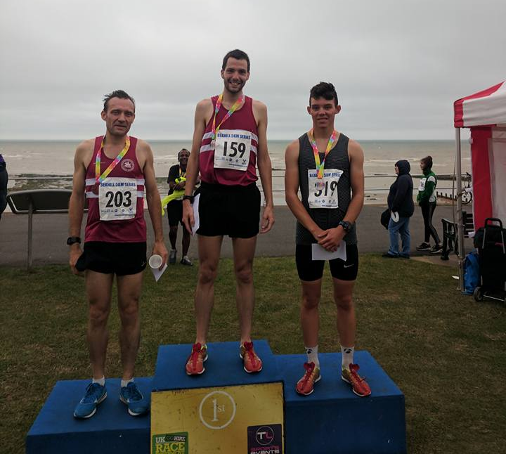

Russ Mullen (centre) in 1st place, Luke Howard (right) and James Skinner (left) in 3rd place.

On last Wednesday 26 m July at the Bexhill 5 km, Haywards Heath Harriers were dominant again in the event with Harriers picking up individual honours with Russ Mullen winning the race in blustery conditions. Results were as follows:
1st Russ Mullen 16:39.45, 3rd James Skinner 16:53.25, 15th Tom Mullen 18:12.10, 52nd Matt Quinton 20:07.30, 54th Emma Navesey 20:08.65 (pb), 106th Darja Knotva-Hanley 22:09.25, 128th Oliver Farr 22:38.70, 133rd Chris Glanfield 22:57.90, 139th Amy Mitchell 23:06.80, 150th Amanda Soper 23:55.45, 222nd Peter Cobbett 27:17.15,

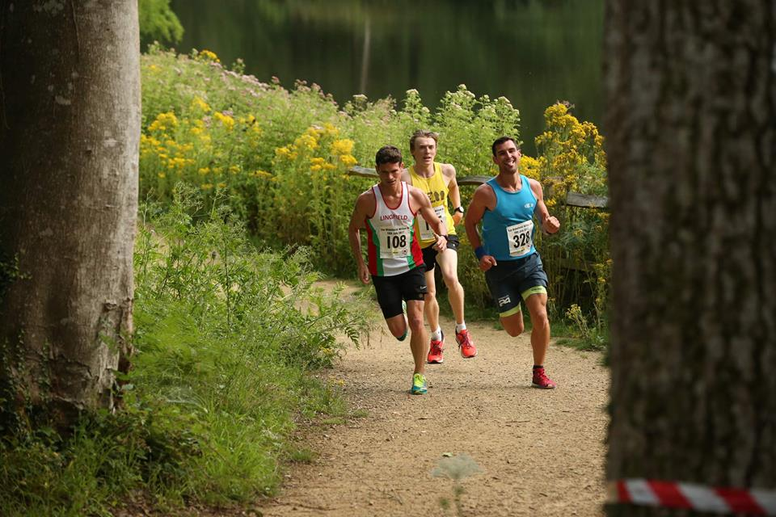
Photo courtesy of Sussex Sport Photography.
Luke Davis (left), pursued by Jason Harrold (middle) and Ben Short (right).

On July 18^{th,} the second Wakehurst Willow 8km race was held at Wakehurst Gardens. The race was won by Luke Davis (Lingfield Running Club) in a new course record of 28:28 (beating last year’s record by nearly 4 minutes!), 2nd was Ben Short (Horley Harriers) in 29:37 and 3rd place was Jason Harrold (Saints and Sinners). First lady across the line was Amelia Brown of Saints and Sinners in 34:16 followed by Kirsty Armstrong (Burgess Hill Runners) in 35:56 and Cheryl Evans unattached) for 3rd place in 37:06.
Harriers results were: 4th Ben Gibson 29:54,5th James Collins 30:34, 7th Phil Payne 31:30. 8th Matt King 31:40, 9th Peter Harding 33:55, 13th Robin English 34:47, 43rd Hannah Chapman 39:06, 53rd Bryan Tiller 39:40, 66th Carl Bicknell 40:50, 78th Georgina Mugridge 41:42, 85th Liam Bahnham-Rayward 42:11, 98th Sam Ridley 43:06, 104th Graham Kenward 43:19, 108th Sarah Banks 43:28, 116th Jacqueline Barnes 44:16, 126th Clare Kenward 45:31, 138th Gina Hobson 46:09, 142nd Kat Barratt 46:32, 166th Sarah Hamilton 47:45, 210th Shelagh Robinson 49:54.

Phil Radford ran in the Bristol & West AC Fast 5000m Open at Yate on 22 July. Even though Phil ran a life time best to record a personal best (pb) of 15:15. He could only finish this high standard race in 11th position!

Harriers were also taking part in the last Sussex Vets Track and Field League meeting of the season last Wednesday at Eastbourne. Harriers were part of a joint team with Lewes AC. Harriers results were as follows:
Harriers results were as follows:
Mike Bale V60 1st Hammer 31m79, V50 1st 7m50.
Julian Boyer V35 1st ‘B string 400m 68.4 secs, V35 3rd ‘B’ string 1500m 5:31.9 secs.
Paul Cousins V35 2nd ‘A’ string 5000m 18:27.7 secs.
Barry Tullett V50 3rd 5000m 21.01.7 secs.
John Morgan V35 3rd ‘A’ string High Jump 1m10.
Linda Tullett V50 3rd Hammer 6m17, V50 3rd 400m 1:35.0 secs, V50 3rd 100m 17.2 secs, V50 2nd 1500m 7:44.1 secs, V50 3rd Javelin 9m11.
Helen Diack V35 2nd High Jump 1m20, V35 ‘A’ string 1st Triple Jump 8m42.
Abigail Redd V35 3rd 400m 90.0 secs, V35 ‘A’ string 3rd 100m 17.7 secs, V35 3rd ‘A’ string Javelin 9m05.

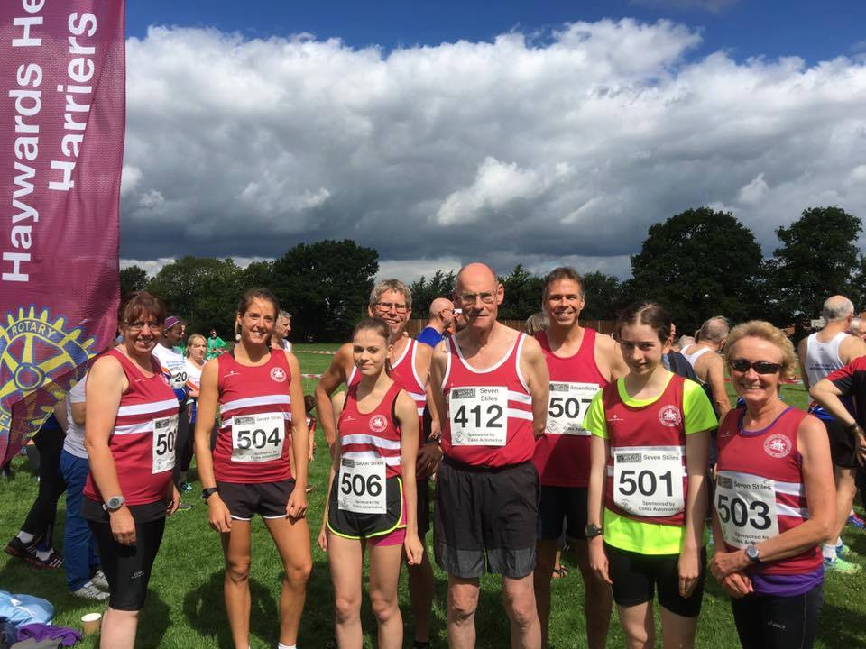

Harriers at Henfield 7 Stiles
On Sunday 30 July, a handful of Harriers took part in the West Sussex Fun Run League at Henfield in the 7 Stiles race. The ladies led the men home in this race and the results were as follows: 29th Katie Morgan 25:28 (3rd lady), 48th Barry Tullett 27:08, 57th Phil Scott 27:48, 71st Darja Knotkova-Hanley 28:48 (10th lady),86th Mark Armitage 29:47, 92nd Amy Mitchel 30:06 (15th lady), 234th Marion Hemsworth 40:10, 314th Linda Tullett 48:14, 342nd Rupert Purchase 51:59.

