Middy Report 28.01.18

Harriers Survive the Southerns this week at Stanmer Park

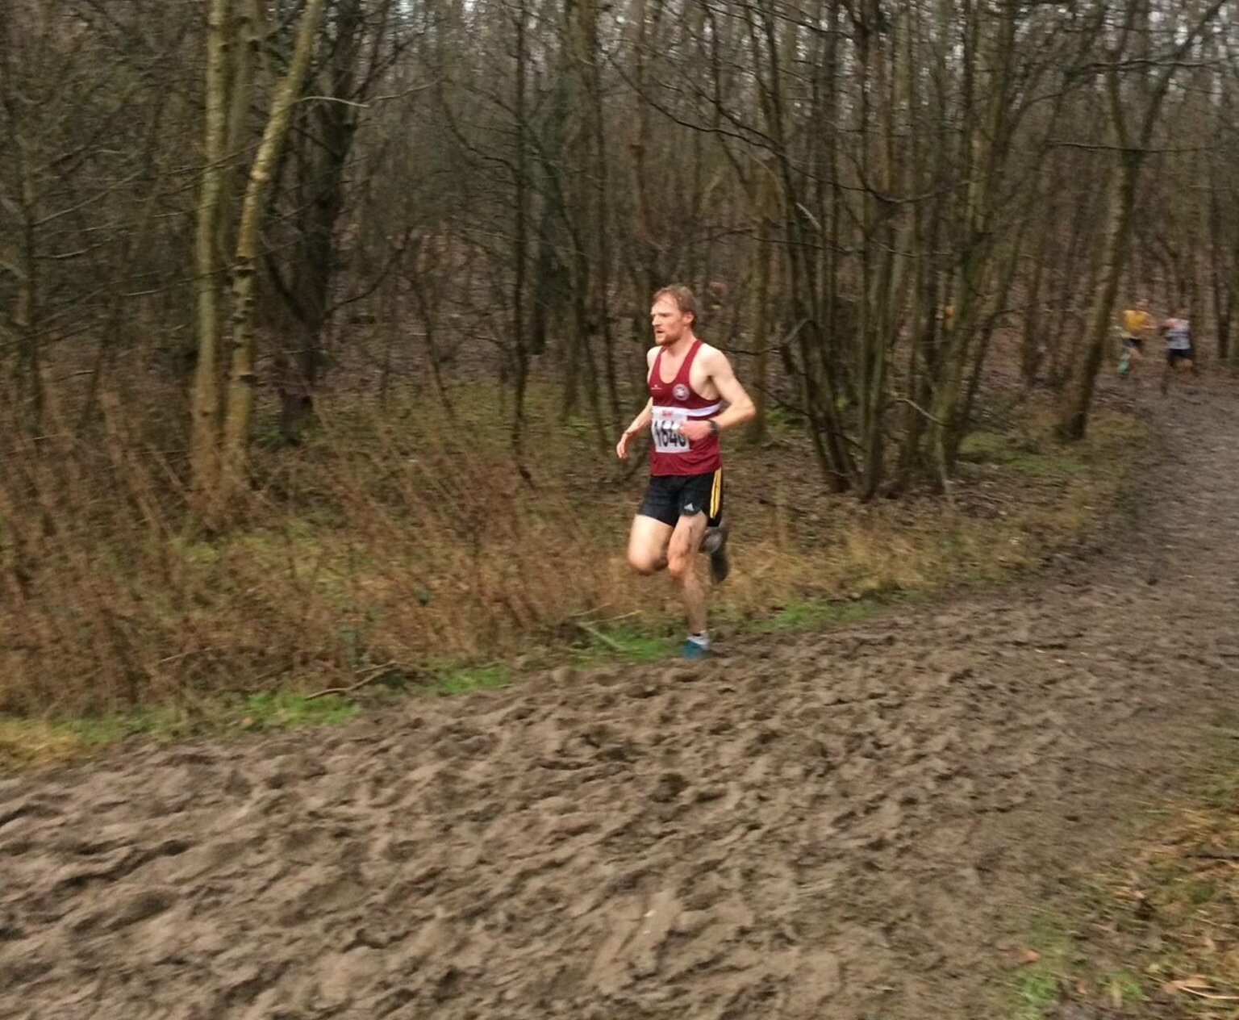
James Collins makes light of the muddy conditions.
Haywards Heath Harriers were competing at the Southern Counties Cross Country Championships last weekend. With the last few weeks bringing in the rain, and with a hilly course to contend with, Haywards Heath Harriers took on the best in the south of England.
In the Senior Men’s race, James Collins led the team home in a super 71st place. With 4 scoring in the team event, the Harriers managed 38th place out of 75 teams.
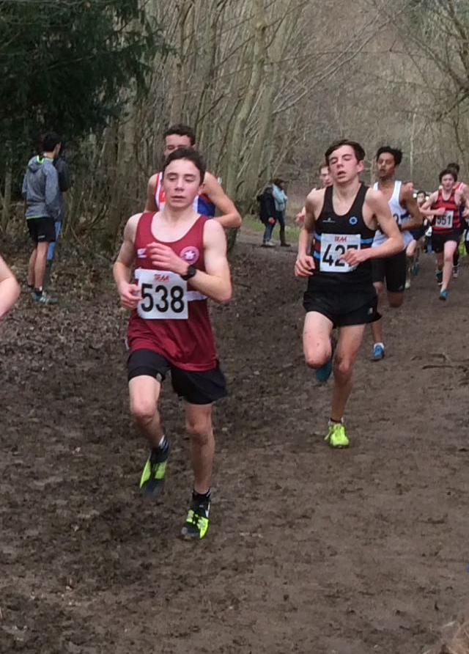
Adam Dray in the Under 15 Boys race

There were other top 100 results for Darja Knotkova-Hanley in the Under 17 Girls and Adam Dray in the Under 15 Boys.
l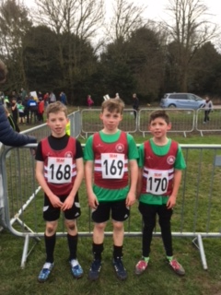
(Left to right) Charlie and George Bonwick-Adams and Noah Perrett.
In the Under 13 Boys race Charlie Bonwick-Adams and brother George were running at the bottom end of this age group with both boys have another two years in this age group. Charlie was the first brother home in 147th place followed by George in 220th place.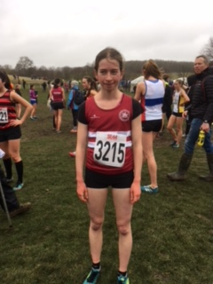
Darja Knotkova-Hanley – 22nd place.

Results were as follows:
U13 Boys:147th Charlie Bonwick-Adams 12:00, 220th George Bonwick-Adams 12:48, 255th Noah Perrett 14:24.
U15 Boys:45th Adam Dray 15:36.
U17 Women: 22nd Darja Knotkova-Hanley 18:58.
Senior Men’s: 71st James Collins, 269th Russ Mullen, 273rd Phil Payne, 330th Paul Cousins, 369th Tom Mullen, 422nd Julian Boyer, 424th Andy Hind, 458th Barry Tullett.
Senior Women’s: 313th Sarah Hamilton 49:07, 325th Claire Annesley 50:51.

