Marathon Report
The Beachy Head Marathon was held last Sunday starting at Eastbourne. The weather made the race even tougher after much rain from the previous weeks which made the condition quite slippery in places on an already very hilly course. This affected the finishing times as the first runner Luke Deiderfield finished in just over three hours in a time of three hours and five minutes and 55 seconds.

Results were:
39th Michael Burke 3 hours 42 minutes and 0 seconds, 520th Siobhan Amer 4 hours 54 minutes and 52 seconds, 626th Bryan Tiller 5 hours 6 minutes and 11 seconds, 627th Lydia Levy 5 hours 5 minutes and 19 seconds, 762nd Katherine Buckeridge 5 hours 16 minutes and 9 seconds, 828th Oliver Farr 5 hours 24 minutes and 13 seconds, 1065th Carl Bicknell 5 hours 43 minutes and 46 seconds, 1261st Sarah Banks 5 hours 59 minutes and 39 seconds, 1847th Michelle Robinson 7 hours 15 minutes and 54 seconds.

Athletics Report
At the indoor Lee Valley Minithon on 19 October, young Jonathan Parkin competed in under 13’s competition. Jonathan competed in the 60 metres race and ran 9.00 seconds and he long jumped 4 metres and 24 centimetres. His best result came in the high jump where he set a new personal best and an age group club record with 1 metre and 49 centimetres. This was Jonathan’s first experience of competing in an indoor athletic stadium.

Cross Country Report
The first cross country of the Sussex Cross Country League race was held at Goodwood on October 12th.

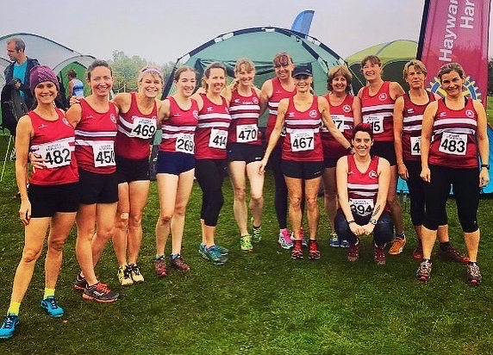
Harrier ladies at the Sussex XC League.

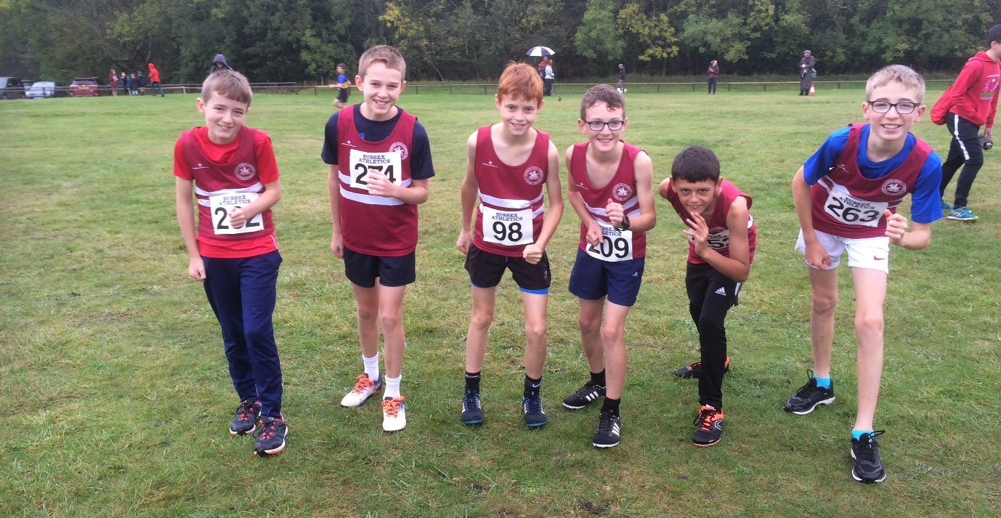
Young Harrier under 13 Boys at the Sussex XC League.

At the first Sussex Cross Country League event at Goodwood on 12 October, the lady Harriers set the pace for the men in the senior races. This was because the ladies managed to get 5 team results as opposed to the men who managed 3 teams. The Harriers team-wise have scored well in this first event of the season this is because they generally get a good turn-out in this first crucial event which is one of the Harriers strengths. The Under 13 boys managed to get two teams out (see photo above). The Harriers are training hard for the second event at Lancing Manor on the 9th of November where hopefully they can continue to strengthen and consolidate their team positions in this event.

Results were as follows:
Under 13 Girls race: 31st Maya Dell’Aira Bromley 14:35.
Senior Ladies /Under 17 Girl’s race: 7th Darja Knotkova-Hanley 19:15, 47th Kim Lo 21:39, 56th Sam Ridley 22:25, 60th Rosie Beckett 22:49, 66th Gemma Morgan 23:37, 67th Karen Thompson 23:41, 76th Kath Buckeridge 24:21, 80th Jacqueline Barnes 24:45, 90th Julie Essex 26:03, 95th Shelagh Robinson 26:46, 99th Claire Annesley 27:18, 114th Carys Hind 30:14, 120th Linda Tullett 32:08, 130th Jenny Denyer 38:11.
Under 13 Boys race: 5th Arun Khursheed 11:53, 14th Jacob Roderick 12:08, 20th Jonathan Beckett 12:26, 34th Finley Blythe 13:04, 48th Harry Russell 13:51, 64th Adam Beckett 17:47.
Under 17 Boy’s race: 22nd Ryan Armstrong 18:52.
Senior Men’s race: 1st Chris Smith 25:10, 17th John Kettle 27:27, 18th Ben Gibson 27:32, 32nd Matt king 28:59, 41st Darren Bird 29:44, 49th Andy Hind 30:26, 63rd Julian Boyer 32:11, 77th James Moffat 33:10, 78th Greg Hilton 33:20, 87th Andy dray 33:53, 97th Barry Tullett 35:01.

Fun Run League Report
At the Steepdown Challenge at Lancing on Sunday 27 October which is part of the West Sussex Fun Run League, the Harriers came away with some great results. In the junior race, young Seb Dell’Aira Bromley finished in tremendous first place in the junior race in 5 minutes and 51 seconds. In the adult’s race, the Harriers had 10 runners taking part bringing home maximum participation points in the league. Marcus Kimmins was first home for the club in 5th place.

Results were:
5th Marcus Kimmins 29:55, 12th Darren Bird 30:57, 16th Paul Cousins 32:09, 20th Julian Boyer 33:10, 30th Chris Russell 34:25, 31st Ryan Armstrong 34:29, 86th Ian Dumbrell 39:17, 133rd Jonathan Bromley 42:09, 203rd Sarah Hamilton 48:41, 253rd Richard Bates 55:03.

Other events
At the K2 Crawley 10k race Harriers has 3 runners taking part. First home was Tim Miller in 10th place with 43:02, next was Jack Chivers in 27th place in 46:07 and Matt Quinton in 29th in place in 46:20.

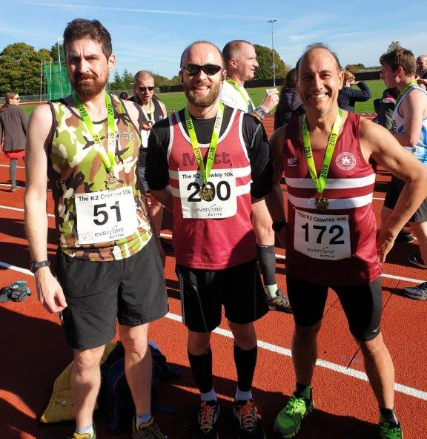
Left to right: Jack Chivers, Matt Quinton and Tim Miller.

