Abi runs in memory of her mum.

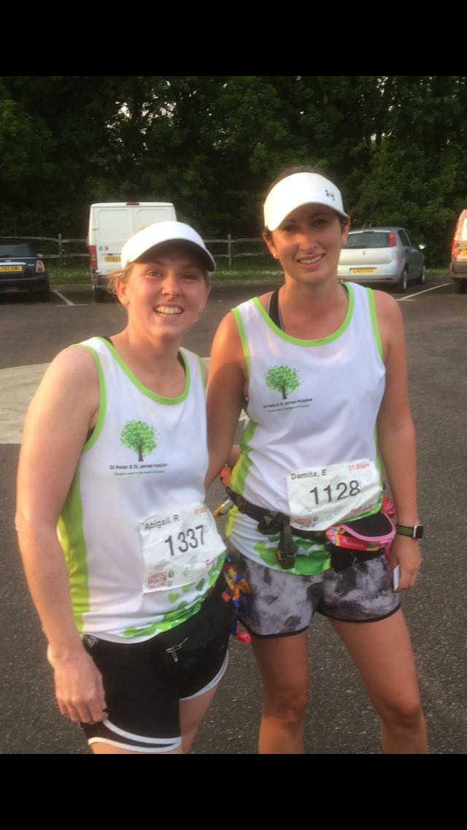

**Abigail Redd and Damita Ewen at 80k. Looking good.**

The London to Brighton Ultra took place last Saturday. One Harrier who was taking part was Abigail Redd and her friend Damita Ewen. Abigail and her friend, Damita, were running on behalf of Abigail’s mother Irene Parsley who was an avid Harrier and a stalwart of the Harriers until she passed away last year. Abigail decided to do something in her memory, so she chose to run the London to Brighton race – a 100km race – and was joined by her friend Damita. The pair of ultra-runners did not just have the long distance to contend with but also the hot weather: they had to make sure they took on enough food and water for the long journey to the finish. I am told they finished the run at midnight, so were running last few hours in the dark!!

Meanwhile, on the same day across to the east at Ashford in Kent, the Southern Counties Vets AC Champs Track & Field Championships was taking place where Mike Bale won 3 medals as a Vet 60 in the throwing events: Gold - Hammer 32.43; Gold - Discus; Silver - Shot.

The Youth Development League Under 17 and Under U20 took place at Erith last Sunday. Team Sussex won their match and who are now leading their division. Team Sussex comprising of 4 clubs: Haywards Heath Harriers, Eastbourne Rovers, East Grinstead Athletic Club and Lewes Athletic Club.

Individual Harriers results were:

Jasmine Mamoany – 1500m A string – 3rd    5:38.0; 3000m A string – 2nd   13:00.4; Javelin A string – 4th    14m56.

Adam Dray - 800m B String – 1st 2:10.9; U20 4 x 400m – 1st 3:53.2.

Other results.

At the Rye 10 miler, Matt Quinton finished in 15th place in 1 hr 17:28.

On Sunday 20 May, Steve Dallman ran in the Arun River Marathon.

28 May Bank Holiday Monday. Newhaven to Lido (15 km return): Teresa Mockeridge 2nd lady Lido 1 hr 45:10.

At the West Sussex Fun Run League at Trundle Hill(Chichester) on May 23rd two Harriers took part in this off-road league race. Amy Mitchell was 172nd in 56:24 and Richard Bates finished in 274th in 66:04.

Russ Mullen ran in the London 10km on Bank Holiday Monday and finished in 36:12 and Emma Navesey finished in 38:21.

Lindfield fun Run

At the Lindfield 10km fun run on Bank Holiday Monday, over a rugged terrain between the villages of Lindfield and Ardingly and over a thoroughly testing course and another super-hot day that we are beginning to get used to this summer, many local runners took part in the annual fun run event which comprises of 2 races: the shorter run over the 5km distance and a longer run over 10km. It was the first year where chip timing was used giving each runner an exact running time for the run. There were altogether 445 finishers in the 10km run and 332 finishers in the 5km.

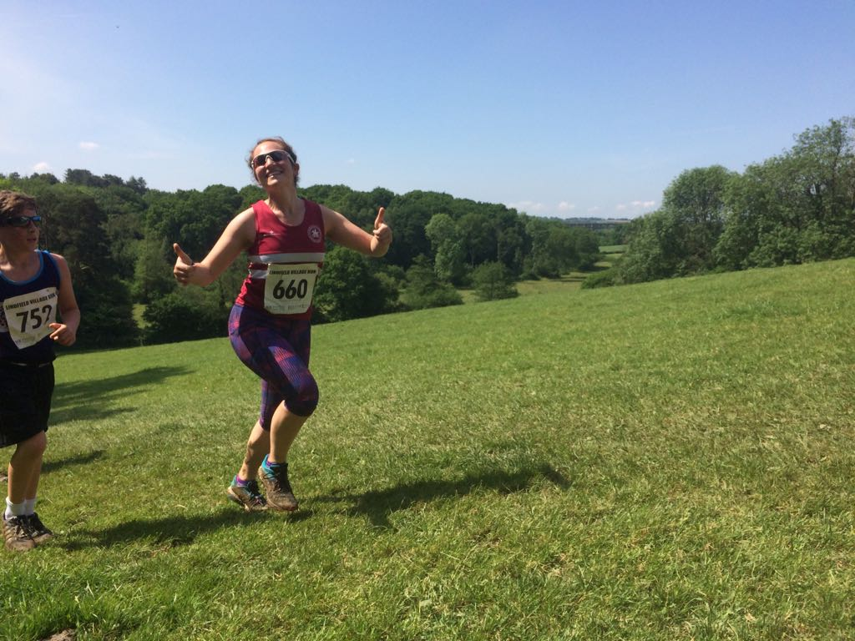

**Lydia Levy at the Lindfield 10km on Bank Holiday Monday.**  
  
First place in the lady’s 5k race was Darja Knotkova-Hanley in 22 minutes 6.8 seconds and Katie Morgan was first lady in the 10k in a time of 47 minutes and 44.7 seconds.

Full Harriers results were as below:  
In the 10km Lindfield fun run:

9th overall, and 1st lady Katie Morgan 47:44.7.  
11th Matt King 48:16.2.  
13th Matt Cooke 48:58.1.

33rd Rob English 58:00.4.  
48th Sam Ridley 59:37.3.

105th Lydia Levy 65:49.5.

107th Kath Buckeridge 65:59.9.  
111th Carl Bicknell 66:06.8.  
118th Matt Howell 66:51.8.

125th Seamus Cannon 67:09.6.  
131st Sarah Banks 67:35.5.

144th Ewen Kemsley 68:42.9.

163rd Gina Hobson 70:13.4.

181st Gemma Morgan 71:50.6.

185th Jaqueline Barnes 72:25.5.  
187th Shelagh Robinson 72:47.4

In the 5km Lindfield fun run:

6th overall, and 1st lady, Darja Knotkova-Hanley 22:06.8.

10th Harvey Alcock 22:33.7.

55th Thomas Pearce 27:21.3.

80th Fionnuala Lingard 28:54.3.

104th Cash Crouch 30:20.1.

115th Booh Crouch 31:09.7.

123rd Lio Robinson 31:44.1.

203rd Erin Gaston 35:15.9.

252nd Graham Kenward 37:17.1.

313th Eliza Martin 40:02.06.