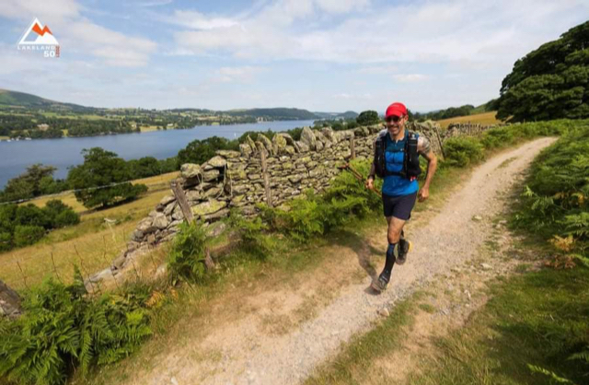
Michael Burke running the Lakeland 100.

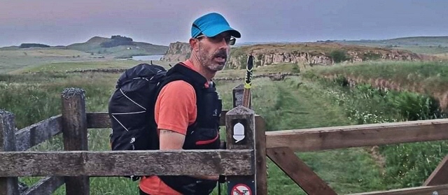
Michael Burke on Hadrian’s Wall.

COMING OUT of lockdown Haywards Heath Harrier ultra-runner Michael Burke set himself some challenging targets. Three ultra runs over extremely hazardous terrains and distances.

There are so many aspects to the events that Michael covers from the physical ability to run the distances he does, across the terrain that is desolate and dangerous and the mental ability to cope with it. The greater the distance the more you have to be in the right place mentally due to the time you are spending on your own and exhaustion that it puts your body through. On top of that with the runs spanning up to six consecutive days there is little chance of any real recovery.

Michael normally runs in support of Mind the mental health charity but this year he has been running in support of Macmillian cancer support in memory of his mother who he lost to cancer in July. This makes these runs a lot more personal for him.

Montane Spine, Saturday 19th June 2021 at 16:00 hrs.

Highly regarded as one of the world’s toughest endurance races over the Pennine Way National Trail. The route is 268 miles (429km) from Edale in Derbyshire to Kirk Yetholm, Scotland, tracing the backbone of England. It crosses some of the finest upland landscapes in the country, from the Peak District, through the Yorkshire Dales, across the North Pennines and over World Heritage-listed Hadrian’s Wall, on the remote Cheviot Hills and, ending at the village of Kirk Yetholm. The event is run over five continuous days of running and the clock doesn’t stop for rest, food or sleep.

Results: 1st Keith, 77:34:52; 2nd Troupe, 80:28:35; 3rd Leavesley, 91:39:06. Michael finished the event in 8th place overall and 7th male finisher with a time of 99:35:23. Michael said: “I completed it in 4 days and 3 hours and only managed about 9 hours sleep during the event.”

The Montane Lakeland 100, Friday July 23rd 2021, 18:00
The Lakeland 100 ‘Ultra Tour of the Lake District’ is the most spectacular long distance trail race with a circular route that encompasses the whole of the Lakeland fells, includes in the region of 6300m of ascent and consists almost entirely of public bridleways and footpaths. The route starts in Coniston and heads South before completing a clockwise loop which takes in the Dunnerdale Fells, Eskdale, Wasdale and Buttermere before arriving in Keswick. From here the route heads to Matterdale and continues over to Haweswater before returning via Kentmere, Ambleside and Elterwater to the finish at Coniston.
The event is continuous in nature, competitors don’t have to stop or sleep on the route and the winners are generally expected to finish close to the 20-hour mark. The overall time available for the route is 40 hours so sleep at intermediate checkpoints is possible, but time was not on Michael’s side.
Results: 1st Mark Darbyshire, Veteran40, 19:10:27; 2nd Marcis Gubats, Open, 20:46:42; 3rd Rory Harris, Veteran40, 21:26:00; Michael finished 128th with an amazing time of 33:03:40.

Dragons Back Monday 6th September 2021
The Dragon’s Back Race was a five days event run across mountains from North to South Wales. Running from Conwy to Llandeilo, with ascents in it that add up to twice the height of Mount Everest.
In August 2020 the organisers, Ourea Events, released the news that the 2021 race would mark a step change in the evolution of the event with the addition of a sixth day, which would see the race finish at the iconic Cardiff Castle.
This made the event 236 miles (380km) and an ascent of 17,400m (57,087 feet). Throwing in the extra day, miles and ascent was a real physical and mental challenge for Michael to overcome.
Day one, Conwy Castle to Nant Gwynant 30.5 miles (49km) and 12,467 ft (3800m). Day two, Nant Gwynant to Dolgellau 36.5 miles (59km) and 11,155ft (3400m). Day three, Dolgellau to Ceredigion 43.5 miles (70km) and 11,155 ft (3400m). Day four, through Elan Valley 43 miles (69km) and 7,546 ft (2300m). Day five, into the Brecon Beacons National Park 43.5 miles (70km) and 10,499ft (3200m). Day six, to Cardiff Castle 39 miles (63 km) and 4,265ft (1300m).
Results: 1st Simon Roberts 45:42:11; 2nd Russell Bentley 47:08:55; 3rd Matt O’Keefe, 52:08:13. Michael said, “Of the 367 participants who joined me on the start line, only 90 finished. Of those 24% of finishers, I came in 41st overall, 37th male and 11th in the age category”.
So far Michael has raised almost £1500 for Macmillan Cancer Support, the charity his mum asked him to support. She was Michael’s biggest race fan and loved to dot watch satellite track him during these long runs, www.justgiving.com/fundraising/michael-burkedbr2021.

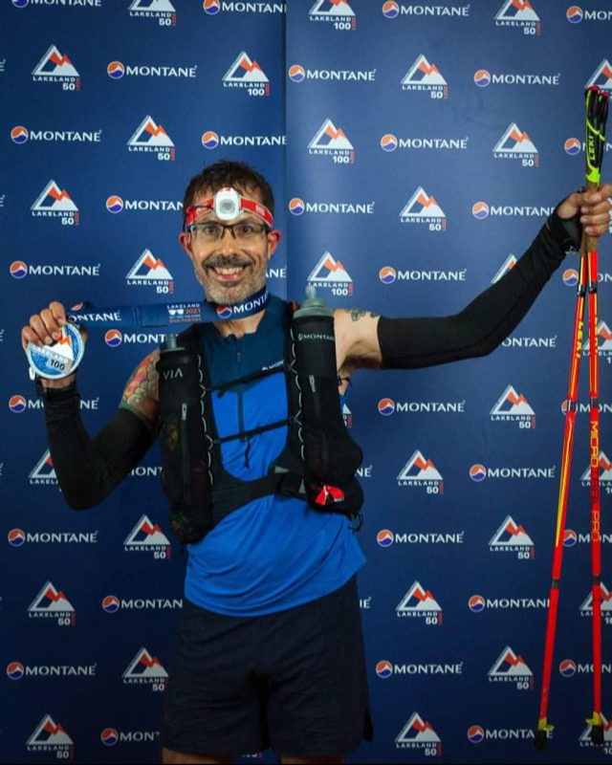
Michael Burke receiving his finisher medal on the Lakeland 100.

********************

#RunAndTalk
By Michael Parish

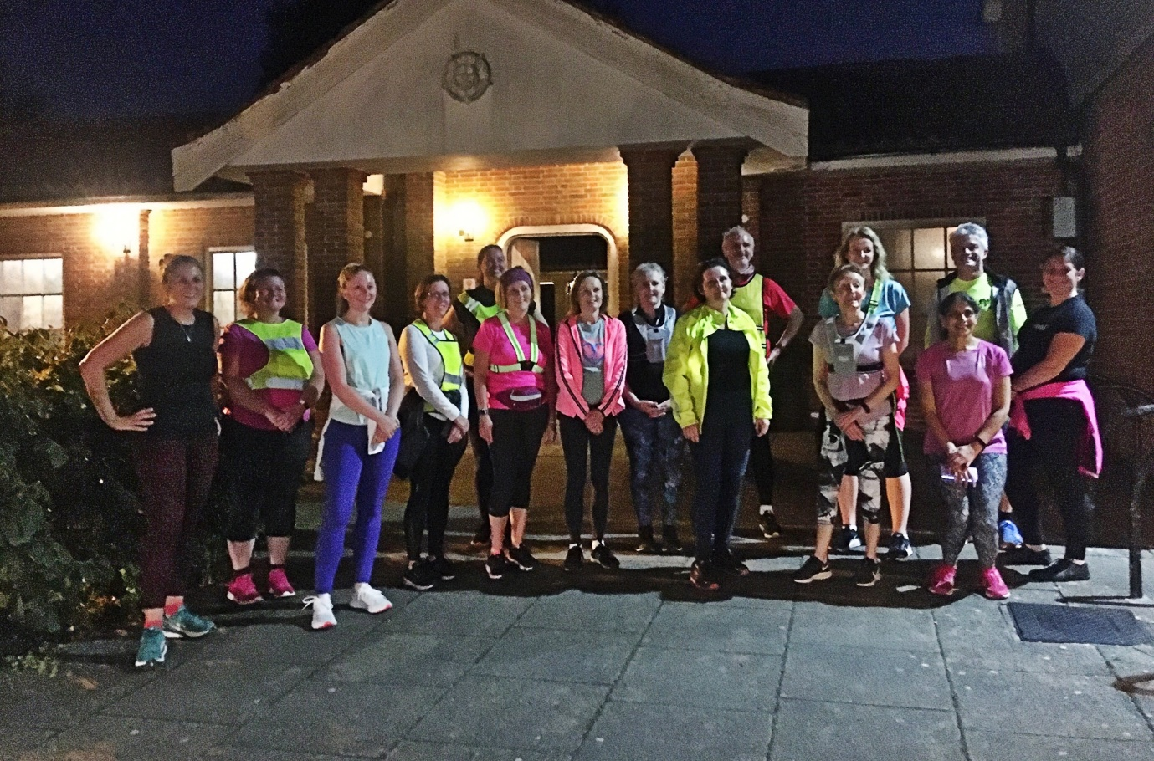
#RunAndTalk at Beechurst, Haywards Heath.

ENGLAND ATHLETICS publicised their first post pandemic #RunAndTalk programme asking athletics clubs across the UK to arrange a group run between the 20th and 26th September 2021, coinciding with “World Gratitude Day”.

#RunAndTalk is an England Athletics programme supporting people to promote good mental health through running, starting conversations and ending stigma. The sessions are also supported by Mind the mental health charity.

The aim of the event is to encourage physical activity through running, whether that is supporting them to start running, returning to or continuing running. It has been widely publicised that there has been a marked increase in mental health issues through the pandemic and as a result more people have taken up running.

Led by Haywards Heath Harriers mental health champions Michael Parish and Marion Hemsworth they decided that instead of supporting one event the athletics club would support two. The first one would be based in Haywards Heath supported by J&M Runners open to anybody who wanted to run and chat, to either keep fit or for good mental health. The event was publicised at AJ Barbers, Sainsbury’s, Waitrose, Tesco Express, Co-operative in Lindfield and Haywards Heath Railway Station.

The second was to be held in Lewes for emergency service staff who are office based answering 999 and 101 calls from across Sussex and arranging appropriate emergency responses. This was as a “thank you” for all of their hard work, keeping people safe and working through the pandemic.

Jo Shiner, Chief Constable of Sussex said: “Run and Talk is an excellent initiative which encourages all types of people to get out in the fresh air, and walk, jog or run at a pace which suits them and at which they can still hold a conversation. The combination of fresh air, good company and a listening ear can make all the difference to someone who doesn’t know where to start talking about their worries. It also means that you are not ‘faced’ by someone, and instead they are ‘by your side’, both physically and metaphorically speaking.”
At Haywards Heath there were 15 people who ran the distance between 4 to 5km. At Lewes there were six people who ran the 5km from the Force Contact Command and Control Department.

