Michael Burke Storms the Beacons

Ultra:

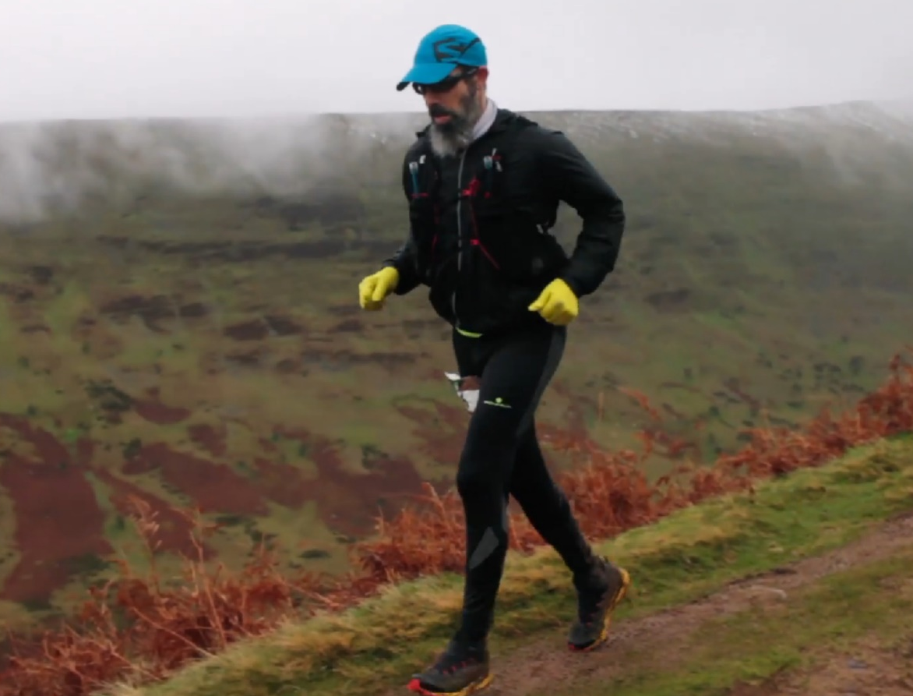
Michael Burke.

By Michael Parish.

WINTER RUNNING can be a challenge when you are exposed to the weather and even more so when you run in a harsh hostile environment. The Brecon Beacons, in South Wales, is an Ultra 46 mile race with its unpredictable weather is such an environment.

This is a mixed trail, mountain, canal and road run where climatic conditions can vary quite considerably with obligatory rain and mist thrown in to remind the athletes that they are running in Wales in all its glory. And in the middle of all this is Haywards Heath Harrier Michael Burke.

The event takes place in the heart of the Brecon Beacons, in November, starting and finishing in the delightful village of Talybont-on-Usk. From the start you follow the picturesque Monmouthshire and Brecon Canal toward Llangyndir. The route then splits from the canal at the canal locks and heads up the Beacons Way for about a mile before detouring off to take in the much appreciated trek up and over Tor y Foel before descending down into Talybont forest. Here it picks up the old coal route with a steady climb towards Torpantau before dropping slightly and entering the Taf Fechan Forest. The forest trail then starts to widen into open hill and follows what the locals call the ‘Gap Road’. The highest point of the route is 600 metres above sea level at the ‘Gap’ itself.
After all that height gain there is quite a bit of descending along one of the Brecon Beacons ‘classic’ routes, down to the canal at Pencelli and back to Talybont-on-Usk where you can rest and refuel before departing for the 2nd loop.

Michael ran the two laps (23 miles per loop) in 8 hrs, 14 mins and 16 seconds, coming 16th out of 162 finishers.

Road racing:

At the Brighton 10 Kilometres race last Sunday November 17th, saw a host of Harrier’s setting personal bests on this fast seafront course. James Skinner finishing first for the club in tenth place improving on his personal best and also club vet 45 record in the process with a time of 32 minutes and 13 seconds.

All Harriers results were 10th James Skinner 32:13 (pb), 30th Matt Cooke 34.05 (pb), 289th Chris Russell 42:46, 335th Chris Faulkner 43:54 (pb), 423rd Karen Thompson 45:46 (pb), 468th Dave Harper 46:15, 613th Rebecca Healy 49:32 (pb).

At the Crowborough 10 Kilometres race on Sunday 24 November. Four Harriers took park in this race. First home for the club was Darren Bird in 10th place overall in a time of 39 minutes and 8 seconds. Next was Jack Chivers finishing in 37th place in 42 minutes and 23 seconds, followed by Karen Thompson in 121st place in 50 minutes and 17 seconds and then Jenny Denyer bringing up the rear in 366th place in 1 hour 21 minutes and 8 seconds.

Cross Country:

On November 9th, was the second of the Sussex Cross Country League races that were held at held in Stanmer Park at Brighton. The race being transferred to Stanmer Park at late notice by the organisers saw lively cross country running by all Sussex clubs in this competition.

The men did well to strengthen their position in Division One with great packing. The ladies again managed to field 5 teams again to their credit!

The third league event, also at Stanmer, this weekend will need the club to have another big turnout to maximise the club’s successes both individually and also team-wise!

Senior Ladies race: 17th Darja Knotkova-Hanley 22:02, 43rd Kim Lo 23:31, 66th Sam Ridley 25:17, 76th Karen Thompson 26:15, 83rd Gemma Morgan 27:03, 87th Liz Earley 27:23. 91st Jacqueline Barnes 27:36, 93rd Julie Essex 27:38, 97th Katherine Buckeridge 27:44, 101st Sarah Banks 28:19, 111st Shelagh Robinson 30:02, 118th Sarah Hamilton 30:55,131st Cary’s Hind 34:12, 140th Jenny Denyer 42:28.

Under 11 Boys race: 35th Noah Blythe 9:17, 39th Raffi Merchant 9:52.

Under 13 Boys race: 2nd Arun Khursheed 11:44, 15th Charlie Bonwick-Adams 12:41, 19th Jonathan Parkin 12:50, 37th Finley Blythe 13.40, 40th George Bonwick-Adams 13:45.

Under 15 Boys race: 33rd Sam Fernley 16:47, 45th Sebastion Dell’Aria Bromley 17:44, 55th Louis Henry 22:04.

Under 17 Boys race: 26th Harvey Alcock 21:42, 27th Ryan Armstrong 21:55.

Senior Men’s race: 12th Ben Gibson 30:44, 13th John Kettle 30:56, 29th Marcus Kimmins 32:10, 30th Phil Payne 32:27, 44th Matt King 33:03, 46th Will Herbert 33:07, 56th Russ Mullen 33:57, 63rd Paul Cousins 33:41, 75th Julian Boyer 35:29, 76th Andy Hind 35:30, 79th Michael Burke 35:35, 89th James Moffat 36:21, 100th Greg Hilton 37:07, 114th Tim Hicks 38:52, 116th Andy Dray 39:07, 133rd Bryan Tiller 42:03, 148th Mark Sykes 43:37, 158th Carl Bicknell 45:43.

