**West Sussex Fun Run League**

**By Michael Parish**

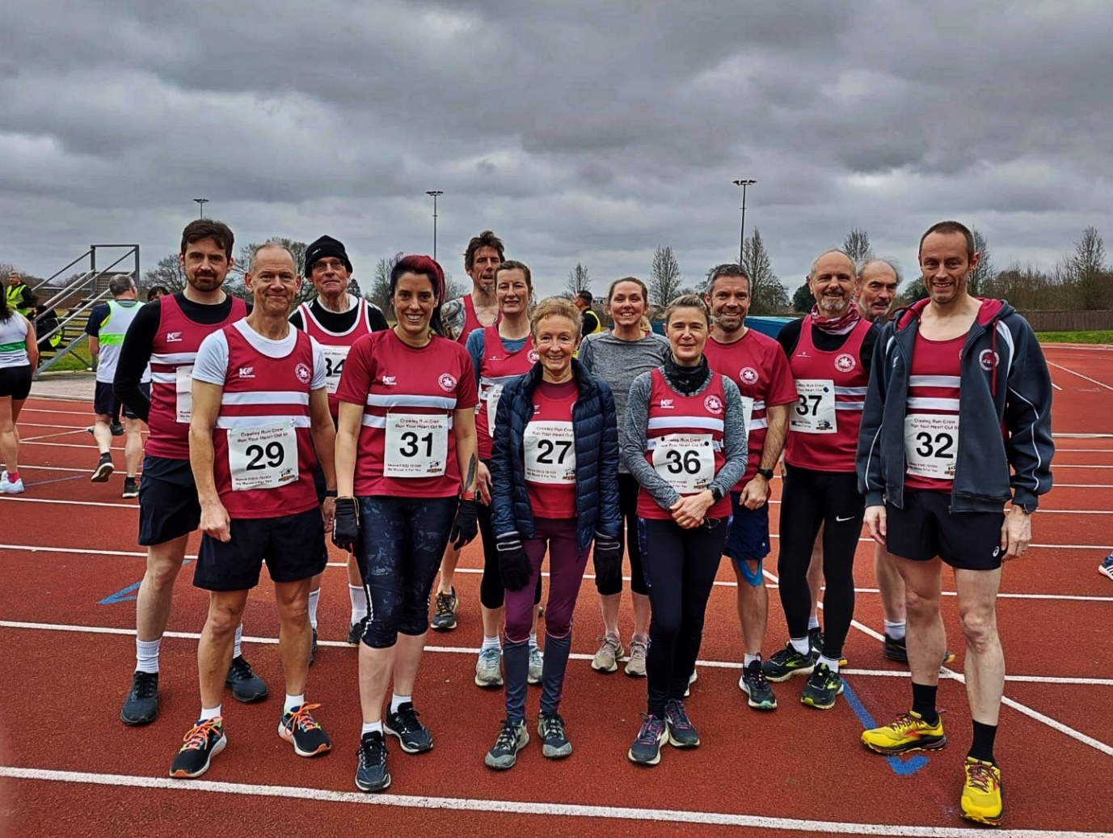

**(L-R): Jack Chivers, Eric Hepburn, Rupert Purchase, Carys Hind, Andy Hind, Katherine Buckeridge, Marion Hemsworth, Abby Redd, Caroline Gumm, James Smyth, Michael Parish, Richard Bates and Dave Warren.**

**SUNDAY 13th February 2022 saw Crawley Run Crew host their “Run Your Heart Out” 8km endurance run. This was the second run of the season in the West Sussex Fun Run League calendar taking place in Tilgate forest/park over an multi terrain course.**

The League is comprised of 17 athletics clubs over Sussex with each club hosting one event over the year. This equates to a massive 17 races over 85 miles. Run Your Heart Out was Crawley Run Crew’s inaugural run in the League and what a run they had planned!

Starting from K2 Leisure Centre the route went around the 400m track, along the side of the car park into the forest. The run wound around the forest before taking a turn into Crawley Park heading past the Tilgate Nature Centre and up towards the Smith and Western tavern. Running downhill athletes did a three quarter run of the large lake before being turned around and sent back via the forest to the second lake. This led to the last stretch home around the forest before completing one last lap of K2’s 400m track.

The run is multi terrain with an undulating course as it goes from concrete footpaths around the Nature Centre, around the lakes and the velvety smooth footpaths through the forests. The course has something for everybody and some real challenges to complete the required 8km.

Haywards Heath Harriers had some star performances with **Andy Hind**, **Dave Warren** and **Jack Chivers** chasing down the front runners and completing the course in a great time. This was the first event by **Caroline Gumm** who did an excellent run and managed to achieve her PB for an 8km course.

In the Junior race, **Lara Chivers** was the sole Harriers representative and she did a fantastic job ensuring our junior team got points on the board. Lara came 18th with a time of 18:29.

Results were: 1st Mike Houston 28:13, Chichester Runners; 2nd Lian Briscoe, 28:57, Fittleworth Flyers; 3rd Michael Daly 29:13, Horsham Joggers.

Haywards Heath Harriers results were: 10th - **Andy Hind**, 32:09; 36th - **Dave Warren** 35:45; 73rd - **Jack Chivers** 38:58; 14th - **Abigail Redd** 39:22; 86th - **James Smyth** 39:37; 99th - **Eric Hepburn** 40:35; 52nd - **Katherine Buckeridge** 45:46; 64th - **Marion Hemsworth** 47:13; 162nd - **Michael Parish** 48:54; 75th - **Carys Hind** 49:11; 113th - **Caroline Gumm 55:01**; 18rd - **Richard Bates 57:24**; 191st - **Rupert Purchase 01:02:58**.

**Other Harriers Results:**

**James Bennett** ran in the Tunbridge Wells Half Marathon on 20 February, finishing in 109th position in a time of 1 hour 36 minutes and 9 seconds.

On Saturday 12th February, **Kim Lo** ran in the Marriott’s Way Trail Half. She finished in a time of 1 hour and 45 minutes.

**Harrier’s Parkrun Round-up:**

On Saturday 19 February saw parkrunners turn up for the normal free run on a Saturday morning at Clair Park, Haywards Heath. What many did not know was that at some point during the parkrun that the 50,000th finisher at Clair Park would cross the line. That special person finished in 47th position was Noel Jennings. Clair parkrun has been part of Clair Park since the first parkrun was completed on 20 July 2013.

Also, the ever-improving **Abby Redd** improved her overall parkrun time down to 21 minutes and 44 seconds at Preston Park parkrun.

Brighton and Hove parkrun: 38th **Graham Hart** 19.:48.

Horsham parkrun: 27th **Abby Ross** 21:51.

Tilgate parkrun: 154th **Jack Chivers** 28:03.

Clair parkrun: 1st **Ben Gibson** 18:10; 3rd **Andy Hind** 19:31; 9th **Simon Robinson** 21:13; 11th **Paul Cousins** 21:19; 20th **Katie Reed** 23:04; 22nd **Eric Hepburn** 23:16; 39th **Ian Dumbrell** 25:24; 64th **Sarah Hamilton** 27:41; 66th **Shelagh Robinson** 28:03; 76th **Carys Hind** 29:54; 95th **Oliver Francis** 31:59; 105th **Greg Hilton** 33:43; 122nd **Jason Robinson** 39:33.

Preston Park parkrun: 64th **Abigail Redd** 21:44; 197th **James Smyth** 25:50.

Jersey parkrun: 46th Carl Bicknell 24:07.

Littlehampton parkrun: 11th **Pete Francis** 20:45.

Uckfield parkrun: 33rd **Emma Pryor** 33:30.