Tim Hick ran in the Ras y Gader, which is the Cader Idris mountain race in Wales. Tim is an experienced mountain runner and is a regular competitor in this popular race.

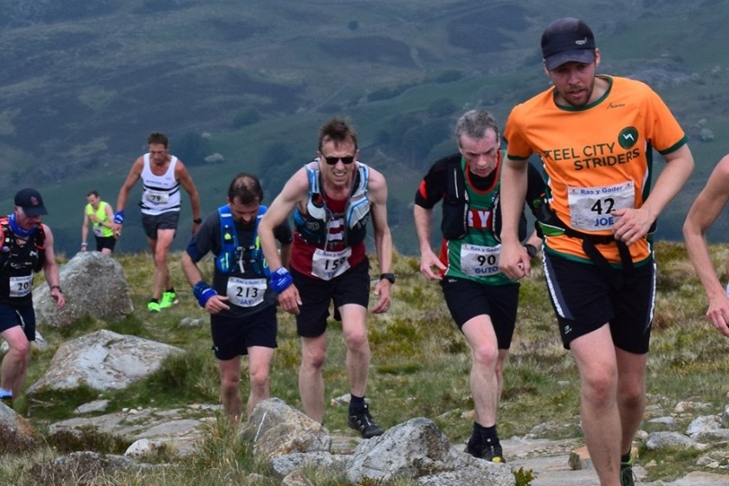

**Tim Hicks at Cader Idris fell race in Wales.**

Tim managed to make light in this tough race where runners had to run over differing terrain from steep roads to flat tracks, steps up the Pony Path and also running among a boulder field. Tim finished in a great time of 2 hours 5 minutes 00 seconds and was second Vet 60 to finish and was 113th overall in the race out of 258 runners.

At the Sussex County Track & Field Championships on May 11 & 12th the Harriers had a three senior and ten youngsters taking part. Top performance was when Emma Navesey won the first women’s 5000 metres race by a 50 second victory margin winning in 17.52.87.

Lucie Venables: 3rd 100m 14.57 secs, 2nd 400m 73.17 secs, 3rd Triple Jump 8.43m.

Karen Thompson: 4th 100m 16.55 secs.

Emma Navesey: 1st 5000m 17:52.87 secs.

Sam Fernley (U15 Boys) 14th 1500m 4:55.06 secs.

Amy Rutherford (U15 Girls) 15th 1500m 5:32.59 secs, 17th 800m 2:39.07 secs.

Harriet Dray (U15 Girls) 7th 800 2:27.81 secs.

Under 13 Boys Minithon results:

Jack Bannister: equal 23rd (LJ 3.74m, 150m 23.88 secs, SP 5.04m).

George Bonwick-Adams: 20th (LJ 3.52m, 150m 23.73 secs, DT15.08m).

Charlie Bpnwick-Adams: equal 28th (LJ 3.36m, 150m 22.88 secs, DT 9.42m).

Oscar French: equal 21st (LJ 3.25m, 800m 2:38.85 secs, SP 4.77m).

Arun Khursheed: equal 17th (LJ 3.59m, 8020m 2:30.19 secs, SP 4.30m).

Jonathan Parkin: 14th (LJ 4.15m, 150m 22.26 secs, SP 4.92m).

Under 13 Girls Minithon results:

Siobhan McMahon: equal 30th (LJ 3.21m, SP 3.80m, 150m 22.8 secs).

On 15 May, at Trundle Hill, the fourth event of the West Sussex Fun Run League took place.

Two Harriers went to the Chichester race course. First home for the club was Phil Payne in 6th place in 31 minutes and 54 seconds. Followed by Phil Scott in 108th place in 40:38. There were 368 finishers.

**THE BEACH RUN**

**Beach Report and photos by Mike Parish.**

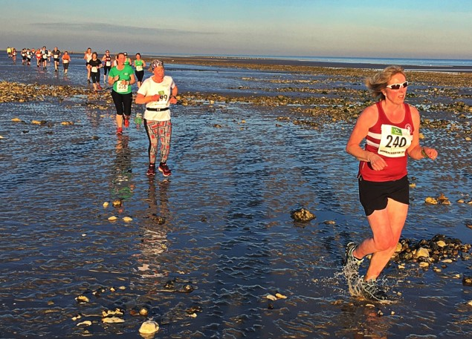

**Sarah Hamilton followed by a trail of beach runners.**

Wednesday saw a beautiful sunny evening as Arunners hosted the West Sussex Fun Run League.  This was the league’s fifth event this season attracting runners from its 18 member clubs to compete. This was a very different run from the usual cross country runs taking place on the South Downs /Mid Sussex area in the fun run league.

With the sun, wind coming off the sea, soft footing on the sand and sea water it was a challenging five miles. Haywards Heath Harriers were represented by Michael Parish, Phil Payne, Kim Lo, Phil Scott, Kath Buckeridge, Sarah Hamilton and Michael Parish.

To cure the post run fatigue competitors discussed the race over seaside fish and chips before the journey home. Thank you for a well hosted and marshalled event by Arunners.

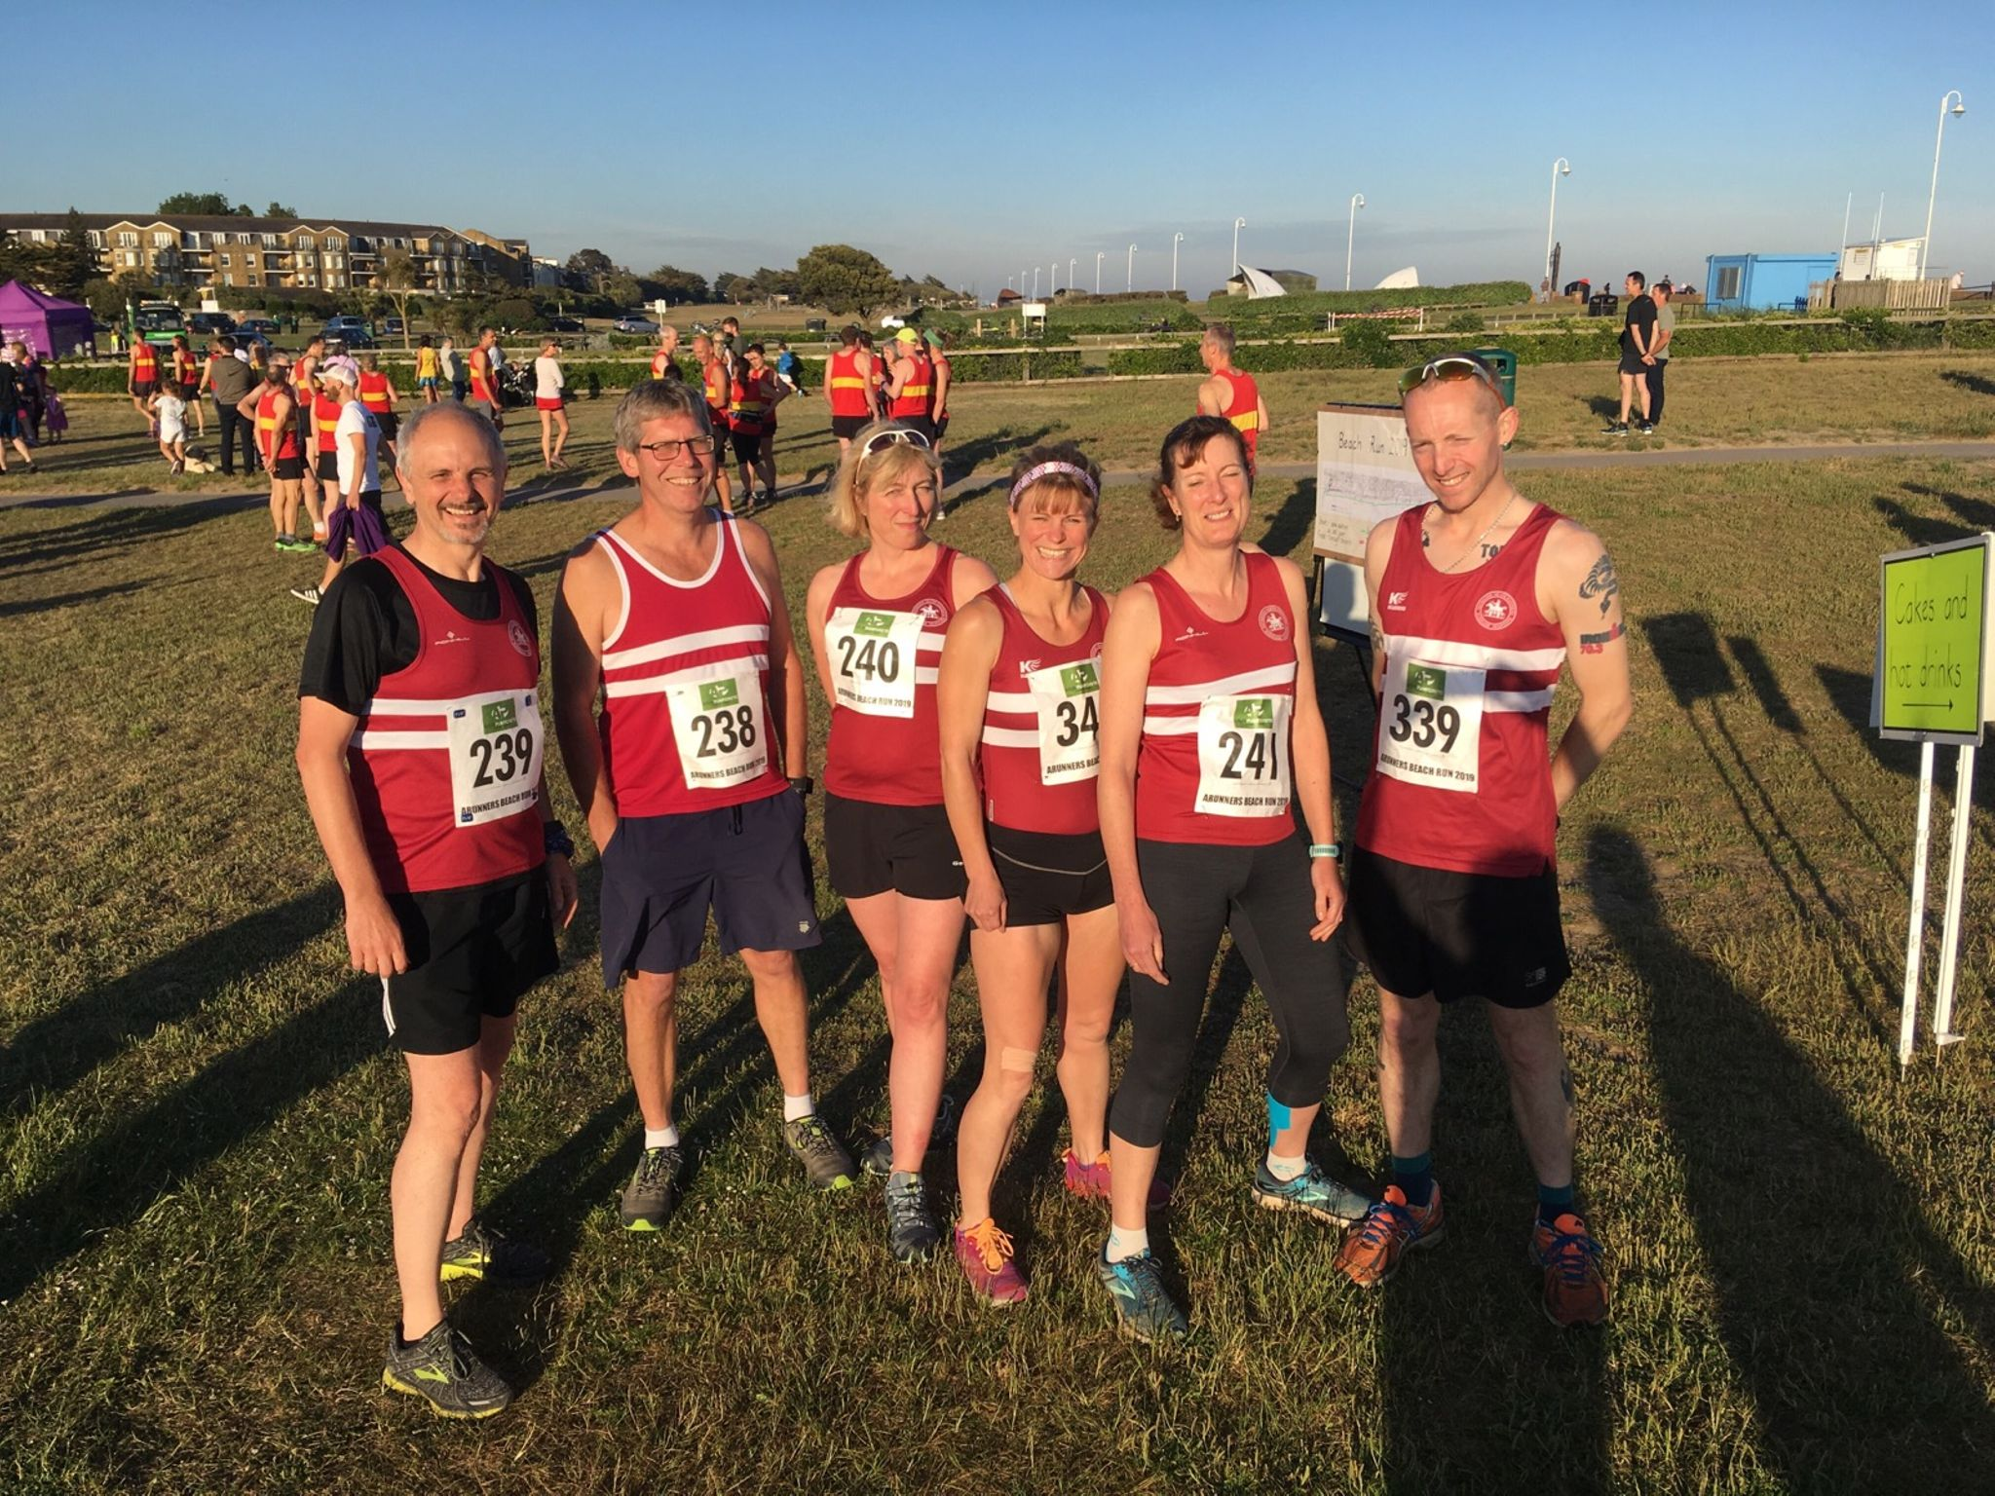

Beach Run results were as follows:

9th Phil Payne 29:55, 53rd Kim Lo 33:55, 138th Phil Scott 37:56, 233rd Kath Buckeridge 42:31, 329th Sarah Hamilton 47:23, 374th Mike Parish 50:10.

Other Harrier results:

Oliver Farr ran his 35th marathon at Richmond Park in a time of 4 hrs 16 mins. He is well on target to reach 100.

In the Wisborough Green 10km race held on 19 May, Kim Lo finished as second lady in 43 minutes 42 seconds over an undulating course.

At the Bognor Prom 10k on 19 May Emma Navesey finished second in the ladies’ race in a time of 38 minutes and 11 seconds. Ryan Armstrong did very well in his first 10 km race which he finished in 42:28. Chris Russell brought up the rear in 43:44.

19 May Run Wisborough 10k & 5k. Three harriers ran at this event. Kim Lo was first lady to finish and also was first home for the club in. Kim finished in a time of 43:41 followed by Jack Chivers in 45:12 and then by Amanda Soper in 55:05.

Young Arun Khursheed achieves another fine run at Clair parkrun in Haywards Heath last Saturday when he improved his best time in the eleven to fourteen years age group to record to a new best time of 18 minutes and 46 seconds.

At theSouthern Counties Vets Athletics Club Championships at Abingdon yesterday:25 May, 2 veteran Harriers from Haywards heath harriers took medal honours in seven events!

Mike Bale achieving three silvers in the Vet Men age 60 age category and Jenny Denyer one gold and three silvers in the Vet Women 60 age category!

Results for Mike Bale:

Hammer 32.44m – Silver medal.

Shot 8.29m – Silver medal.

Discus 27.84m – Silver medal.

Results for Jenny Denyer:

Hammer  20.77m  Silver medal.

Shot Putt 6.26m – Silver medal.

Discus 14.43m – Gold medal.

80m Hurdles 22.21 secs – Silver medal.

At the Rye 10 mile race on 26 May, six Harriers ran at this annual east sussex race. The Harriers results were as follows: first home was Jack Chivers in 1 hour 13 minutes and 39 seconds. Matt Quinton was second home in 1 hour 14 minutes and 57 seconds, followed by Naomi Cikalo in 1 hour 17 minutes and 46 seconds, followed by Martin Tollner in 1 hour 22 minutes and 13 seconds, Amanda Soper in 1 hour 27 minutes 25 seconds and Pete Cobbett in 1 hour 41 minutes and 40 seconds.

At the Vitality 10 kilometres race in central London on Bank Holiday Monday another group of Harriers raced against likes of Mo Farah. But of course, Mo was a little further ahead winning his 7th London Vitality 10 kilometres race. But the Harriers did very well.

Results were: James Collins 34:18. Ben Gibson 34:22, Matt King 36:13, Marcus Kimmins 41:09, Lydia Levy 47:56, Chris Glandfield 48:12, Karen Thompson 48:32, Hannah Gibson 49:04, Andrew McCluskey 49:28, Theresa Almeida Silva 1:04:35.