Cross Country success again for Harriers.

On 10th February, Haywards Heath Harriers were out in force at the final Sussex cross country league races at Stanmer Park, Brighton. The course had not recovered from the multitides that descended on Stanmer Park, at the South of England Cross Country Chanpionships two weeks previous where over a thousand runners churned up the Brighton park.

But on 10th February, at the last of the Sussex Brooks Cross Country League races, the Harriers had a great set of result. Individuals, Chris Smith, who runs for Haywards Heath Harriers as a second-claim member, romped away with a resounding victory in the senior men’s 5 miles race. He was well supported by great performances from James Collins in his first top ten finish, finishing in 3rd place and James Skinner who managed his best position of 5th overall. In the senior ladies three miles race, Emma Navesey also had her best cross-country position ever of 6th place overall.

In the team events, Haywards Heath Harriers ‘A’ Team finished in second place with a total number of points after 4 league races with 467 points to Lewes AC, who came first with 466 points. Brighton Phoenix were in third place with 484 points.

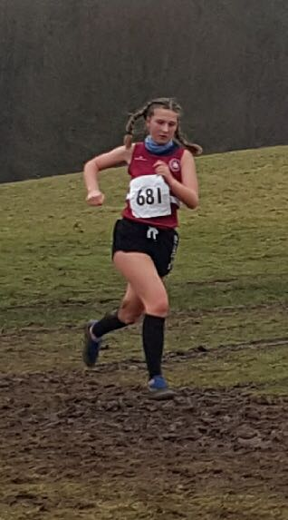
17 year old Jasmine Mamoany makes light of the muddy conditions at Stanmer Park
Individual results were as follows:

Senior Men:
1st Chris Smith 28:49; 3rd James Collins 29:42; 5th James Skinner 29:57; 14th Ben Gibson 31:43; 22nd Marcus Kimmins 32:19; 29th Russ Mullen 32:53; 34th Rob Watts 33:26; 48th Paul Cousins 34:34; 50th Tom Mullen 35:18; 57th Julian Boyer 36:04; 66th Barry Tullett 36:33; 93rd Tim Hicks 39:23; 108th Phil Scott 41:13; 118th Carl Bicknell 43:13; 129th Graham Kenwood 47:10.
Team Results:
Division 1: Haywards Heath Harriers ‘A’ Team 2nd;
Division 2: Haywards Heath Harriers ‘B’ Team 3rd;
Division 3: Haywards Heath Harriers ‘C’ Team 8th; Haywards Heath Harriers ‘D’ Team 15th.
Individual results: O/40s Men 1st James Skinner; O/50s Men 2nd Paul Cousins.
Team: Vet Men: 1st Haywards Heath Harriers.

Senior Ladies:
6th Emma Navesey; 27th Hannah Gibson; 29th Jasmine Mamoany (5th U17); 33rd Sam Ridley; 54th Karen Thompson; 56th Amy Mitchell; 59th Harriet Delbridge; 79th Jenny Denyer.
Team Results:
7th Team overall.
Individual results: 3rd Emma Navesey.

Under 13 Boys:
27th Alex Todd 14:07; 29th Sebastian Dell Aira Bromley 14:16; 41st Oliver Mamoany 15:05.
Team Results:
12 Team Overall.

Under 11 Girls:
16th Ella Chatfield 10:31, 26th Bethany Hilton 12:43.
No Team result.

Under 11 Boys:
19th Lewis king 9:46;
No Team result.
Other results:
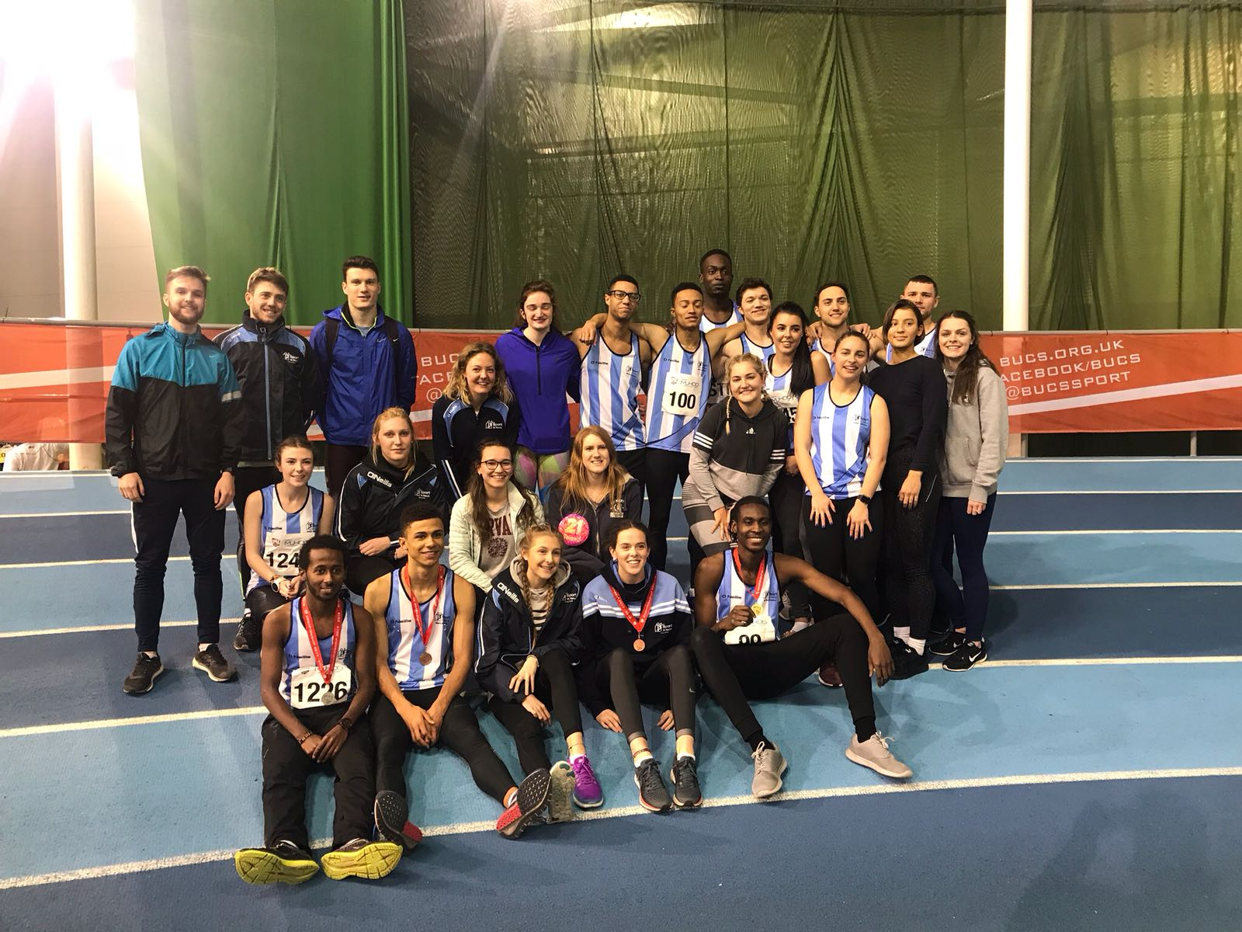
Simeon with the St Mary’s University track team at Sheffield.

Simeon Cousins at the BUCS championships at Sheffield.

At the BUCS indoor Track championships at Sheffield on 17th February, Haywards Heath Harrier Simeon Cousins ran in the 400m heats and finished in third place in a season’s best time of 51.96 secs. Simeon was also part of the 4 x 200m relay team which finished in second but the team were later disqualified after another runner had passed the baton outside the allowed marker zones.

Michael Burke finished a superb 4th place in the Marriot’s Way Marathon in Norfolk in a superb 3 hrs 11 mins and 52 secs at the weekend.

Also, Josh Pewter finished the Hampton Court Half Marathon on Sunday in 1 hr 19 minutes and 25 seconds.

Carl Bicknell finished the Dorney Lake Winter Half Marathon in 1 hr 42 minutes and 2 secs, finishing 3rd in his age category last Saturday and finishing 92nd overall.

Phil Payne won the Slindon Slog (which is a 10 mile off road trail run which includes crossing a river!). His winning time was 1 hr 25 minutes and 6 seconds. Kim Lo was 3rd lady and her time was recorded as 1 hr 41 mins and 29 secs (apparently, she got lost with a quarter of a mile to go!).

At parkrun last weekend, the Harriers were out in force around the country and in Sussex. Emma Navesey broke the Senior women’s club record with 18.41 at Worthing parkrun. Also, Darja Knotkova-Hanley broke the Junior club record at Bushy parkrun with 20.01. There were other great results too.

Parkrun results were as follows:
Bushy parkrun: 60th (4th female) Darja Knotkova-Hanley 20:01.
Clair parkrun: 1st James Collins 18:08; 4th Andy Hind 19:14 (pb); 5th Julian Boyer 19:24; 12th Paul Cousins 21:59; 16th Sam Ridley (1st female) 22:54; 25th Howard Booth 23:49; 31st Phil Scott 24:34; 35th Graham Kenward 25:01; 39th Eric Hepburn 25:24; 98th Maureen Rae 30:49; 127th Carys Hind 44:08.
Colchester Castle parkrun: 1st Ben Gibson 17:19; 41st (2nd female) Hannah Gibson 21:59.
Forest Rec parkrun: 10th Barry Tullett 20:01.
Horsham parkrun: 4th Mark Green 19:30; 220th Justine Tanner 34:08; 250th Jenny Denyer 37:40.
Hove Prom parkrun: 7th Marcus Kimmins 17:17; 8th Rob Watts 17:29; 9th Jamie Gibson 17:33; 10th Matt King 17:43; 12th Ben Duncan 17:56; 16th Tom Mullen 18:12; 19th Ben Adams 18:42; 23rd Oli Gibson 19:18.
Hove Park parkrun: 15th Graham Hart 18:56.
Preston Park parkrun: 424th Peter Cobbett 29:37; 510th Isla Brackenbury 33:44.
Southwick Country parkrun: James Bennet 30th 21:31.
Tilgate parkrun: 109th Karen Thompson 24:13.
Worthing parkrun. 2nd Russ Mullen 15:59; 12th (3rd female) Emma Navesey 18:41.

