Middy Report 17/03/19

HAYWARDS HEATH HARRIERS CELEBRATE EVENING OF SUCCESS

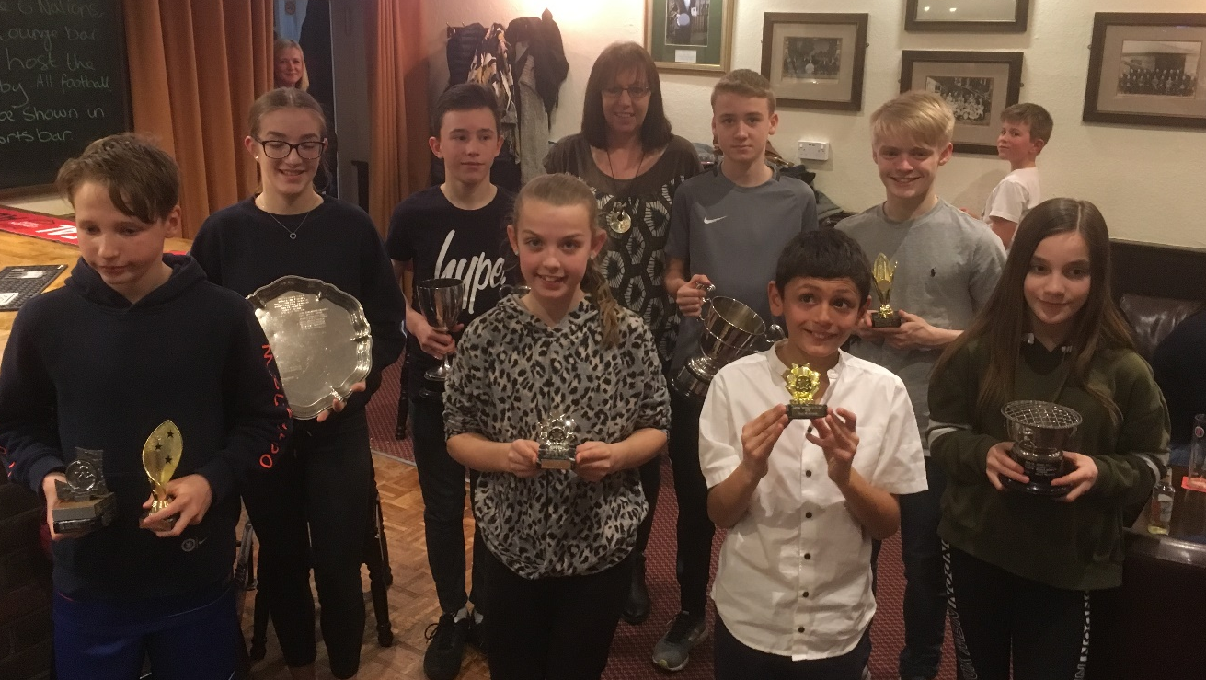
Junior award winner (left to right): Archie Hale, Rosie Beckett, Charlie Parvin, Siobhan McMahon, Linda Tullett (coach), Sam Fernley, Arun Khursheed, Ethan Lambert, Holly Wilkinson.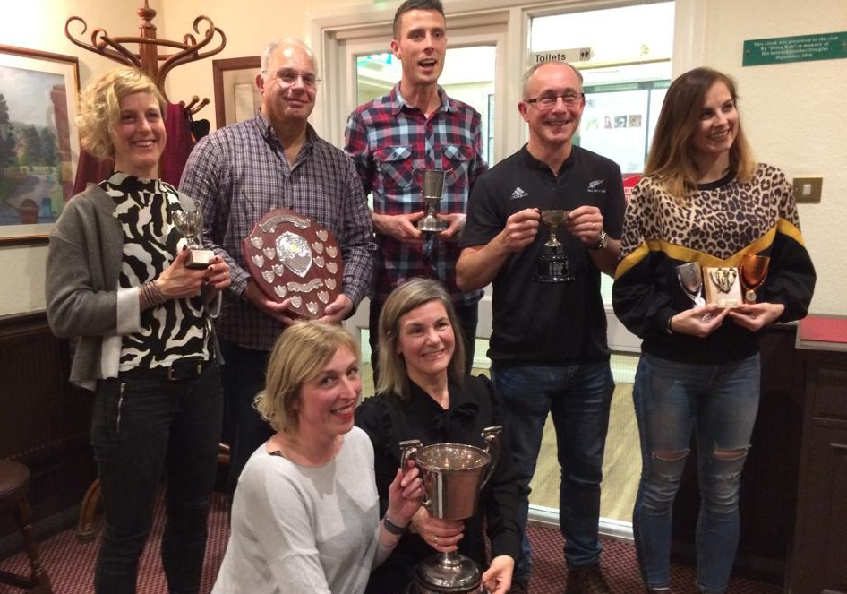
Senior award winners (left to right): Siobhan Amer, Sarah Hamilton, Mike Bale, Claire Annesley, Ben Gibson, Ian Dumbrell, Emma Navesey.

At the AGM and awards and social evening last Friday 15th March many youngsters, senior and vet athletes came together to celebrate the Harriers successes of the last 12 months. Many awards were given out and it was a great opportunity for the Harriers to share the highs and lows of the last year. Haywards Heath Harriers caters for all age groups from nine years and over across parkruns, to cross country competitions through the mud, track and field to road and trail, for those who like the 100 metres or others who prefer to throw objects as far as they can to those who like ultra races that take many days. All are conquerors in their own right.
One of the top results was James Skinner who represent England twice in the Vet Men’s 45-49 age group in cross country and also in the 10 kilometres on the road. Below is a list of the category winners.

Award Winners
SPORTSHALL
Sportshall performance of the year:
U11 Boy- Arun Khursheed,
U11 Girl- Siobhan McMahon
Chairman’s Cup- Sportshall Male Athlete of The Year- Ethan Lambert
Presidents Trophy- Sportshall Female Athlete of The Year- Holly Wilkinson
TRACK & FIELD
U13 League Athlete of the Year- Archie Hale
Horace Clarke Cup- Young Sprinter of The Year U13- Charlie Parvin
Colts award for most improved performances throughout the Track &Field season:
U13 Boy- Archie Hale,
U13 Girl - Phoebe Whiting
Progress Trophy for most improved U15: Boy- Ethan Lambert, Girl- Harriet Dray
En Tout Cas Awards for U16 Athlete of the Year- Male- Adam Dray, Female- Rosie Beckett
Honey Shields for best senior or vet athlete who has best supported the club in league, inter club and open Track & Field competition: Male- Mike Bale, Female- Darja Knotkova- Hanley
CROSS COUNTRY:
Rita Bosley Cup - Jasmine Mamoany, Claire Annesley and Sarah Hamilton.
John Siddle Cup - Sam Fernley and Adam Dray.

Cross Country Performance Of The Year:
Female-Emma Navesey
Male-James Skinner

Bill Page Memorial Award - Male- Ben Gibson Female- Katie Morgan

Best time recorded for a marathon: Male- Darren Bird, Female- Kim Lo
Best time recorded for a half marathon: Male- James Skinner, Female- Emma Navesey
Best time recorded for a 10km: Male- James Skinner, Female- Emma Navesey

Merit Cups - Male- Ian Dumbrell, Female- joint winners, Siobhan Amer and Jasmine Mamoany

Steve Horn Memorial Award - Richard Bates

Recent results:
Congratulations to the young Haywards Heath Harriers who on 3 March competed in the Regional Sportshall League Final at the Triangle Sports Centre, Burgess Hill. Well done to these young athletes!

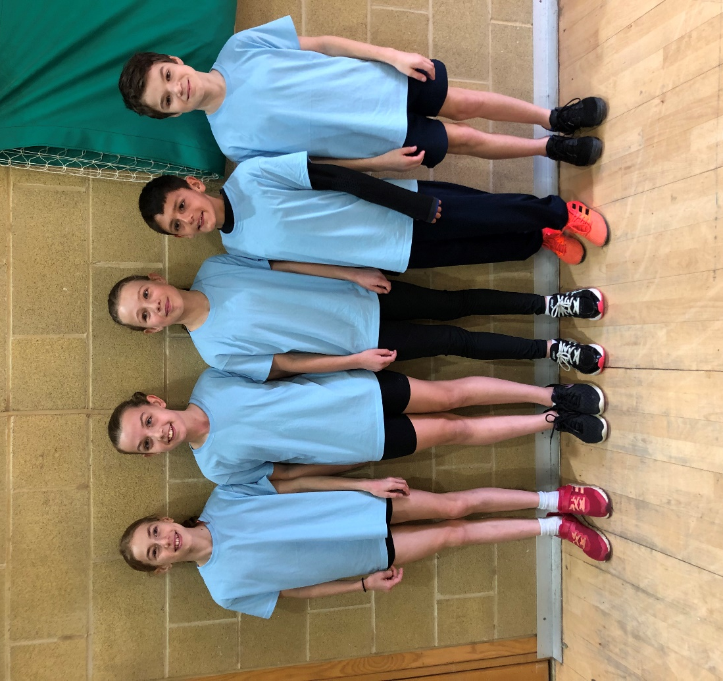
Under 11 Sussex representatives in the regional sports hall fun in athletics festival - Megan Eyre, Lucy Barker, Siobhan McMahon, Arun Khursheed and Jack Twibell.

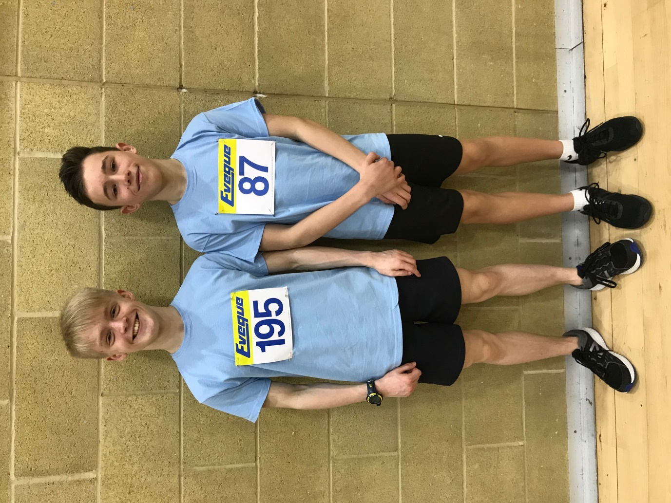
Ethan Lambert (left) and Charlie Parvin, who competed for Sussex in the sports hall regional final.

Other Harrier results:

At the English Schools Cross Country Championships at Leeds last Sunday 17 March, three Haywards Heath Harriers represented their county of Sussex. Darja Knotkova-Hanley and Jasmine Mamoany competed in the Senior Girls age category and Adam Dray competed in the Inter Boys category. Adam Dray had a super run finishing top Harrier just outside the top 50, Results were as follows:
Senior Girls race: 129th Darja Knotkova-Hanley17:34, 258th Jasmine Mamoany 19:01 (315 finishers).
Inter Boys race: 52nd Adam Dray 18:08 (331 finishers).

At the Endurancelle 10k to Ultra races last weekend at Birling Gap, Oliver Farr and Tim Hicks both took part in the gruelling and testing courses. Oliver Farr finished ran the marathon and Tim the half marathon. It was Oliver’s 31st marathon on this hilly terrain of the Seven Sisters completing the course in 5 hours 30 minutes and 16 seconds. Oliver is attempting to run 100 marathons by the age of 45. But by the way he is knocking out the marathons this year maybe he could do it by the age of 40! His other recent marathons include the Steyning Marathon on 3 March where he finished in 4 hours 55 minutes and also the Phoenix Excalibur at Waltham-on-Thames (along the tow-path) on 21 February where he ran 4 hours 21 minutes. Tim Hicks finished the half marathon in a time of 1 hour 58 minutes.

At the West Worthing 10 kilometres road race that was held on 10th March, Matt King finished in 3rd place overall in a season’s best time of 37 minutes and 48 seconds. Matt Quinton finished in 28th position in 45 minutes 29 seconds and Graham Kenward finished in 66th place in 50:08.
At Worthing there was also a 5 kilometres race which by all accounts was slightly over the distance of 5kilometres. Young up and coming runner, Ryan Armstrong, finishing in 9th position in a time of 23 minutes 39 seconds whilst his mum Kirsty who runs second claim for the Harriers but her first club is Burgess Hill Runners, finished 4th lady in the 10 km race in 42 minutes 34 seconds losing to the 3rd place lady by 1 second!

Bryan Tiller ran in the Lydd 20 mile race on 10 March. And finished in 486th place in a time of 2 hours 46 minutes and 34 seconds.

Russ Mullen ran for Sussex at the Essex 20 mile race on 3 March and finished in 52nd place in a time of 2 hours 7 minutes 35 seconds. Barry Tullett also ran and finished in 206th position in a time of 2 hours 44 minutes and 57 seconds.

James Bennett has also been busy recently and had completed the Seville Half on 27 January in 89:49, the Cambridge Half on 3 March in 90:05 and the Vitality Half on 10 March in 91:42.

