Russ runs super marathon at Brighton
Road Running

At Brighton on 2 April, was the Brighton Marathon and the Brighton 10k race, both which are now run by London Marathon group.
The marathon was on a new course that did not include the power station section. There were eight thousand four hundred and fifty-six finishers in this year’s race and two thousand seven hundred and fifty finishers in the ten kilometres race.
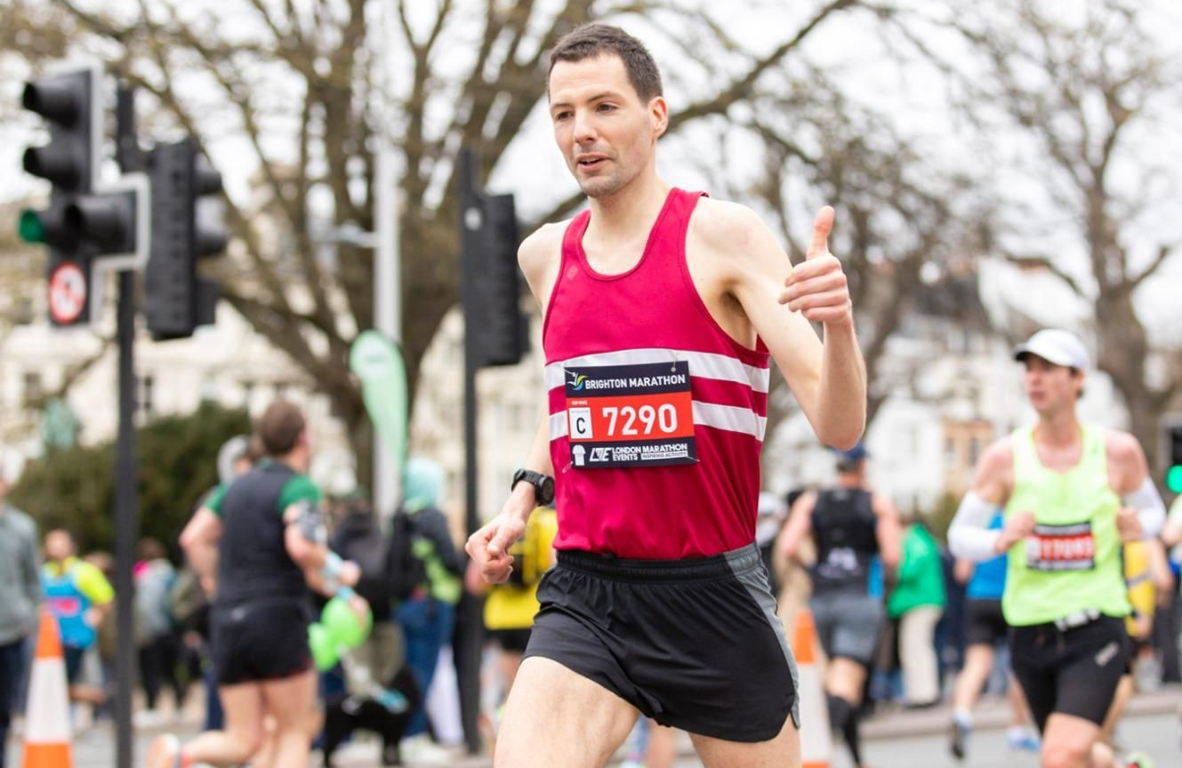
Russ Mullen at the Brighton Marathon
Russ Mullen led the Hayward Heath Harriers onslaught of personal bests from the endurance runners in the club. Russ coming home in forty-eighth position with an impressive ten minute personal best time and a club leading time for the year of two hours forty-nine minutes and fifty three seconds. Siobhan Amer was the leading first Harrier lady home in three hours and forty-two minutes and thirty five seconds closely followed by Georgina Mugridge (three hours and forty three minutes and fifty three seconds) and Abigail Redd (three hours and forty four minutes and forty four seconds) both getting new personal bests.
There were many personal best times set by the Harriers in this local marathon all who had been training hard over the winter months with the club and on their own.
Greg Hilton also smashed his personal best time by a staggering eighteen minutes over in Paris on the same day as the Brighton Marathon beating his previous best by nearly eighteen minutes to finish in three hours eleven minutes and twenty-one seconds.
The Harriers results in the 10k race were:
22nd Jamie Topping 34:31; 79th James Moffat 38:05; 340th Rachael Overton 45:04; 870th Sarah Hamilton 56:04; 2375th Michelle Robinson 75:24.
Harriers results in the marathon were:
48th Russ Mullen 2:49.53 (pb); 270th Tim Stannard 3:02.33 (pb); 363rd Curtis McNeice 3:08.07 (pb); 631st Pete Francis 3.18.01(pb) 958th Tim Miller 3.26.12; 1825th Siobhan Amer 3:42.35; 1840th Georgina Mugridge 3:43.53 (pb); 1889th Abigail Redd 3:44.44 (pb); 3140th Kevin Frost 4:01.32 (pb); 3283rd Ollie Farr 4:03.57; 8041st Caroline Mackey-Khursheed 6:01.21 (pb).
Paris Marathon (2 April): Greg Hilton 3:11.21.
Other Harrier results:
Ollie Farr ran in the Saturn Cool Runners Half Marathon on 19 March in one hour fifty four minutes.
At the Reading Half Marathon on Sunday 2 April, James Bennett finished in 268th position in one hour twenty-six minutes and five seconds.
Oli Fyfe ran in the Battersea 5k on 22 March finishing in a time of seventeen minutes and forty seconds.
Ultra Running
Shelagh Robinson
Two Haywards Heath Harriers competed in the South Downs Way Fifty Mile race on 8 April. Shelagh Robinson and Simeon Wishlade both took part in this hilly terrain race over the South Downs from Worthing to Eastbourne. The elevation of climb was over six thousand feet. Shelagh finished in ten hours and fifty six minutes and Simeon finished in 7 hours and 14 minutes.
Carl Bicknell ran in the Centurion Hundred Hills Fifty Kilometres race on 18 March. He finished in a time of seven hours and fourteen minutes.

Athletics roundup:
Mike Bale competed at the Throws Open at Kingston on 1st April. He finished third place in the Weight with a throw of 11.55 metres, a second place in the Hammer with a throw of 31.91 metres and a first place in the Discus with a throw of 27.91 metres. Mike said that they were all season’s bests and all close to his personal bests, so he said that he is “looking good for the season.”
Charlie Stay ran at the Crawley AC Easter Monday Open athletics event on 10 April. He competed in the 100 and 200 metres races finishing in second in his 100 metres race in 14.31 seconds and second in the 200 metres in 29.92 seconds which was a personal best for him.
Kleri Tantele
Also competing at the same event was Harrier Kleri Tantele, who competed in the javelin, throwing a personal best of 26.46 metres.

