HARRIERS CELEBRATE CROSS COUNTRY SUCCESS.

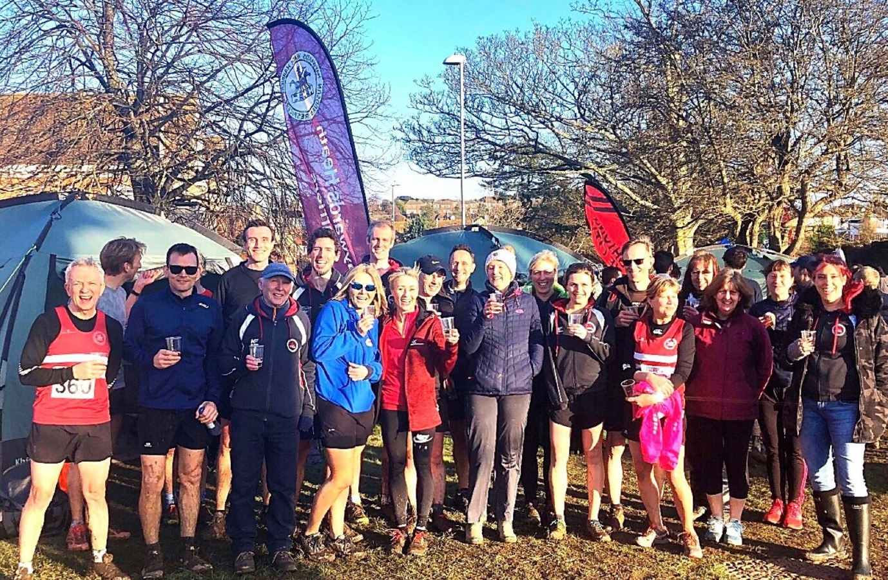
End of the cross country season celebrated with runners and their coaches.
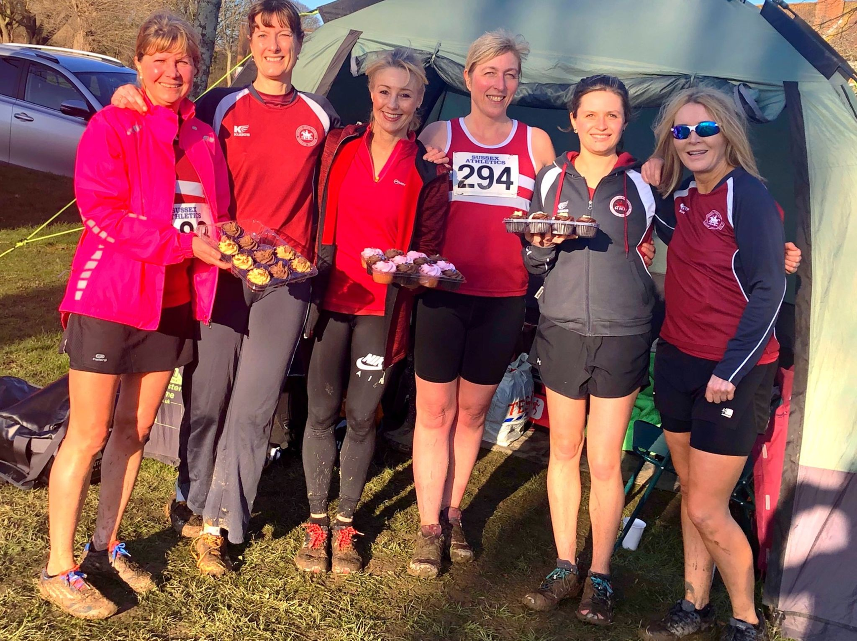
Cake celebrations!

The Harriers celebrating as they best know…with cakes and champagne when celebrating Sam Ridley’s (centre) birthday in this instance and also the end of the cross country season. Athletics is a sport that celebrates getting a little bit older.

The last of the Sussex Cross Country League races was held at Bexhill on Saturday 8 February where the final standings of the league were decided. Most of the races had a depleted number of runners taking part though that did not hinder the excitement of a muddy course in Bexhill awaiting the runners!!

The Under 13 boys stole the show for the Harriers by winning a team silver medal. All season the young boys have run so well as a team and were consistently strong in each race with some of the them finishing strategically in front of the opposition helping the scoring front three to gain silver!

Individual results after 4 races:
The Harriers still did very well with five individuals gaining an award, they were:

Darja Knotkova-Hanley – Gold in the Under 20 Women;
Arun Khursheed – Silver in the Under 13 Boys;
Jenny Denyer – Silver in the Over 65 Women;
Tim Hicks – Bronze in the Over 60 Men,
Karen Thompson – ties with Bronze in the Over 55 Women.

Team results after 4 races:

In the team events after four events the final standings were as follows:

Men: Haywards Heath Harriers A team were fourth in division one; the B team were fourth in division two and the C team were thirteenth in division three.

Women: Haywards Heath Harriers A team were eighth in division one and the B team were 13th in division two.

The vet Men won Bronze in the team event and the vet ladies were 8th.

Results on the day for the last league race were as follows:

Under 11 Boys race:
25th Noah Blythe 5:23, 28th Finn Nunn 6:25.

Under 13 Girls race:
34th Maya Dell’Aira Bromley 16:04.

Under 13 Boys race:
3rd Arun Khursheed 12.21, 7th Jacob Roderick 12:33, 14th Jonathan Beckett 12:52, 18th Charlie Bonwick-Adams 13:20, 19th Kai Nunn 13:26, 22nd Finlay Blythe 13:30, 28th Oliver Downey 13:50, 39th George Bonwick-Adams 14:11.

Under 15 Boys race:
22nd Sam Fernley 17:58, 35th Sebastian Dell’Aira Bromley 19:57.

Senior Womens’ race:
45th Sam Ridley 26:37, 49th Liz Earley 27:26, 50th Kath Buckeridge 28:16, 59th Teresa Mockridge 29:29, 71st Sarah Hamilton 32:59, 79th Alison Shore 40:21, 80th Jenny Denyer 45:36.

Senior Men’s race:
31st Matt King 32:59, 38th Darren Bird 33:51, 39th Marcus Kimmins 33:55, 47th Michael Burke 34:34, 49th Andy Hind 34:45, 59th Paul Cousins 35:49, 61st James Moffat 36:08, 74th Tim Hicks 38:06, 77th Andy Dray 38:31, 96 Mark Sykes 41:39, 107th Carl Bicknell 44:55.

Other Harrier results:

Darja Knotkova-Hanley took part in the BUCS Indoor Track and field Championships at Sheffield on 15 February. In her first indoor race experience, she finished in a super ninth place in her heat in a season’s best time of 10 minutes and 47 seconds.

Ian Dumbrell and Darren Bird both ran in the Hendy Tunbridge Wells Half Marathon last Sunday. The weather being very windy (Storm Dennis) and the course hilly, they did the club proud by taking part. Ian finishing in 1 hour 46 minutes and 37 seconds and Darren finishing in 1 hour 28 minutes and 12 seconds.

