Middy Report 15.10.17

Harriers Shine at Goodwood

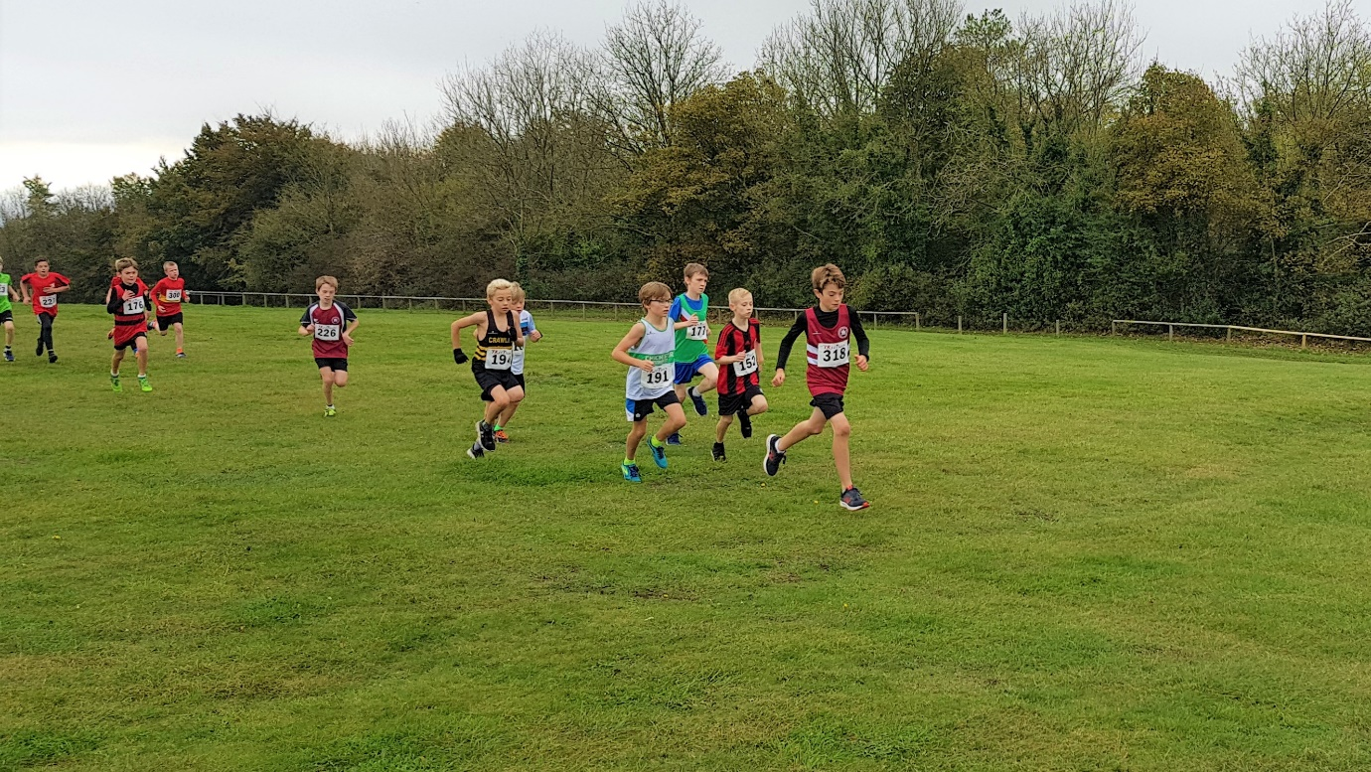

Last Saturday, the first of this seasons Sussex Brook Cross Country League races took place at Goodwood Race course. The conditions were very mild for this time of year. Many clubs came along to take part, and races started off with the youngsters and continued into the afternoon with the Senior and Vets mixed races. The Harriers were well supported by the senior members and this year, the young athletes were taking part in greater numbers than previous years. The seniors managed to put out 5 men and 5 women’s teams: whilst the young athletes had many new Harriers getting a taste of Cross-Country at County standard for the first time. In the good conditions, young Adam Dray made light of the Goodwood course to finish a commendable fourth position in the Boys Under 15 race and was top Harrier finisher overall on the day throughout all the age groups. In the Senior Men’s race, Chris Smith finished a superb 5th place for the club although Chris admitted he was not at his fittest for the race! The Senior men took 2nd place in the team event with 6 scoring and the Vet men (3 scoring) taking top spot in the Vets team competition. The Harriers are now looking to the next league race as Bexhill in 4 weeks to help improve their medal prospects later in the year.

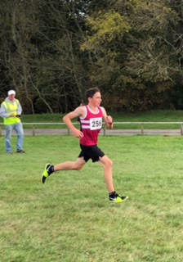
Top Harriers place went to Adam Dray 4th place in the U15 Boys race

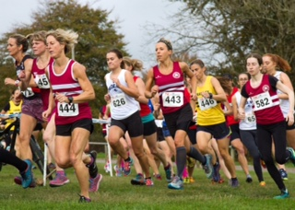
The Senior Women’s race at Goodwood.

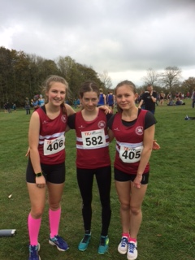
Young Harriers: (Left to right) Jasmine Mamoany, Darja Knotkova-Hanley and Millie Flower).

Results at Goodwood were as follows:
U13 Girls: 16th Harriet Dray 13:13.
U15 Girls: 37th Isobel Russell 19:25; 43rd Lily Bliss-Tomlinson 20:07.
Senior Women: 22nd Emma Navesey 20:02; 32nd Siobhan Amer (V35) 29:34; 34th Kim Lo (V35) 20:39; 49th Gillian Forest (V35) 22:04; 57th Darja Knotkova-Hanley (U17) 22:29; 62nd Amy Mitchell (U20) 22:40; 72nd Millie Flower (U17) 23:17; 80th Kath Buckeridge (V45) 23:53; 82nd Jasmine Mamoany (U17) 24:08; 86th Clare Kenward (V45) 24:45; 88th Karen Thompson (V45) 24:50; 104th Michelle Holdstock (V35) 27:02; 106th Sarah Hamilton (V45) 27:30; 123rd Jenny Denyer (V55) 38:22.

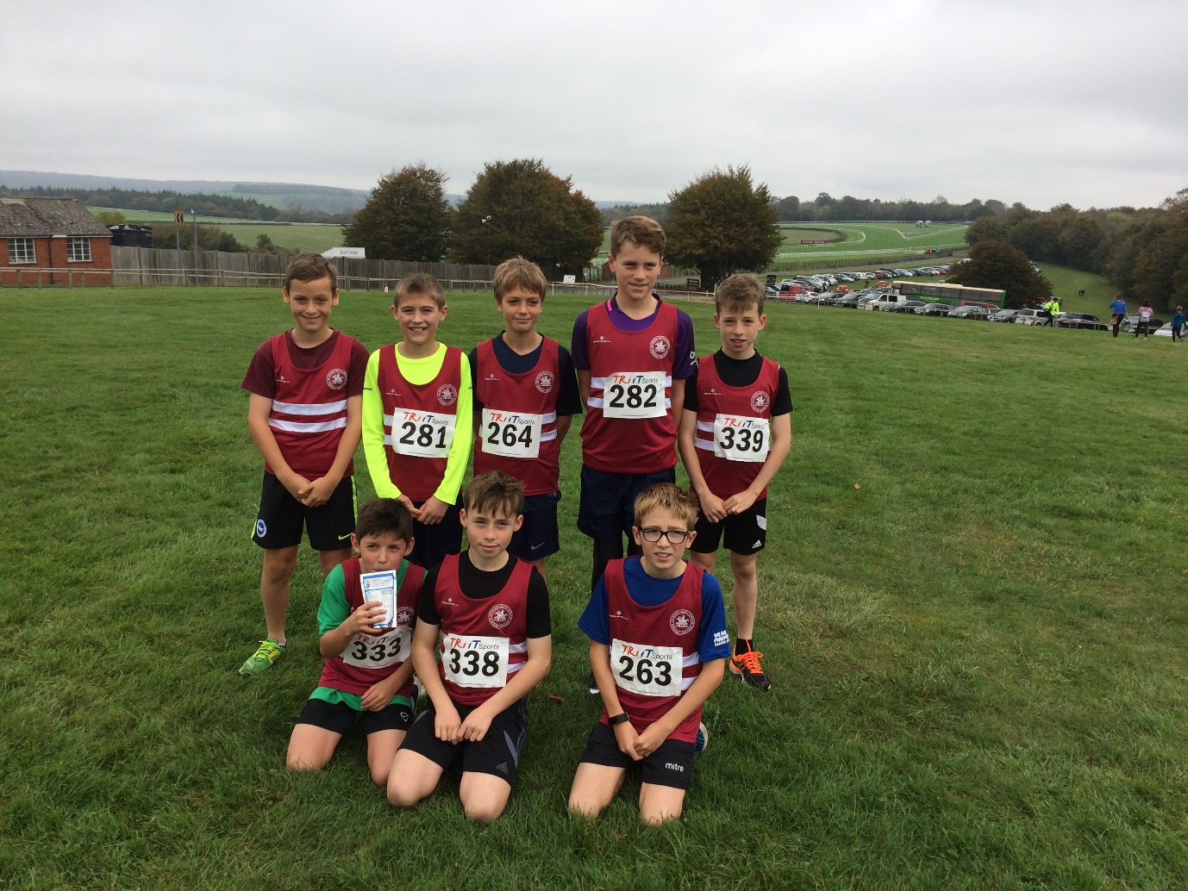
Back row (left to right): Louis Henry, Oliver Mamoany, Alex Todd, Sam Quickfall, Charlie Bonwick-Adams. Front row (left to right): Noah Perrett, George Bonwick-Adams, Jonathan Beckett

U11 Boys: 14th Harvey Gwynn 8:02; 15th Harry Russell 8:04; 28th Noah Perrett 8:34.
U13 Boys: 23rd Charlie Bonwick-Adams 12:18; 33rd Alex Todd 12:37; 42nd Oliver Mamoany 12:48; 44th George Bonwick-Adams 12:48; 47th Jonathan Beckett 12:53; 52nd Sam Quickfall 13:03; 72nd Louis Henry 14:59.
U15 Boys: 4th Adam Dray 15:01; 36th Harvey Alcock 17:10; 51st Tom Spensley 18:42; 58th Ewen Kemsley 19:15.
U17 Boys: 15th Joseph Martin 17:11; 24th Dan Blain 18:15.
Senior Men: 5th Chris Smith (V40) 25:35; 14th James Skinner (V40) 26:49; 15th James Collins 27:07; 20th Ben Gibson 27:43; 26th Marcus Kimmins (V40) 28:06; 27th Russ Mullen 28:19; 46th Matt King 29:39; 49th Paul Cousins (V50) 29:48; 66th George Adams (U20) 30:53; 82nd Julian Boyer (V40) 32:14; 85th Barry Tullett (V50) 32:38; 92nd Andy Dray (V40) 32:59; 111th Graham Purdye (V60) 34:33; 117th Phil Scott (V50) 34:54; 139th Carl Bicknell (V50) 37:26; 148th Steve Navesey (V55) 39:59; 149th Michael Essex (V40) 40:19; 150th Graham Kenward (V50) 40:26; 153rd Mark Sykes (V50) 42:11.

At the Bright 10 last Sunday (15th October) on a fast and flat course, many harrier s took part hoping to run a quick time.
Harriers results were as follows:
17th Phil Hardaway 57:24 (pb); 22nd Russ Mullen 59:10; 30th Ben Duncan 1 hr 00 mins 33 secs (pb); 38th Phil Payne 1 hr 01 min 32 secs (pb); 47th Matt Cook 1 hr 02 mins 43 secs (pb); 79th Ben Adams 1 hr 05 mins 46 secs; 90th Jack Chivers 1 hr 06 mins 55 secs; 115th Jason Russell 1 hr 08 mins 29 secs; 116th Emma Navesey 1 hr 08 mins 27 secs (pb); 133rd Kim Lo 1 hr 09 mins 26 secs; 155th Matt Quinton 1 hr 10 mins 36 secs; 164th Rob Engilsh 1 hr 11 mins 15 secs (pb); 206th Adam Judd 1 hr 13 mins 13 secs; 230th Matt Howells 1 hr 14 mins 05 secs (pb); 437th Chris Glanfield 1 hr 20 mins 50 secs (pb).

Hickstead Gallop (8 October)
The Hickstead Gallop is part of the west Sussex Fun Run League. The race this year was held also in remembrance of two members of Haywards Heath Harriers who were great supporters of the fun run league races: Steve Horn and Irene Parsley.
The Harriers results this year were as follows:
11th Paul Cousins 30:57, 83rd Mark Armitage 37:36, 244th Richard Bates 49:34, 265th Rupert Purchase 52:10.

Haywards Heath Harriers Sussex Marathon (8th October) results: – Steve Dallman 5th in 3 hrs 38 mins 01 secs:

Mid Sussex Tri Sussex Half Marathon results (8th October): Stephen Alden 7th in 1 hr 37 mins 8 secs; Mike Jaffe 9th in 1 hr 38 mins 13 secs; Andrew Biggs 15th in 1 hr 43 mins 27 secs; Rob Hoodless 16th in 1 hr 45 mins 47 secs; Colin Muggle-Chambers 18th in 1 hr 46 mins 37 secs; Rachel Baker 22nd in 1 hr 48 mins 58 secs; David Ricketts 27th in 1 hr 52 mins 11 secs; Douglas McTaggart 36th in 1 hr 59 mins 11 secs.

