Middy Report 15.04.18
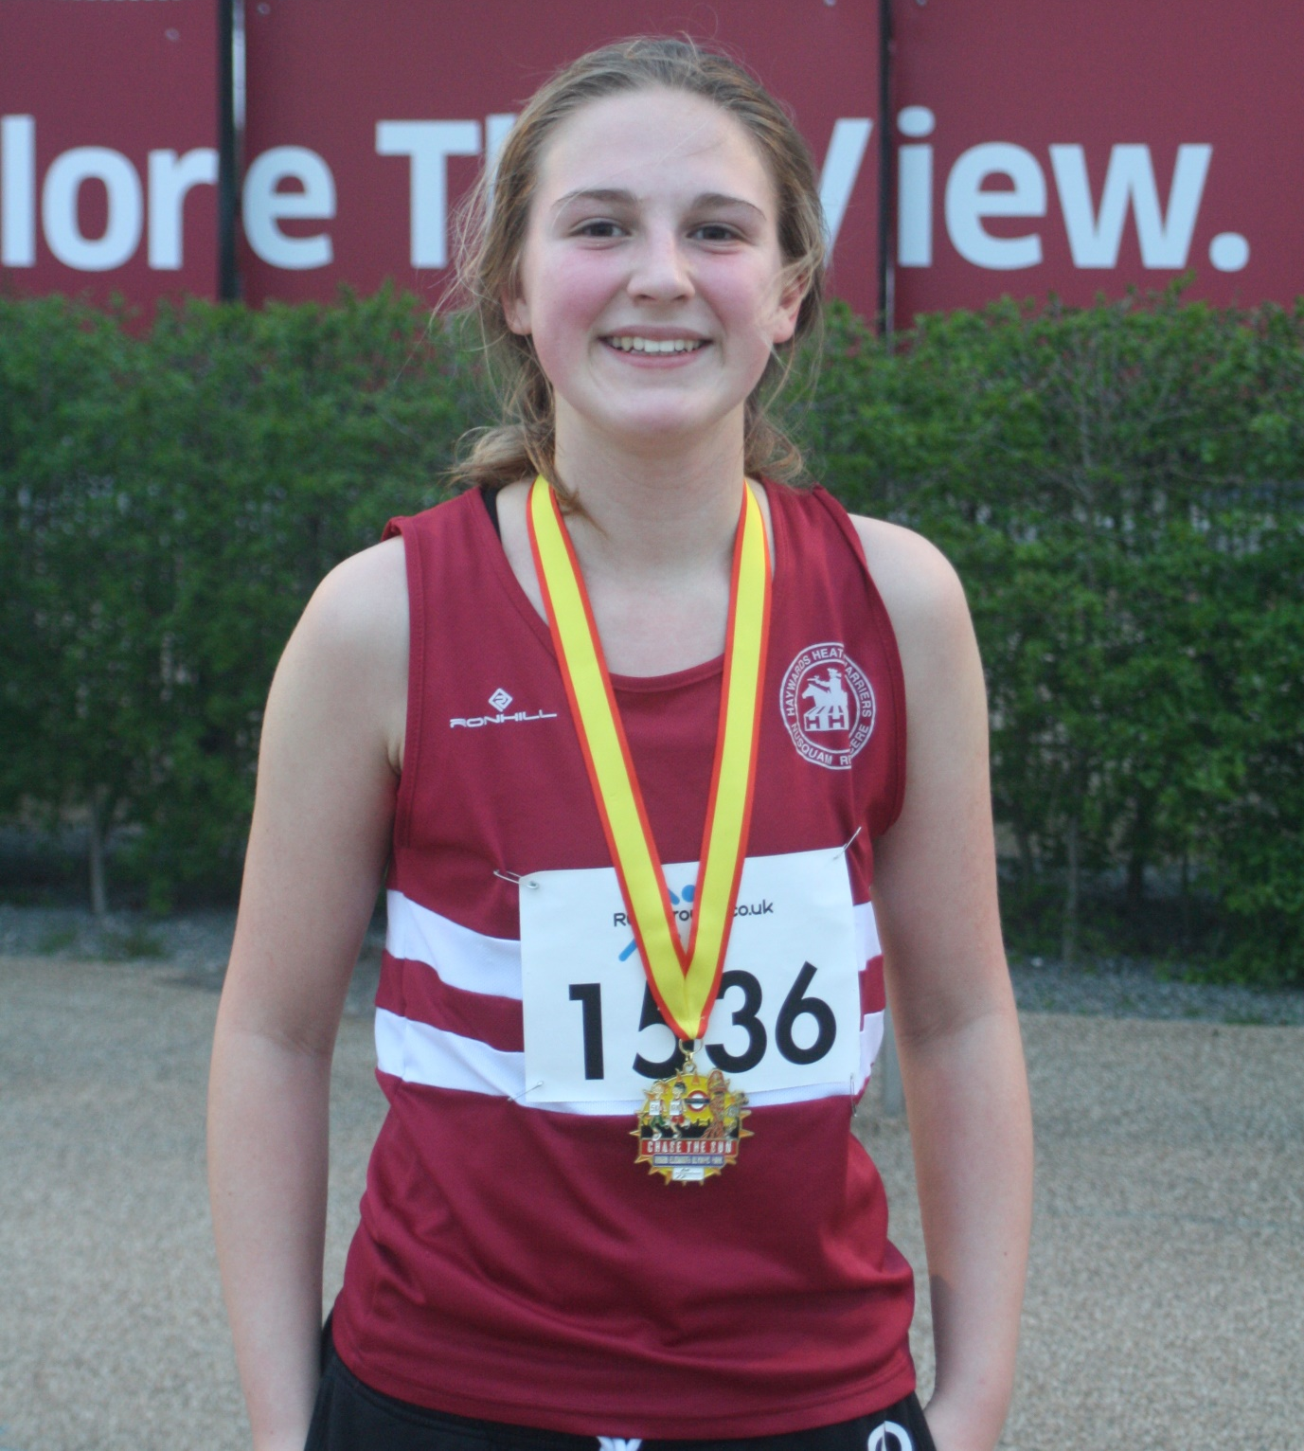
Jasmine Mamoany.

Youngster Jasmine Mamoany, ran a 5K at the Olympic Park on Wednesday 10th April during the evening in her club vest! It was a Chase the Sun run organised by Run Through (or rather the cloud, as no sun was shining!). She did well with a time of 22 minutes 25 seconds coming in 6th out of 247 women. Lovely medal too!

At the Brighton Marathon last Sunday, the Harriers had many of their runners taking part. The weather conditions were great for marathoning as it was not as hot as last year’s race. The organisation of the event was much better this year and there was not the problem of the heat like last year. Harriers were honoured with two of their runners selected being as pacers for the marathon: Russ Mullen, who was the pacer for the 3 hour marathon runners and Josh Pewter, pacer for 3 hour 15 minutes runners.

Congratulations also goes to Julian Boyer, who ran his first ever marathon after following a detailed 16 weeks training plan. Next weekend it’s the London Marathon. If you have any marathon stories, please get in touch with sport.sussex@jpress.co.uk

Brighton Marathon results were as follows:
Darren Bird 2hrs 58 mins 12 secs (pb), Russ Mullen, 2hrs 59 mins 41 secs (pb) (3:00 pacer) , Matt Cook 3hrs 00 mins 49 secs, Julian Boyer 3hrs 05 mins 25 secs (pb), Josh Pewter 3hrs 14:40 (3:15 pacer), Mark Green 3hrs 26:05 secs (pb), Matt Quinton 3hrs 45 mins 29 secs (pb), Rod Catton 3hrs 50 mins 47 secs, Ian Dumbrell 3hrs 59 mis 47 secs, Andy Guy 4hrs 8 mis 22 secs, Oli Farr 4hrs 09:49, Carl Bicknell 4 hrs 12 mins 59 secs.

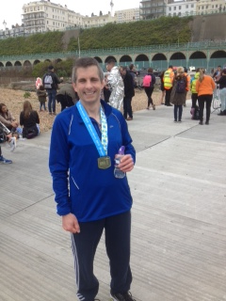
Julian Boyer – after his successful debut at the marathon distance.

In the Brighton 10km, Emma Navesey ran a stormer to smash her personal best and run under 38 minutes for the first time.

Brighton 10km results were as follows:
James Collins 33:32, Ben Gibson 33:48 (pb), Marcus Kimmins 34:56 (pb), Ben Duncan 35:53 (pb), James Gibson 37:14, Emma Navesey 37:48, (pb), Tom Mullen 38:28, Oli Gibson 39:07, Katie Morgan 39:20 (pb), Matt King 41mins 53 secs, Hannah Gibson 42:50, Karen Thompson 47:59.

At the Southern Athletics League at Eltham last Saturday, Haywards Heath Harrier’s teamed up with Lewes Athletics Club. The team came fourth overall. In warm conditions for the time of year, another young Harrier, Darja Knotkova-Hanley, had a super run in the Women’s 3000 metre race and ran an evenly paced race to take a win in a new personal best by 21 seconds in a time of 10 mins 39.06 secs.

Other Harriers results were:
Time Popkin: 400m 3rd ‘B’ 67.05 secs, 1500m n/s 5mins 22.18 secs, 2000ms/c 3rd ‘A’ 9 mins 30.58 secs, 800m n/s 2mins 29.66 secs.
Daniel Holbrook: High Jump 4th ‘A’ 1m50, 400mH 2nd ‘A’ 67.00 secs, 400M 4th ‘A’ 59.83 secs, Long Jump 4th ‘A’ 4m95.
Jenny Denyer: Javelin 3rd ‘A’ 12m80, Hammer 3rd ‘A’ 18m47, Discus 3rd ‘A’ 14m40, Shot Putt 3rd ‘A’ 5m77.
Paul Cousins: 5000m 3rd ‘A’ 17 mins 46.6 secs.

Boys Under 13 1 mile race:
2nd Charlie Bonwick-Adams 5 mins 38 secs, 22nd George Bonwick-Adams 6 mins 14 secs.

At the Sussex Road Relays at Christ’s Hospital last weekend, following last week’s report in the Middy, the full Harriers results are as follows:

Under 13 Girls:
9th Haywards Heath Harriers A: (Harriet Dray 7:19, Phoebe Whiting 7:12, Ruby Stedman 7:38) 22:09,
13th Haywards Heath Harriers B (Millie Sommerville 7:53, Amy Rutherford 7:43, Ella Chatfield 7:44) 23:20.
Under 13 Boys:
11th Haywards Heath Harriers A: (Charlie Bonwick-Adams 6:40, Alex Todd 6:53, George Bonwick-Adams 7:01) 20:34.
28th Haywards Heath Harriers B: (Oliver Mamoany 6:57, Harvey Gwynn 7:58, Loius Henry 7:59) 22:54.
Under 15 Boys:
10th Haywards Heath Harriers A: (Adam dray 5:30, Ben Fenner-Meadows 6:21, Ryan Armstrong 6:47) 18:38.
17th Haywards Heath Harriers B: (Patrick Steadman 6:53, Ethan Lambert 7:39, Jack Flower 7:14) 21:46.
Senior Women:
15th Haywards Heath Harriers A: (Darja Knotkova-Hanley 12:24, Millie Flower 15:27, Jasmine Mamoany 14:05) 41:56.
25th Haywards Heath Harriers B: (Justine Tanner 16:55, Michelle Holdstock 18:45, Michelle Robinson 17:49) 53:29.
Vet Women’s 40:
7th Haywards Heath Harriers A: (Katherine Buckeridge 15:27, Kelly Robertshaw 15:09, Karen Thompson 15:27) 46:03.
14th Haywards Heath Harriers B: (Jacqueline Barnes 16:33, Claire Annesley 17:32, Sarah Hamilton 16:36) 50:41.
Vet Women’s 50:
15th Haywards Heath Harriers A: (Jenny Denyer 23:20), incomplete team result.
Senior Men:
14th Haywards Heath Harriers A: (James Collins 10:45, Mark Green 11:49, Alex McGregor 12:09, Oliver Nelms 12:32), Richard Cole 12:55, George Adams 12:26) 1hr 12:36.
Vet Men 40:
7th Haywards Heath Harriers A: (Marcus Kimmins 11:05, Ben Duncan 11:26, Andy Dray 13:10, Mike Essex 16:15) 51:56.
Vet Men 50:
3rd Haywards Heath Harriers A: (Barry Tullett 12:02, Paul Cousins 11:57, Julian Boyer 12:01) 36:00.
15th Haywards Heath Harriers B: (Ian Dumbrell 13:44, Graham Kenward 15:16, Phil Scott 13:58) 42:58.
Vet Men 60:
13th Haywards Heath Harriers A: (John Morgan 23:20), incomplete team result.

Please be aware that the annual Haywards Heath Harriers Track and Field Meeting is being held at K2 Leisure Centre at Crawley on the evening of Thursday 26th April and that entry forms can be found on the club website or you can choose to enter on the night. There is also featured a one mile race that is open to any runners interested. For more information and an application form, please go to: www.haywardsheathharriers.co.uk.

