The Middy Report – w/c 10 October

Haywards Heath Harriers – Reports by Michael Parish and Paul Cousins

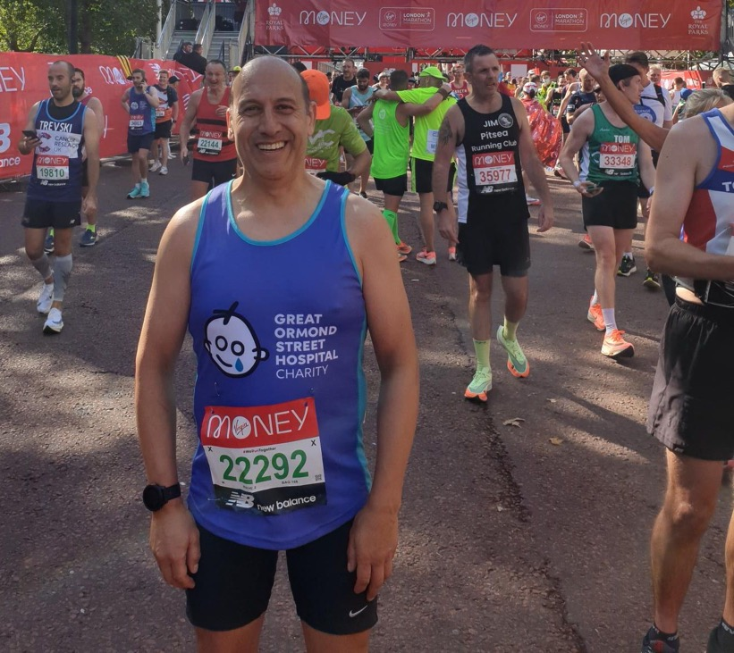
Tim Miller

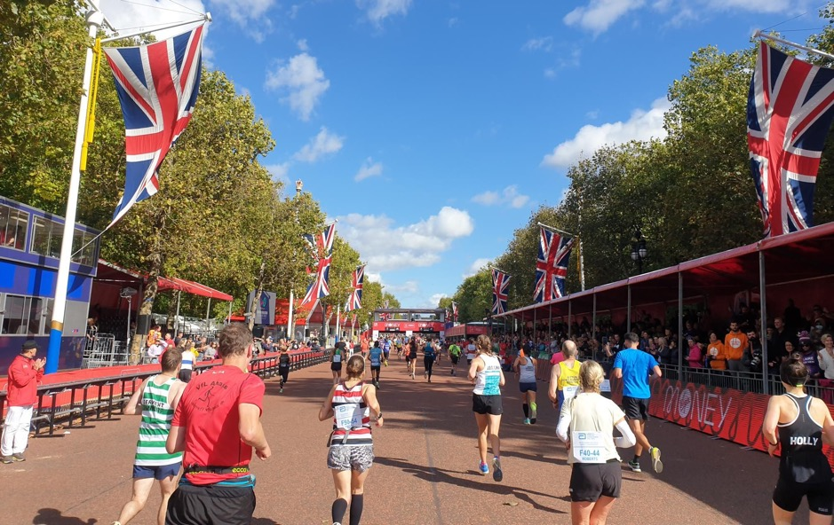
Tim Miller – London Marathon.

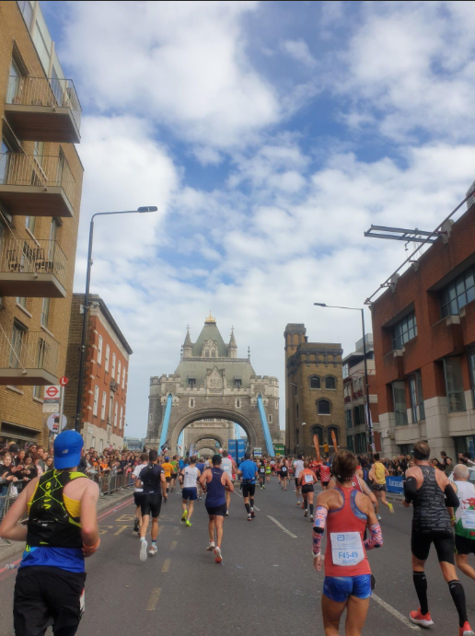

Photo by Tim Miller

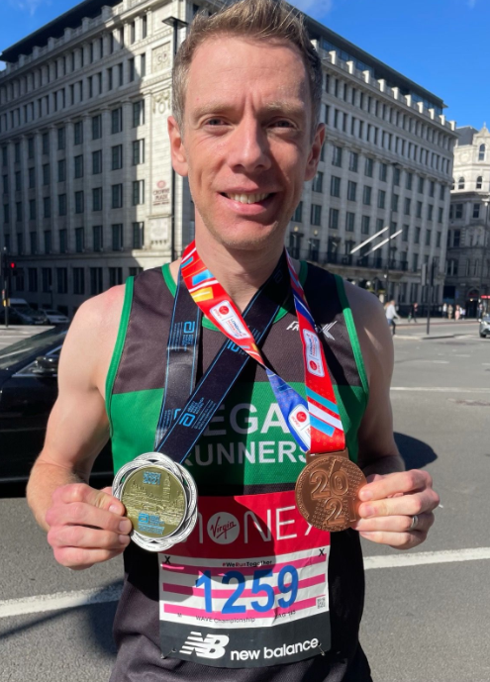
Matt Cook with medals
YOU HAVE to picture the scene, at 09:00 on Sunday 3rd October 2021, 40,000 people started their 26.2-mile journey from Blackheath to the Mall as the full version of the London Marathon returned to London’s hallowed streets since 2019.
Meanwhile, at the same time, another 40,000 will run or walk the event “virtually” across the globe during a 24-hour window, making it the biggest mass participation event since lockdown.
Along with that there were a further half a million people expected on the streets to watch. Organisers hoped it will raise tens of millions for charity and mark another important step on the journey towards normality.
The London Marathon was a bit different this year, with measures in place to make it Covid safe. At the hotels where elite racers are staying, athletes from red-list countries have been kept in separate bubbles.
There was also a different experience for club and charity runners, with participants starting in 40 waves over a 90-minute period to avoid large crowds gathering. Unlike in previous years, there will be no pacers to guide people to personal bests.
Michael Burke set a new club record in the marathon for men’s V45 beating the record set by John Gill.

Men’s elite results: 1st Sisay Lemms, 02:04:01; 2nd Vincent Kipchumba, 02:04:28; 3rd Mosineth Geremew, 02:04:41. Women’s elite results: 1st Joyciline Jepkosgei, 02:17:43; 3rd Degitu Azimeraw, 02:17:58; 3rd Ashete Bekere, 02:18:18.
Men’s mass event: 1st Kenny Wilson, 02:18:42; 2nd Matthew Dickinson, 02:19:23; 3rd Ross Braden, 02:19:33. Women’s mass event: 1st Shalane Flanagan, 02:35:04; 2nd Chloe Richarson, 02:37:08; 3rd Sarah Webster, 02:41:24.
Men’s virtual results: 1st Andrea Mestriner, 02:18:57; 2nd Sam Cussen, 02:21:08; 3rd Robbie Ventham, 02:29:12. Women’s virtual results: 1st Julia Stockton, 02:24:28; 2nd Jane Williams, 02:36:43; 3rd Stephanie DeLoach, 02:39:16.
Haywards Heath Harriers results: 991st Matt Cook V40 02:49:56, 1,260th Michael Burke (V40) 02:53:06; 1,611st Jamie Topping (V40) 02:56:21; 5562nd Mike Dickinson 3:27:42, 8,136th Tim Miller V55 3:41.45, 10,855th Jack Chivers V40 3:53:47, 15,713 Joshua Franks (V40) 04:14:19; 25,912nd Marion Hemsworth (V70) 05:00:46, 26,143rd Liz Earley 5:02:03.
Brighton Half Marathon
At the Brighton Half Marathon last weekend, the Harriers had a group taking part in this popular local half marathon event. With many people taking part from across the country it was set to be a successful event. There were road closures along the route that made it easier for the runners and spectators. The weather conditions were also good for road running by the sea with a northerly wind which did not appear to slow the runners and the temperatures average for the season of the year in the low teens.
Matt Cook ran a super race after his London Marathon run last week to finish in just over one hour twenty one minutes.
Congratulations to Caroline Mackey-Khursheed, after battling injury in recent months ran a scintillating race to gain a personal best and Tim Stannard improving his personal best by two and a half minutes.
First home for Harriers in fifteenth place was Ben Duncan in a very fast one hour eighteen minutes and fifty-eight seconds.
Harrier’s results were as follows:
15th Ben Duncan 1:18.58; 35th Matt Cook 1:21.47; 87th Tim Stannard 1:27:01 (pb); 1308th Jacqueline Barnes 1:56.51; 1527th Paul Turner 1:59.10; 1676th Caroline Mackey-Khursheed 2:03.18 (pb).

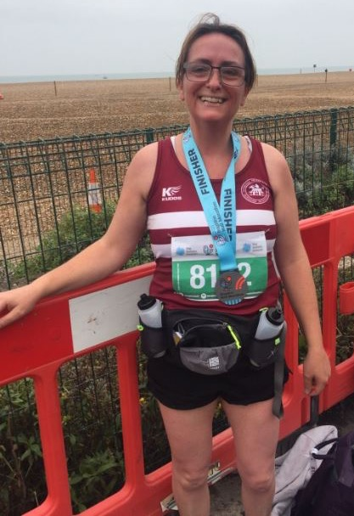 Caroline Mackey Khursheed after her first road half marathon.

Other Harrier results:

James Bennett ran in the Bournemouth Half Marathon on 10 October, finishing in 81st place in one hour 29 minutes and 12 seconds.

At the Worthing 10 Kilometres Race also on Sunday 10 October, three Harriers took part.

Russ Mullen leading the men home in 23rd place with 34 minutes and 37 seconds Not far behind him was Jamie Gibson in 35th place with 35 minutes and 47 seconds. Phil Payne, bringing up the rear in 36 minutes and 40 seconds in 47th place.

Harriers Parkrun Round-up:

Clair parkrun: 2nd Sam Fernley 18:41, 3rd Arun Khursheed 18:50; 4th Andy Hind 19:21, 5th Sean Duff 20:09, 13th Simon Robinson 22:23, 15th Oliver Francis 22:40, 24th Eric Hepburn 23:46, 39th Mark Sykes 25:11, 42nd Ian Dumbrell 25:39, 50th Clare Kenward 26:42, 77th Carys Hind 30:40, 85th Graham Kenward 32:20.

Broadwater parkrun: 69th Carl Bicknell 26:40.
East Grinstead parkrun: 5th Paul Cousins 21:19.
Horsham parkrun: 405th Jenny Denyer 46:07.
Hove Promenade parkrun: 167th James Collins 25:10.
Tilgate parkrun: 47th Ian Tompkins 23:10, 163rd Linda Tullett 29:31.

