Middy Report 10 June 2018.

HARRIERS AT THE SOUTH DOWNS WAY RELAY.

The South Downs Way Relay last Saturday took place. It is one of the highlights on the Haywards Heath Harriers calendar. This year, the Harriers had only 2 teams entered for this 97 mile trail event covering much of the South Downs National Park. The relay started at Beachy Head, Eastbourne and finished at Winchester. The relays consist’s of 6 runners in a team and each runner will run 3 times throughout the day covering about 17 miles each in total for their 3 runs. Each team is backed up usually by a minibus which drops a runner at the start of a leg and aims to get to the end of the leg to change over to a new runner before the incoming runners arrives.

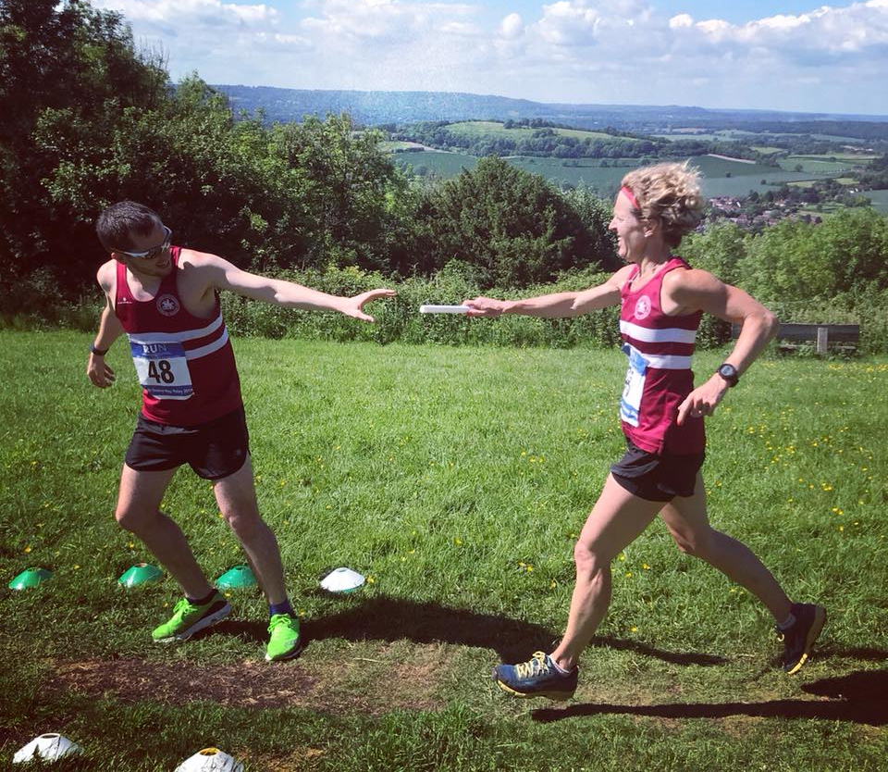
Relay change at the South Down Way Relay: Siobhan Amer passing the baton to Tom Mullen.

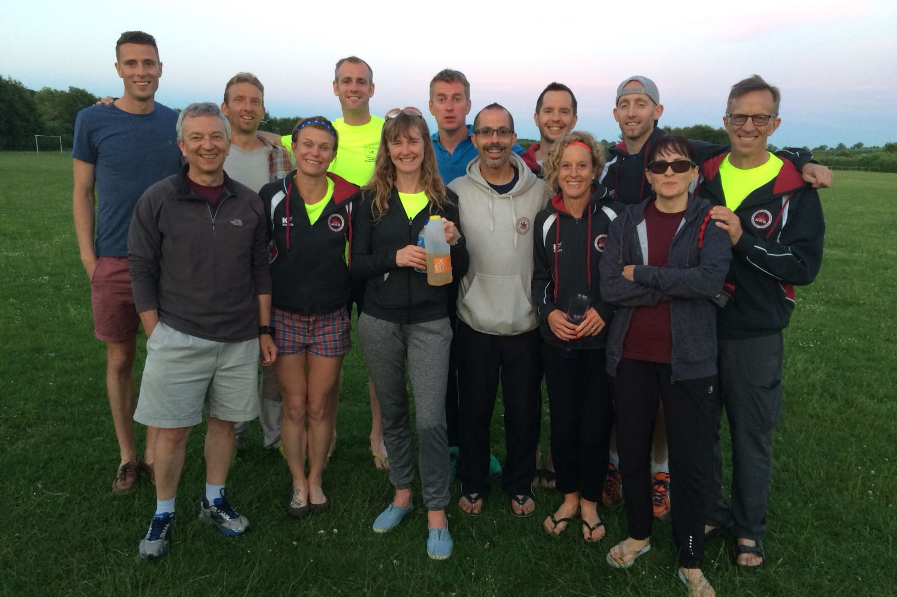
Team A and Team B Haywards Heath Harriers.

The A Team finished in 4th place in the A race in a total time of 11 hours 19 minutes and 25 seconds. The B Team finished in 6th place in the B race in a total time of 13 hours 45 minutes and 5 seconds.

One Harrier Karen Thompson said about the event:
“The first Saturday in June has for the past 30 years been the date of a very special low key event for the Harriers: the South Downs Way Relay.
Being relatively new to the world of running I had only just learnt of this special race. I loved the sound of a day where instead of being an individual runner you worked as a team.
I was lucky enough to be included in the B team. Full of excitement and nerves I began the essential job of doing the “reccies” to the legs that had been given to me. With the help of fellow team and club members by walking and running them, I felt confident of the routes for actual race day.
The day of the race started at an eye wateringly early time of 3 a.m. to get to our start time of 6am at Beachy Head, near Eastbourne. Once there and after an unusually neutralised start due to only 15 metres of visibility the ‘race on’ shout went up at the Berlin Gap. In an instant the race started in earnest. From that moment the excitement of the day continued to grow, six runners two drivers flashing around Sussex getting us all in the correct position to make the crucial baton changes.
It’s hard to describe the feeling when you see your teammate approaching with their arm outstretched and it’s your turn...
Each leg has different elements of difficulty and you know what your teammates are going through. What I found amazing is how quickly you missed the presence of your running teammate from the minibus as they ran their next leg.
The day is exhausting and full of highs: the best day of running I’ve had.
Everyone involved in this event from the organisers, marshals, the other competing teams and certainly my team members and drivers made this a day I will always remember.
So, all runners out there who want to push themselves and be part of a special team event save the date...”

Other results:
On 9th June both Phil Payne and Kim Lo both ran in the Man v Horse race in Wales. Kim finished 8th lady and covered the 20.15 miles course in 3 hrs 38 mins 46 seconds and Phil finished in 3 hrs 33 mins 7 secs.

Oliver Farr ran in the Black Phoenix Marathon in 4 hours 5 minutes and 25 seconds.

On Sunday was the West Sussex Fun Run League that was held a Hove Park by Arena 80 Athletics Club. Julian Boyer was first Harrier home in 21:26, followed by Mark Armitage in 25:41 and Richard Bates in 33:58.

Ben Duncan ran in the Run Dorney Half Marathon at Run and ran a personal best time of one hour 19 minutes 53 seconds and finished in 7th place.

Will Herbert came third in the Mid Sussex Triathlon at Burgess Hill at the weekend. Will, who is an experienced triathlete and also trains with Haywards Heath Harriers competed in the three disciplines of a 400 metres swim, a 25 kilometres bike ride and a 5 kilometre run at the end.

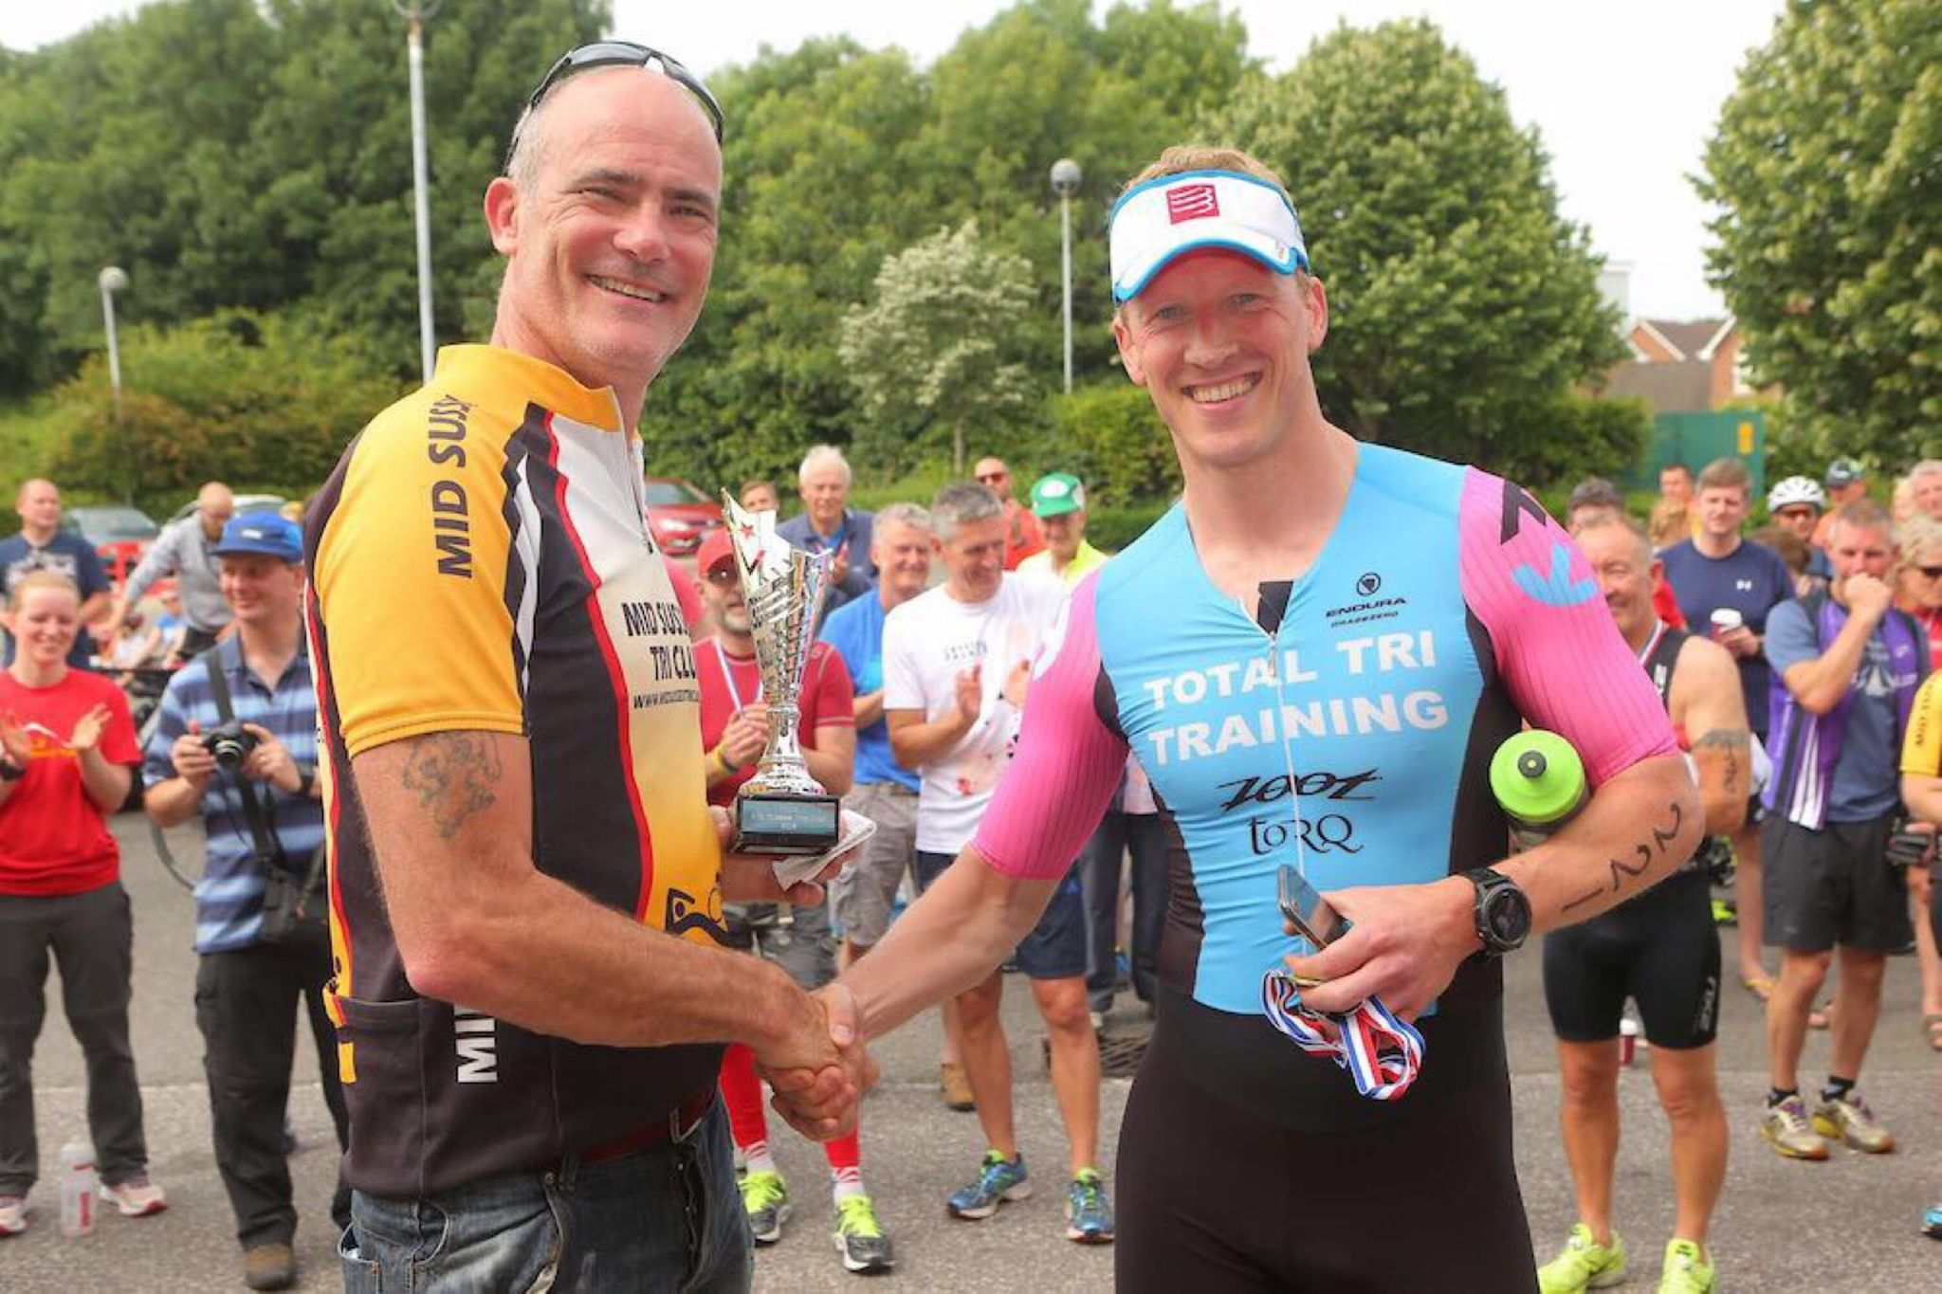
Will Herbert (right).

At the Sussex Schools Track and Field Championships last weekend, the Harriers had several youngsters competing in various track events.

Darja Knotkova-Hanley won the Senior Girls (under 20) 3000 metres, beating fellow competitor Olivia Macdonald in a time of 10 minutes 36.25 seconds which was just outside Darja’s best time of 10 minutes 27 seconds set earlier this year.
In the Intermediate Boys (under 17) 1500 metres, young Adam Dray came third in a new personal best time of 4 minutes and 15.27 seconds.
In the Intermediate Girls 1500 metres (under 15), Jasmine Mamoany was just outside her personal be by 4 seconds finishing in a time of 5 minutes 38.89 seconds.
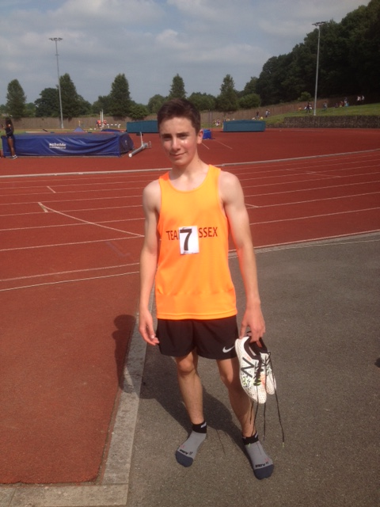
Adam Dray.

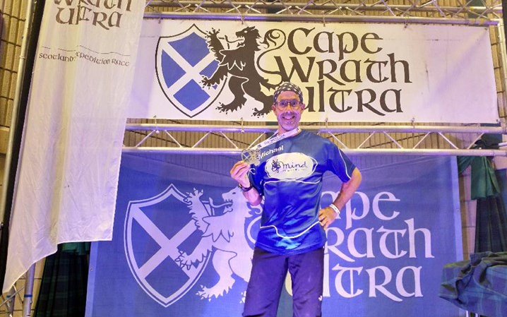
Michael Burke after finishing the Cape Wrath Ultra.

Michael Burke completed in arguably one of the toughest running endurance events in the world when he ran the Cape Wrath Ultra in Scotland. This ultra-trail running event is an 8-day event covering 400 kilometres of the Scottish Highlands on the west coast. Michael started the race on 20th May and finished on 28th May, He finished in 17th place in a superb time of 58 hours and 43 minutes. Apparently 177 runners started the race and only 110 finished it!

