Khursheed wins Bronze!

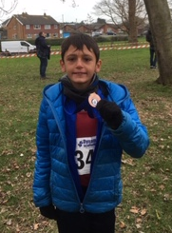
Last weekend saw Haywards Heath Harriers at the Sussex County Cross Country Championships at Bexhill. The Harriers fielded over 40 athletes from all age groups to take part in this fiesta of cross-country which brought together all the best cross-country runners from the whole of East and West Sussex into one venue.
The conditions were not muddy as in the last few outings at Bexhill as the ground was quite firm, resulting in the runners running much quicker times than usual.
Top Harrier performance of the day was from young Arun Khursheed in the Under 11 Boys who had a great run to finish a superb 3rd place with only one second separating the top three places.
Arun was well supported by Jacob Roderick in fourth place and Finlay Blythe in ninth place.
There were many other top 10 performances which were all by the younger athletes.

Arun Khursheed with his bronze medal.

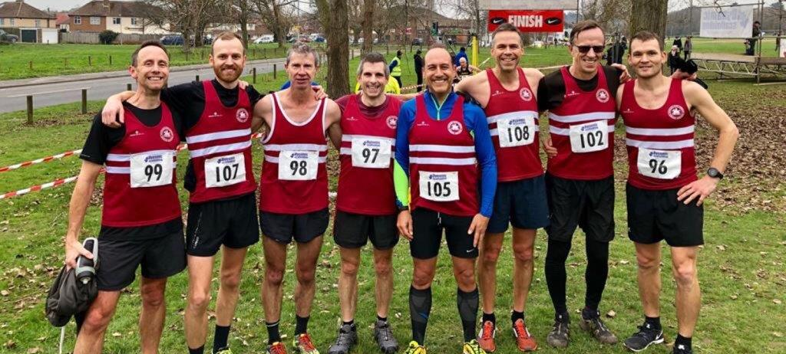
Harriers senior men’s team at Sussex Cross Country Championships at Bexhill.

Cross Country Results were as follows:
Under 11 Boys:
3rd Arun Khursheed 4:14, 4th Jacob Roderick 4:19, 9th Finlay Blythe 4:35, 24th Noah Seymour 5:02, 36th Samuel Harper 5:21.
Under 13 Girls:
26th Maya Dell’Aira-Bromley 14:17.
Under 13 Boys:
14th Sam Fernley 12:13, 19th Charlie Bonwick-Adams 12:26, 28th Roray Dalgliesh 12:48, 29th Jonathan Beckett 12:51, 32nd Sebastion Dell’Aira-Bromley 12:54, 43rd George Bonwick-Adams13:26, 50th Harry Russell 13:42, 55th Seamus Cannon 13:51, 57th Alexander Todd 13:59,
Team: 7th HHH A team, 11th HHH B Team, 18th HHH C Team.
Under 15 Girls:
23rd Harriet Dray 19:11, 38th Rosie Beckett 21:15.
Under 17 Women:
8th Jasmine Mamoany 22:51, 10th Isobel Russell 23:12.
Under 17 Men:
7th Adam Dray 17:30.
Senior Men:
32nd Russ Mullen 44:06, 43rd Paul Cousins 46:09; 44th Darren Bird 46:09, 62nd Julian Boyer 49:02, 67th Nicolas Skov 50:11, 68th Barry Tullett 50:18, 73rd Tim Miller 50:56, 86th Andy Dray 54:34, 93rd Tim Hicks 56:54,
Teams 7th HHH A Team.
Senior Women:
16th Emma Navesey 26:50, 24th Darja Knotkova-Hanley 27:50 (4th Under 20), 30th Siobhan Amer 28:41, 51st Karen Thompson 32:52, 53rd Gemma Morgan 32:58, 66th Claire Annesley 37:05, 67th Kath Buckeridge 38:03, 68th Sarah Hamilton 38:33,
Teams: 6th HHH A Team, 11th HHH B Team.

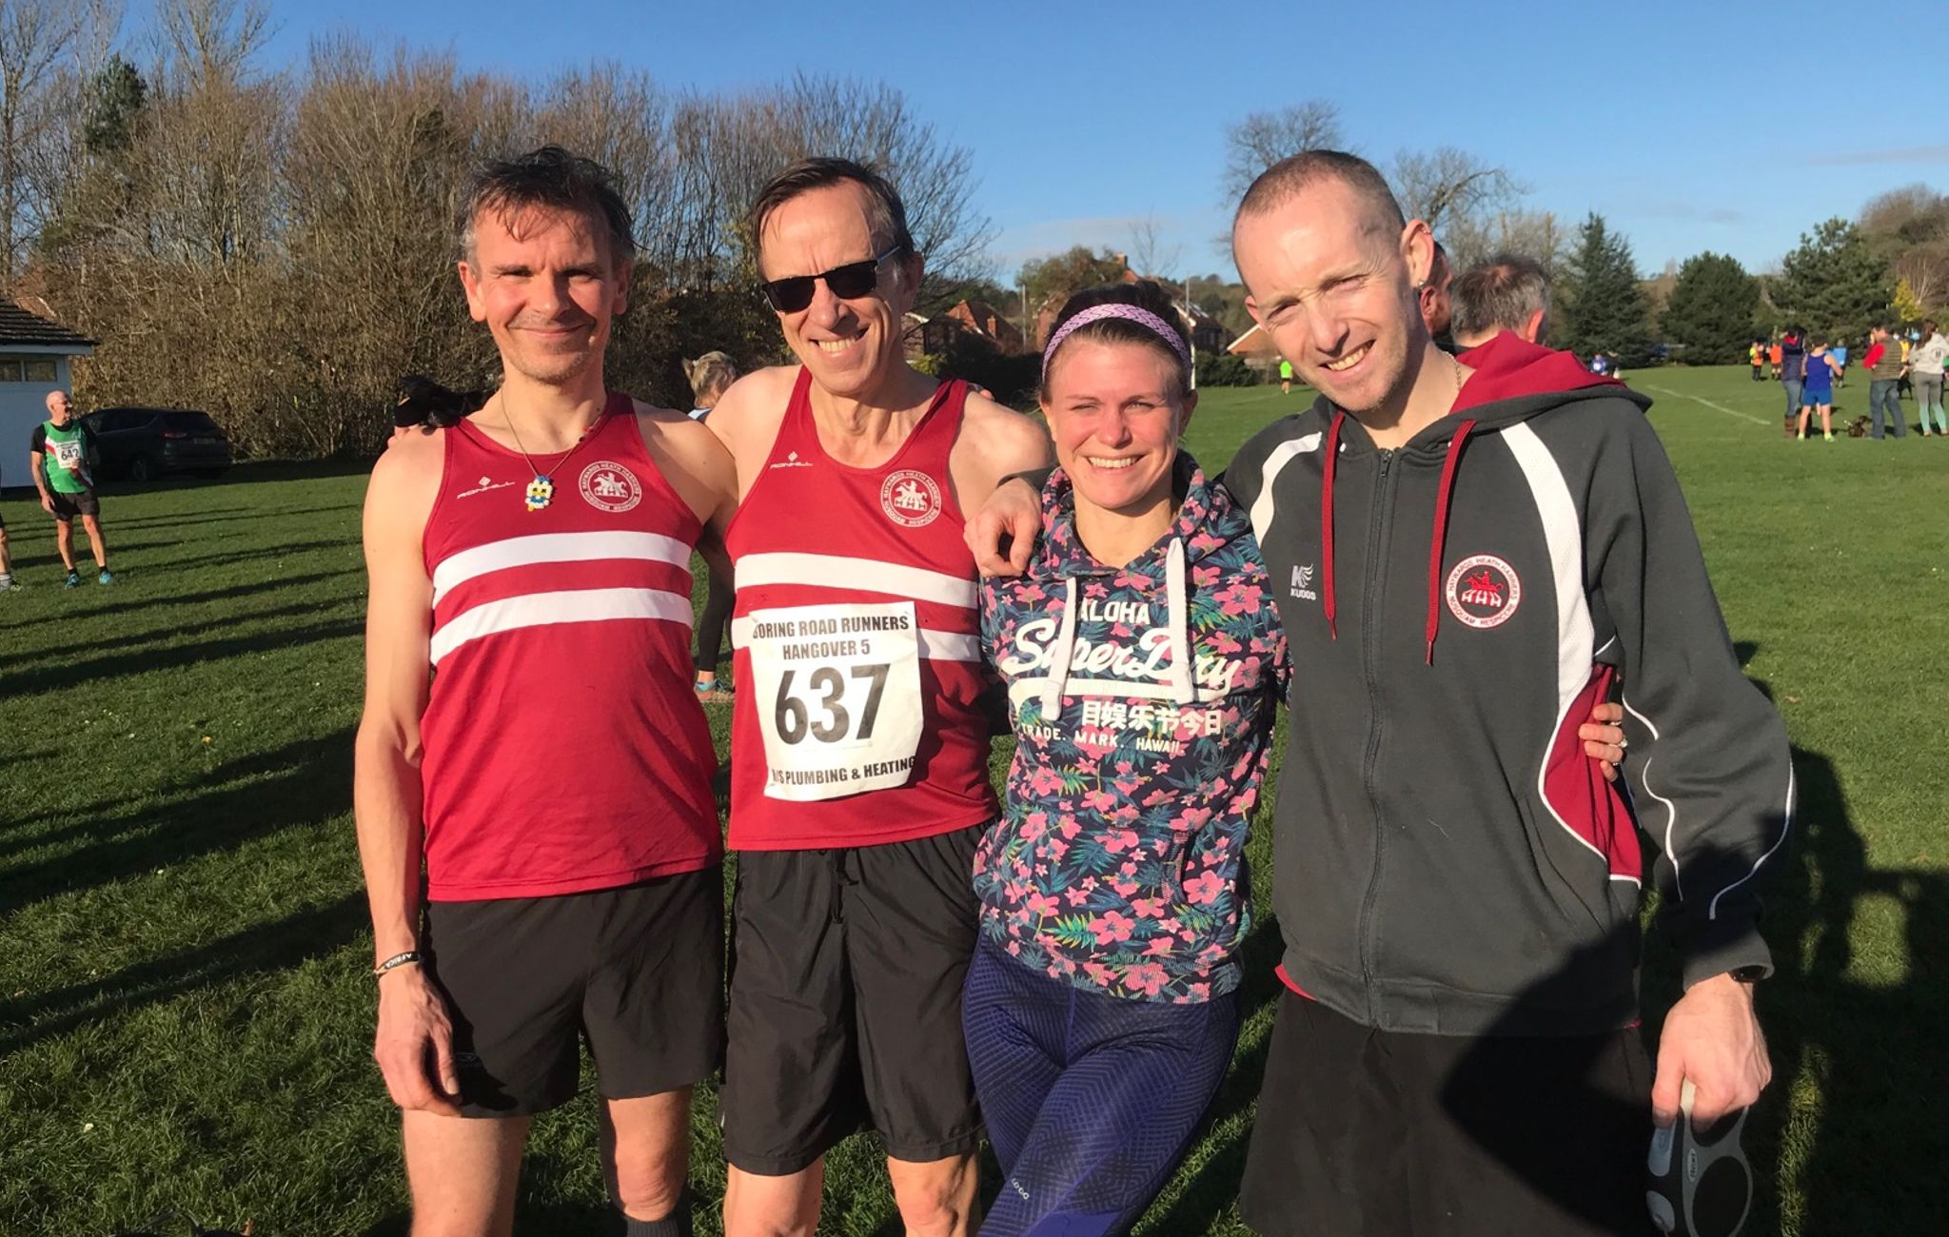
At the Hangover 5 on New Year’s Day at Hill Barn, Worthing.

At the Hangover 5 on New Year’s Day, 8 Harriers took part in this gruelling 5 mile run up onto the South Downs from Hill Barn at Worthing.

Results were as follows:
10th Phil Payne 33:44, 16th Peter Harding 35:26, 24th Nic Skov 36:23, 42nd Tim Hicks 37:44, 64th Kim Lo 39:00, 66th Ryan Armstrong 39:11, 292nd Richard Bates 59:27, 348th Amy Mitchell 62:06.

The Christmas Handicap
.

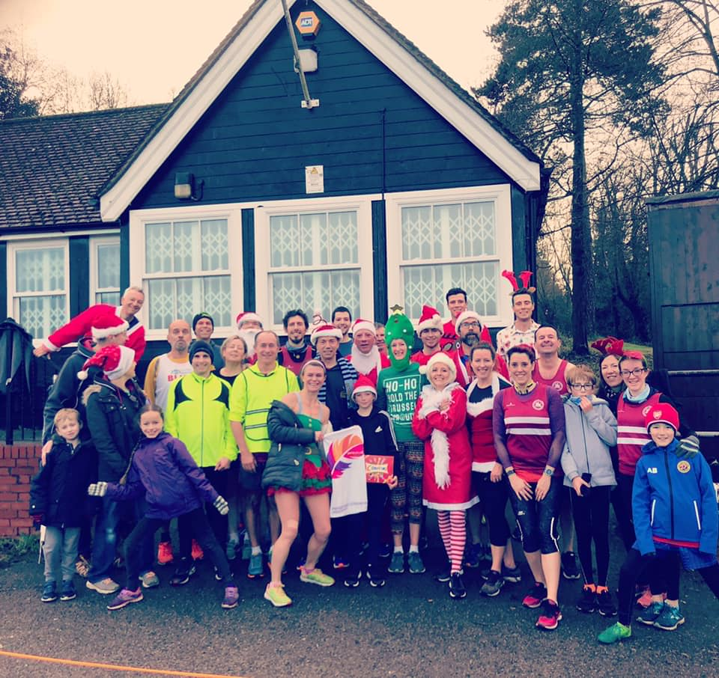
The Haywards Heath Harrier Christmas Handicap (5km).

The Harriers had their Christmas Handicap in Clair park back in December. The handicap is a race that gives each participant an equal chance of winning. The runners start times are guided by their recent 5 km time. The runners then start off one by one by the starter with the slowest run going off first and then each runner goes off at their appointed start time until the final runner who is the quickest, starts to run. Apparently, if dressed in fancy dress, the runners could get a special bonus of starting a little earlier. Anyway, in theory all the runners should cross the finish line at the same time as each other…but that hardly ever happens!

Results of the Mince Pie 10 on 9 December at Seaford.
6th Phil Payne 1 hr 4 mins 34 secs, 44th Siobhan Amer 1 hr 12 mins 29 secs, 53rd Greg Hilton 1 hr 13 mins 41 secs, 66th Matt Quinton 1 hr 15 mina 10 secs, 114th Richard Haynes 1 hr 20 mins 3 secs,137th Maresa Pitt 1 hr 22 mins 29 secs, 186th Carl Bicknell 1 hr 26 mins 29 secs, 194th Amanda Soper 1 hr 27 mins 14 secs, 291st Sarah Banks 1 hr 35 mins 10 secs, 292nd Bryan Tiller 1 hr 35 mins 13 secs, 334th Shelagh Robinson 1 hr 39 mins 47 secs.
Russ Mullen at the Haywards Heath Harrier Handicap in Clair Park.
.

