ARUN BREAKS 41 YEAR OLD RECORD!!

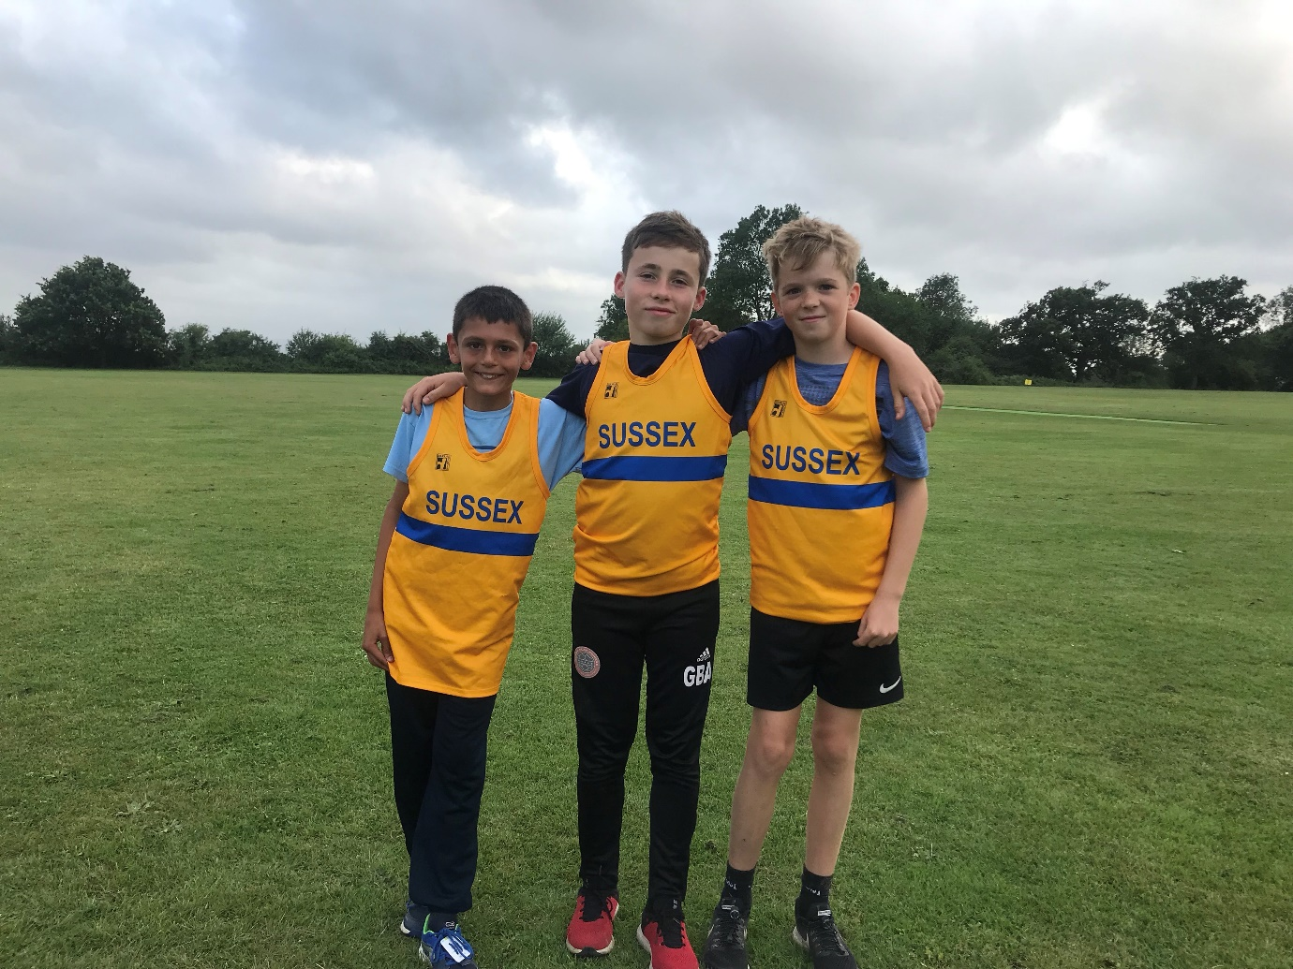
From left to right: Arun Khursheed, George Bonwick-Adams, Jonathan Parkin.

Three youngsters from Haywards Heath Harriers were selected to represent Sussex in the Under 13 Southern Inter Counties match at Kingston last Saturday.

One of the youngsters, Arun Khursheed, ran a super-fast race to break a 41 year old Harrier record to run the 800 metres in 2 minutes 20.47 seconds in the ‘A race finishing in sixth place. The record Arun broke was that of Alan Rowe back in 1978 where Alan ran 2 minutes 20.8 seconds.

The other two Harriers, George Bonwick-Adams and Jonathan Parkin also did well in their specific events. Charlie threw the discus 16 metres and 90 centimetres to finish seventh in the B competition. Just short of his best of 18 metres and 10. Jonathan Parkin took part in the Long Jump and finished in tenth place in the A final with a jump of 4 metres and 21 centimetres again just short of his best of 4 metres and 35 centimetres.

At the Sussex Vets Track and Field League at Lewes on 29 July, the Harriers joined with Lewes Athletic Club in this combined league event. Andy Dray broke his own high jump vet 40 record with a jump of 1 metre 50 centimetres and also ran a personal best in the 400 metres record with his first sub 60 second recording of 59.6 seconds.
Full results were as follows:
Men:

Andy Dray: High Jump 1.50m, 400m 59.6 secs, 100m 13.3 secs.
Ian Tomkins: High Jump 1.35m, Shot Putt 8.27m, Hammer 17.73m, Long Jump 3.36m.
Mike Bale: Hammer 32.17m, Shot Putt 6.49m,
John Palmer:100m 14.6 secs.
Andy Hind: 400m 66.2 secs, 5000m 18:05.7 secs.
Julian Boyer: 400m 63.1 secs, 1500m 5:05.6 secs.
James Skinner: 5000m 15:49.5 secs.
Tim Hicks: 5000m 19:44.8 secs.
Medley Relay (200m, 200m, 400, 800m): 3rd HHH 4:37.1 secs.

Women:
Lucy Venables: Triple Jump 8.38m, 400m 72.3 secs, 100m 14.4 secs.
Jenny Denyer: Hammer 17.08m, Javelin 13.09m.
Helen Diack: High Jump 1.15m, Hammer 11.94m.
Karen Thompson: High Jump 1.25m,
Sarah Hamilton: 1500m 7:05.2 secs.
Linda Tullett Hammer 6.20m, Javelin 9.69m.
Medley Relay: (200m, 200m, 400m, 800m): HHH 3rd 5:23.5 secs.

Non-scoring results were:
Sarah Hamilton: 100m 18.5 secs.
Helen Diack: Triple Jump 7.98m.
John Palmer: 400m 72.6 secs.
Tim Hicks: 400m 66.9 secs.
Simeon Wishlade: 5000m 19.49.2.
Carl Bicknell: 5000m 22:36.1.

The Sussex Under Fifteen Track and Field League at Crawley K2 sports centre was held on Thursday 25th July. With a lack of young athletes from all the clubs the Harriers were also short of youngsters in this normally competitive league. But the determination of the young athletes to strive for excellence was more than apparent with lots of good performances by the athletes from all the clubs.

Harriers boys Results:
Charlie Parvin: 100m ‘A’ string 3rd 12.9 secs, Long Jump ‘A’ string 3rd 4.81m.
Archie Hale: 100m ‘B’ string 5th 14.1 secs, 200m ‘A’ string 5th 30.0secs.
Sam Fernley: 1500m ‘A’ string 2nd 4:52.2 secs.
Alex Booth: Long Jump ‘B’ string 2nd 4.21m, Javelin ‘A’ string 3rd 22.62m.
Ellis Buckridge: Javelin ‘B’ string 2nd 11.97m.
4 x 100m Relay: HHH 3rd 54.3 secs.

Harriers girls Results:
Phoebe Whiting: 800m ‘A’ string 4th 2:52.2 secs, Long Jump ‘A’ string 5th 3.49m.
Amy Rutherford: 1500m ‘A’ string 4th 5:29.4 secs, High Jump ‘A string 6th 1.20m.

More Harrier Results:

Oli Farr completed his 38th marathon towards his target of 100 marathons. This time it was the Phoenix Summer marathon by the river Thames at Sunbury-on-Thames on an out- and back course. His time was 4 hours 14 minutes and 49 seconds.

At the Birthday Boys track 10,000 metres race held on 1st August at the Withdean Stadium in Brighton. Harriers results were: Paul Cousins 37:36.4 secs, Tim Hicks 41:17.7 secs, Greg Hilton 41:42.3 secs.

Clair Parkrun – by Michael Parish.

Clair Parkrun was taken over this week by the NHS Mental Health Awareness team. Taking over a part of the run directors’ role and delivering information on looking after yourself, identifying mental health issues and signposting. They joined all the other runners for the timed 5km timed run and handed out leaflets. First home with an amazing result for the event was Ben Gibson with a new personal best of 17:30.

For all of the Parkrun tourists the Mental Health Awareness Team are based in East Sussex but with sponsorship from Parkrun UK they are travelling around both East and West Sussex joining in the runs and delivering an amazing message. Watch out for them and remember to say “Hello” and get involved.

England Athletics with Mind also supports #RunandTalk created with the aim of improving mental health with the aims of getting people talking about mental health. Sharing their experiences and removing stigma, providing support and guidance to raise awareness of mental health problems. Supporting and encouraging people experiencing mental health problems to be physically active through running, whether that is to support them in starting to run, returning or continuing to run. The next #TimetoTalk week is 23rd to 29th September 2019. Watch out for events taking place during this week and remember to get involved.

The Clair Parkrun results are: Ben Gibson 17:30, Mark Green 19:46, Arun Khursheed 20:06, James Roderick 21:37, Jonathan Beckett 22:04, Isobel Russell 22:15, Harry Russell 23:02, Jason Russell 23:31, Rosie Beckett 23:39, Ian Dumbrell 24:03, Ian Tomkins 25:13, Marion Hemsworth 28:35, Nicholas Skov 28:37, Michael Parish 30:16, Maureen Rea 34:50, Rupert Purchase 49:35.

