Middy Report 03.12.17

Harriers Success at Lancing Cross Country

Haywards Heath Harriers were at the Sussex Brooks League Cross-Country meeting at Lancing Manor last Sunday. The course is mainly a gruelling 2 lap 5.2 mile cross country race that includes ‘the hill’ and with a long climb up to the dew pond by Lancing Ring. The Harriers had athletes competing at most of the different age group races with races at varying distances.

In the senior men’s race the Harriers had 21 runners taking part. The club was very strong and took second place against the top team Brighton & Hove Athletic Club and beating some of the other Sussex clubs, Brighton Phoenix and Lewes Athletic Club. The league results show that there are 14 points separating 2nd 3rd and Hayward Heath in 4th place, leaving all to be settled with a final showdown in February for the last league event at Bexhill. Harriers also had more of their new athletes making their first cross-country debuts for the club.

The Harriers had their top six scoring runners inside the top 30. Results were as follows: 8th James Skinner 30:20, 12th James Collins 30:59, 14th Phil Hardaway 31:13, 17th Ben Gibson 31:27, 22nd Russ Mullen 31:55, 29th Marcus Kimmins 32:12, 42nd Rob Watts 33:18, 43rd Jamie Gibson 33:23, 47th Tom Mullen 33:42, 55th Paul Cousins 34:12, 66th Will Herbert 34:45, 73rd George Adams (U/20) 35:16, 79th Julian Boyer 35:58, 86th Peter Harding 36:28, 90th Barry Tullett 36:43, 91st Alex McGregor 36:49, 102rd James Bennett 37:37, 113th Tim Hicks 38:45, 130th Phil Scott 41:02, 131st Andy Dray 41:05, 152nd Graham Kenward 46:11.

In the senior ladies race, the Harriers finished as 6th team which places them in 6th position after 3 cross country events. The Harriers had 5 senior ladies taking part, 2 girls in the under 17’s race (Jasmine Mamoany and Darja Knotkova-Hanley) and Amy Mitchell in the under 20’s race. First finisher for Harriers was Katie Morgan in a very credible 18th place overall.

Full results were: 18th Katie Morgan 20:12, 32nd Siobhan Amer 20:51, 34th Emma Navesey 20:58, 54th Gillian Forest 22:45, 69th Jasmine Mamoany (U/17) 23:47, 72nd Karen Thompson 23:57, 78th Darja Knotkova-Hanley (U/17) 24:29, 80th Kath Buckeridge 24:35, 83rd Amy Mitchell (U/20) 24:39, 111th Sarah Hamilton 28:08.

In the young people’s race,
Boys under 11: 24th Harvey Gwyn 6:50.
Girls under 13: 27th Harriet Dray 13:22.
Boys under 13: 32nd Charlie Bonwick-Adams12:19, 37th Oliver Mamoany 12:29, 44th Dellaira Bromley 12:48, 49th Jonathan Beckett 13:01.
Boys under 15: 19th Adam Dray 17:33, 40th Harvey Alcock 19:30.44th Ryan Armstrong 20:02, 45th Patrick Stedman 20:15, 49th Ewen Kemsley 20:59.
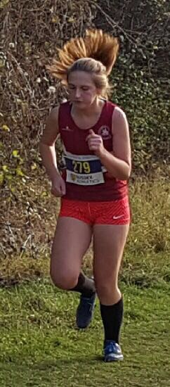
Jasmine Mamoany in the U/17 Girls race

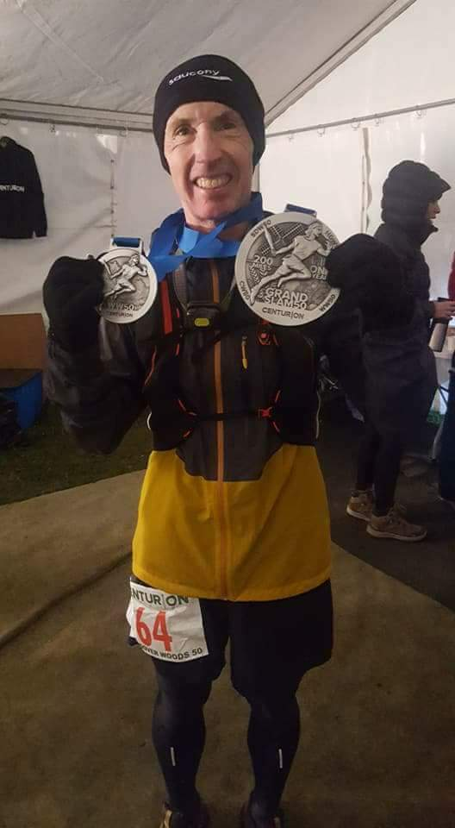
Carl Bicknell completed the Centurion Grand Slam endurance event covering four 50 mile endurance races.

Carl’s report: “On Saturday 25 November I completed Centurion Running's Wendover Woods 50-mile ultra yesterday in dry but near-freezing weather. It comprised five laps of a 10-mile route around Wendover Woods with much more elevation than their other 50-mile ultras. Because of the extra difficulty the usual 13-hour cut-off time was increased to 15 hours which I needed, finishing in 13hrs19mins. As a sign of how tough the course was almost a quarter of the field didn't make it to the end.”
“This race was especially important to me as it marked the completion of the Centurion grand slam of their four 50-mile races, following their previous events across the South Downs, North Downs and Chilterns. I am very pleased to have completed it despite having suffered some injuries on the way, and am grateful to my friends who supported me throughout my training and crewed for me on the day.”

Harrier Roundup:

At the Crowborough 10km race last Sunday, 11 Harriers ventured to Crowborough to run this road race. Katie Morgan had a great run finishing 3rd lady!
Crowborough 10km results were as follows:
42nd Jack Chivers 41:45, 43rd Katie Morgan (3rd lady) 41:52, 97th Matt Quinton 46:00. 106th Matt Howells 46:44, 129th Naomi Cikalo 48:03, 139th Carl Bicknell 48:54, 148th Carole Walters 49:23, 170th Amanda Soper 50:52. 199th Chris Glanfield 52:25, 225th Marion Hemsworth 54:05, 340th Peter Cobbett 1 hr 06:16.

At the Brighton 10k on 19 November,
Brighton 10km results were as follows:
22nd James Collins 33:42 (pb), 24th Russ Mullen 33:52, 38th Marcus Kimmins 34:58 (pb), 108th Oli Gibson 38:00 (pb), 133rd Mark Green 38:28, 190th Emma Navesey 39:40 (pb), 306th Siobhan Amer 41:59, 329th Andy Guy 42:29, 335th Michelle Pearce 42:22, 401st Hannah Gibson 43:50, 446th Matt Howells 44:49 (pb), 675th Georgina Mugridge 47:10 (pb),

In the Harvey Curtis Road Race Challenge Russ Mullen came 6th place overall, James Skinner was 7th overall (and 2nd Masters), Emma Navesey came 10 overall in the Ladies competition. The Haywards Heath Harriers were 3rd team overall.

Young Adam Dray has been selected to run for Sussex in South East Inter County Cross Country Championships at Horspath (Oxford) next weekend where he will run in the under 15 age group.

Oliver Farr ran in the Brett Owler Marathon and finished in 4 hours and 8 minutes.

Karen Thompson ran in a 5 km run at Stanmer on 25 November and was 2nd lady and on the 26 November ran in the Ashford 10km.

David Walker (an ex-Harrier of 30 years!) ran his first 10km at Brighton after having a hip operation. He said he was really pleased

At the Autumn Classic Half Marathon on 18 November at Eton, 3 Harriers took part in this flat and fast late November race. Ben Gibson was first home for the club in 8th place in 1 hour 15 minutes and 57 seconds. Brother Jamie following close behind in 9th place in a new pb of 1 hour 18 minutes and 27 seconds and Ben Duncan not far behind in 13th place, also in a new pb of 1 hour 19 minutes and 58 seconds, both running under 1 hour 20 minutes for the first time.

