Harriers Medal Haul at final Sussex Cross Country League match.

The final match of the cross-country of the season Sussex Cross Country League was held at Bexhill on Saturday 9th February. In windy conditions Chris Smith led the Harriers home to third place overall and a bronze medal in the team title race in Division One after three league races. Chris was the best placed local runner winning the Senior Men’s race on Saturday by 42 seconds from Brighton and Hove’s Howard Bristow. In the Under 11 boys race young Arun Khursheed finished in a super third place notching up another individual medal in his first cross country season for the club.
In the ladies race great performances from the final race helped secure Haywards Heath Harriers ladies to win promotion to Division One from Division Two and also winning a super silver team medal after 3 races.
In the Under 17’s Men’s race, young Adam Dray finished in seventh place in a very competitive race.

Individual league medals went to Chris Smith (gold) in the Vet men’s 40 age group, silver to the ever-improving Julian Boyer in the vet men’s 50 age group and Paul Cousins (gold) in the vet men’s 50 age group. The Vet Men also won gold team medal beating Brighton & Hove Athletics Club in a closely fought contest.

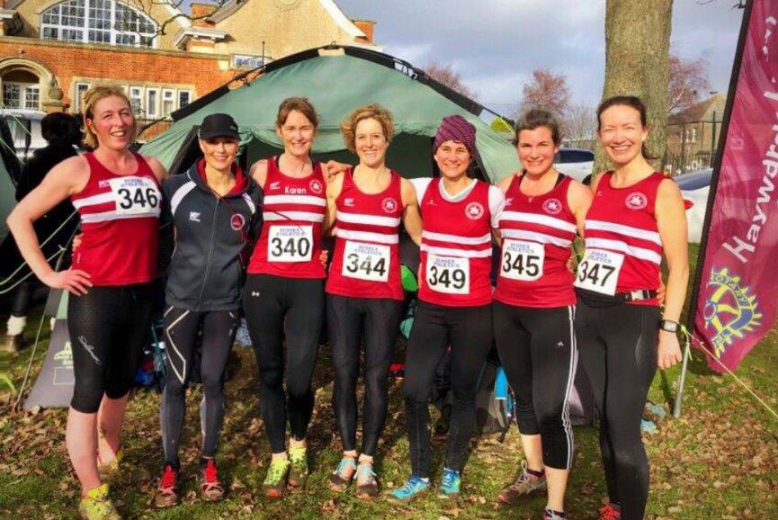
Haywards Heath Harriers Senior Ladies.

Results of the final cross country league races:

Under 11 Boys:
3rd Arun Khursheed 4:23, 11th Finlay Blythe 4:37, 25th Noah Seymour 5:07.

Under 13 Boys:
15th Charlie Bonwick-Adams 12:35, 16th Sam Fernley 12:35, 24th Seb Dell’Aira-Bromley 13:08, 36th Jonathan Beckett 14:03.

Under 17 Men:
8th Adam Dray 18:07.

Senior men:
1st Chris Smith 26.55, 13th Ben Gibson 29:00, 31st Darren Bird 31:15, 34th Paul Cousins 31:28, 44th Julian Boyer 32:21, 50th Russ Mullen 32:35, 52nd Rob Watts 32:49, 62nd Tom Mullen 34:00, 69th Barry Tullett 34:58, 76th Andy Dray 35:38, 95th Mark Sykes 39:15.

Under 13 Girls:
24th Maia Dell’Aira-Bromley 14:31, 42nd Bethany Hilton 18:26.

Under 15 Girls:
21st Rosie Beckett 20:25.

Senior Women/Under 20 Women/Under 17 Ladies:
13th Darja Knotkova-Hanley 21:12, 25th Siobhan Amer 22:07, 38th Jasmine Mamoany 23:12, 54th Gemma Morgan 24:48, 57th Samantha Ridley 25:14, 67 Karen Thompson 26:18, 73rd Jacqueline Barnes 26:59, 80th Claire Annesley 29:33, 83rd Sarah Hamilton 30:21, 91st Jenny Denyer 40:06.

Emma Smashes Club record at Chichester 10km:

Emma Navesey ran a new club record on 3rd February at the Chichester 10 km race. Emma smashed the previous senior women’s Harrier 10km record seconds by 37 seconds by beating the previous record help by Izzy Coomber back in 2015 where Izzy ran 37 min and 28 seconds and Emma setting the new record in a new time of 36 minute and 51 seconds!

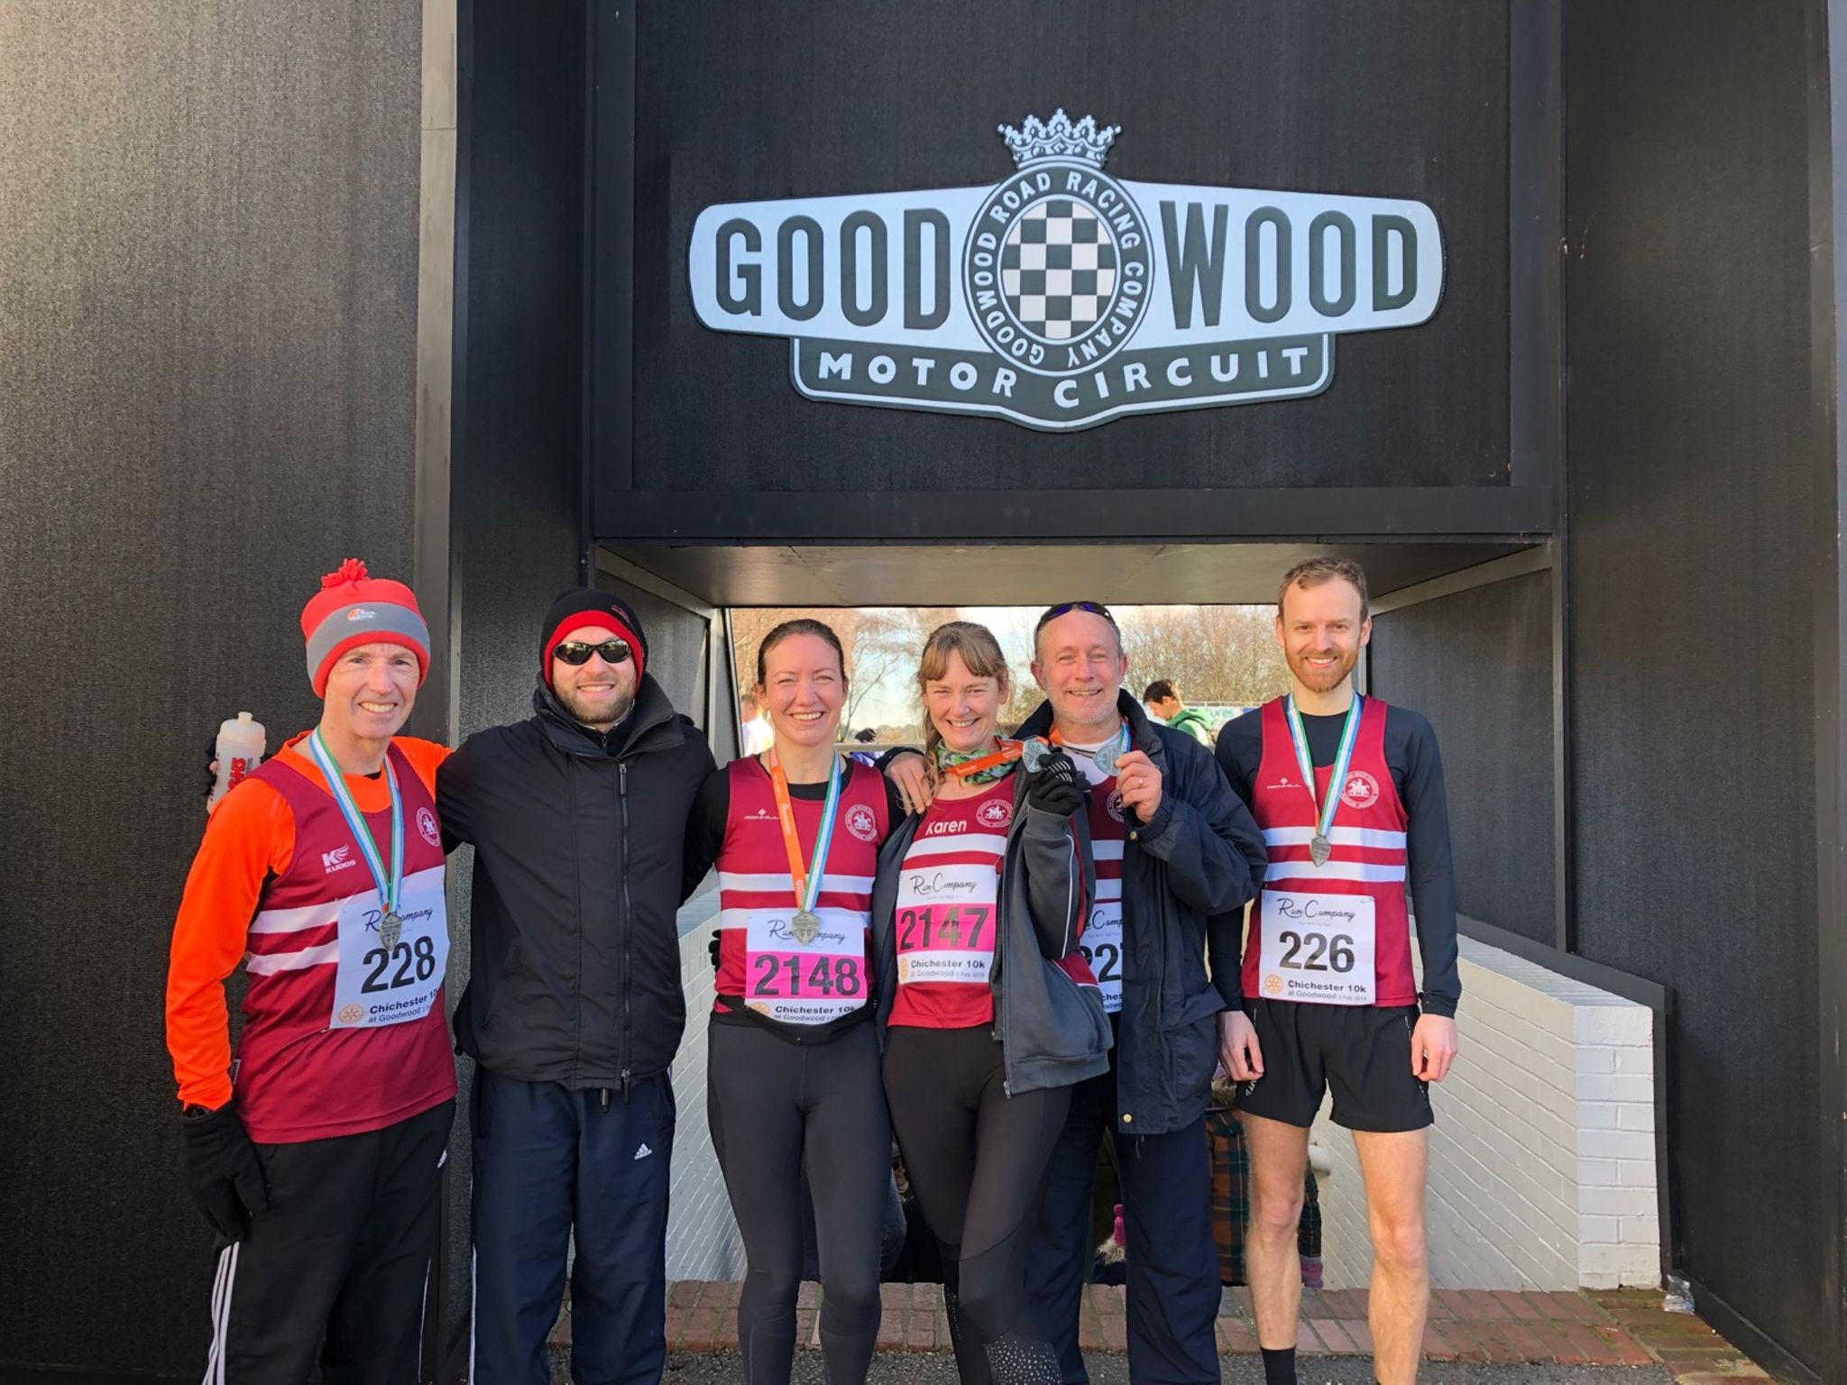
Harriers celebrating success after the Chichester 10km race.

Harrier results at Chichester 10km were:

42nd Russ Mullen 33:28, 135th Emma Navesey 36:51 (pb)(14th lady),
172nd Nicolas Skov 38:10 (pb), 288th Ian Dumbrell 41:44 (pb), 369th Matt Quinton 43:52, 479th Carl Bicknell 46:18, 492nd Gemma Morgan 46:34 (pb), 606th Karen Thompson 48:42.

Other Harrier results:

Great results at Worthing last weekend with Ben Duncan finishing in a notable fourth place overall in the Worthing 10km.

Worthing 10km on 10 February.
Ben Duncan finished in 4th place in 36 mins 30 secs.

Worthing Half Marathon on 10 February.
132nd Steve Dallman 1:30.04, 162nd James Bennett 1:32.41, 200th Siobhan Amer 1:34.15, 263rd Matt Quinton 1:37.45, 292nd Richard Haynes 1:38.48, 335th Ian Dumbrell 1:40.49, 368th Maresa Pitt 1:41.57, 584th Lydia Levy 1:49.55, 748th Chris Glanfield 1:56.41.

Oliver Farr ran his 28th marathon last Saturday at Walton-on-Thames where he ran 4 hours and 21 minutes in the “Phoenix- one run to rule them all Marathon.”

