Middy Report 02.05.18

London Marathon 2018

**HARRIERS GET BAKED AT THE LONDON MARATHON!**

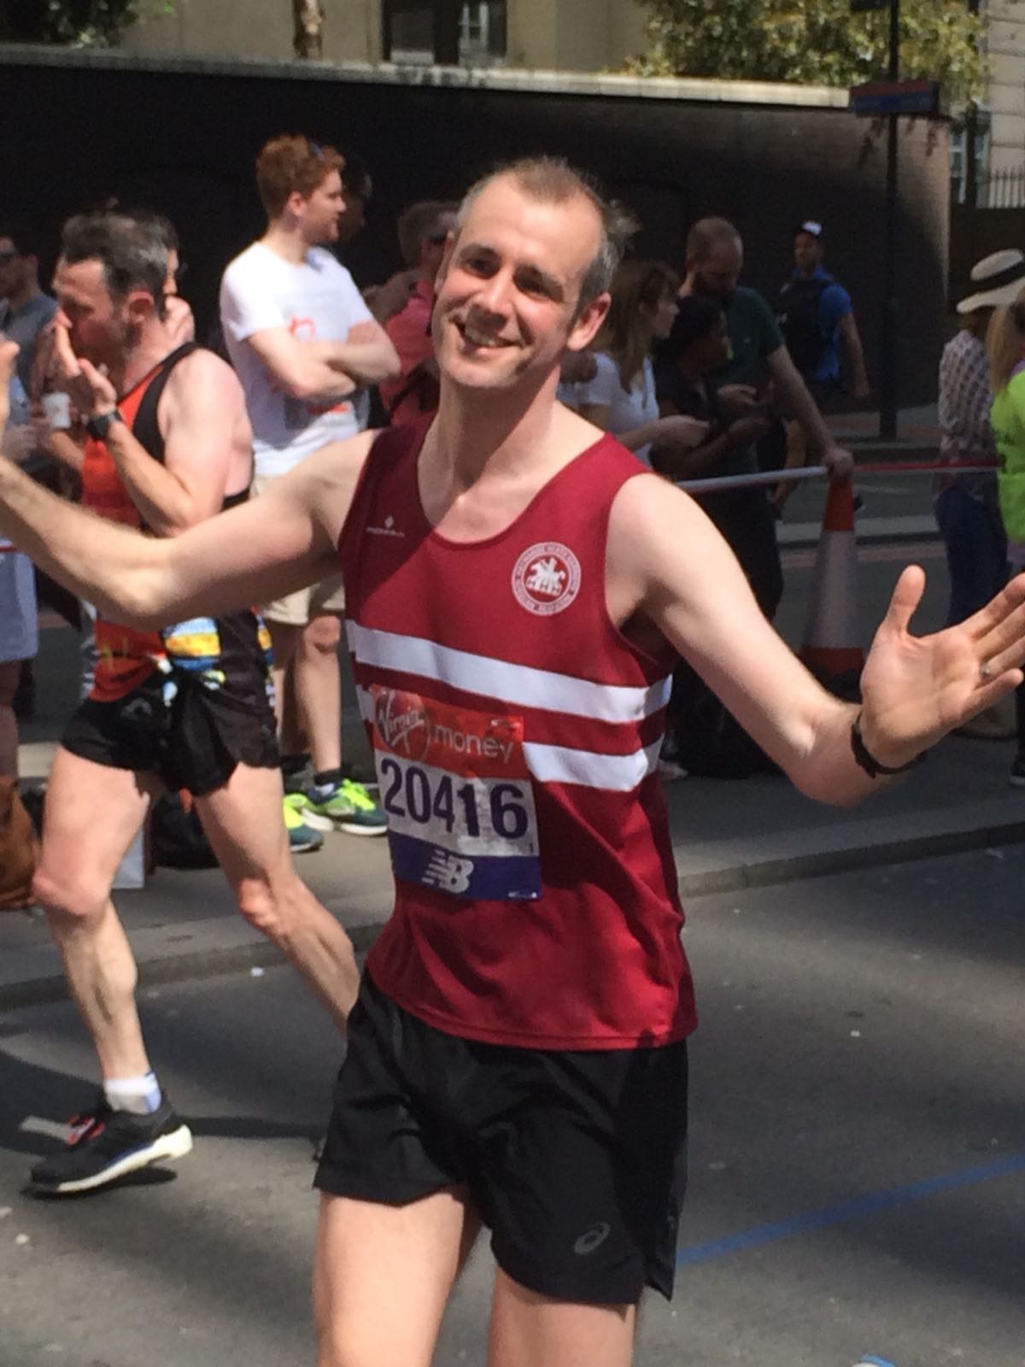

**Matt King enjoying the London Marathon.**

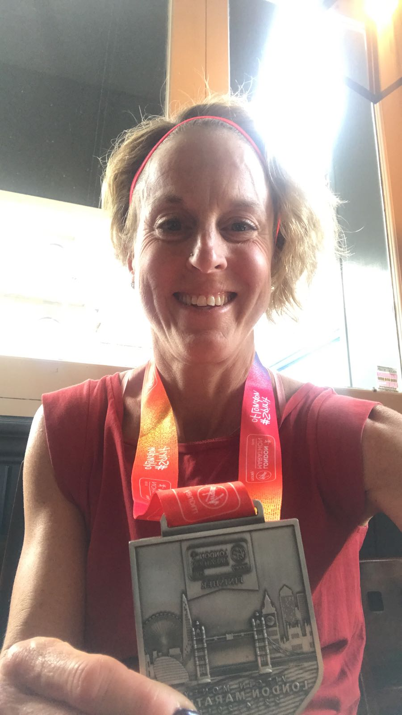

**Siobhan Amer with her finishers medal.**

Last Sunday, the hottest London Marathon in 38 years took place. With temperatures soaring to 24 degrees centigrade during the day, it was not favourable running conditions for the runners as the temperature increased throughout the day. The organisers had on supply plenty of water for the runners and provided some run though showers on route for a cool down. Many runners dropped out of the marathon because of the heat, but still over 40,000 runners crossed the finishing line which was a record for the London Marathon!

London Marathon results are as follows:

Michael Burke 3 hrs 07 mins 30 secs, Barry Tullett 3 hrs 18 mins 57 secs, Matt King 3 hrs 29 mins 39 secs, Siobhan Amer 3 hrs 34 mins 48 secs, David Roper 3 hrs 38 ins 33 secs, Georgina Muggeridge 4 hrs 09 mins 41 secs, Clare Kenwood 4 hrs 18 mins 15 secs, Sarah Banks 4 hrs 30 mins 04 secs, William Davies 5 hrs 11 mins 26 secs, Carys Hind 6 hrs 04 mins 12secs.

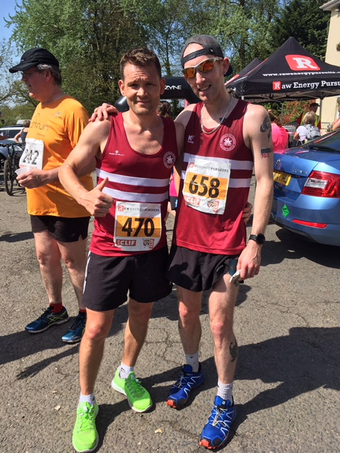

**2nd and 3rd place at the Angmering Bluebell 10 mile trail.**

On Sunday 22nd April, Darren Bird finished in 2nd place in 65 mins 29 secs and Phil Payne was 3rd in 66 mins 37 secs.

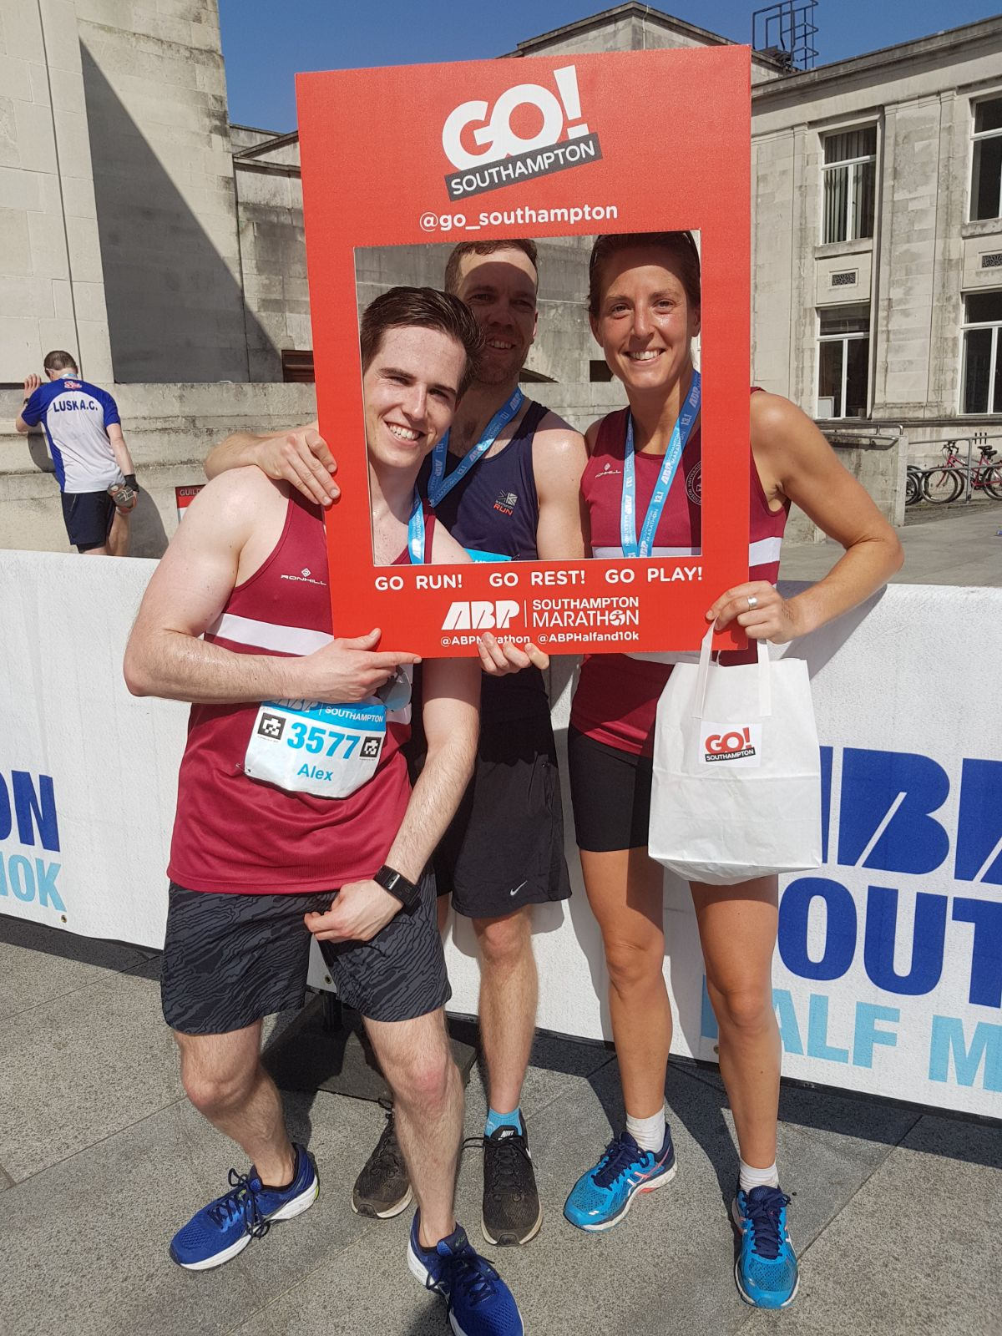

**Harriers at the Southampton Half Marathon.**

Katie Morgan finishing the Southampton Half Marathon as 5th lady in a time of 1 hr 28 min 09 secs. Other Harriers running were: Alex McGregor 1 hr 31 mins 53 secs and James Bennet 1 hr 34 mins 27 secs.

At the Southampton Marathon, Natalie Dimmock finished in a superb 5 hrs 07 mins 27 secs.

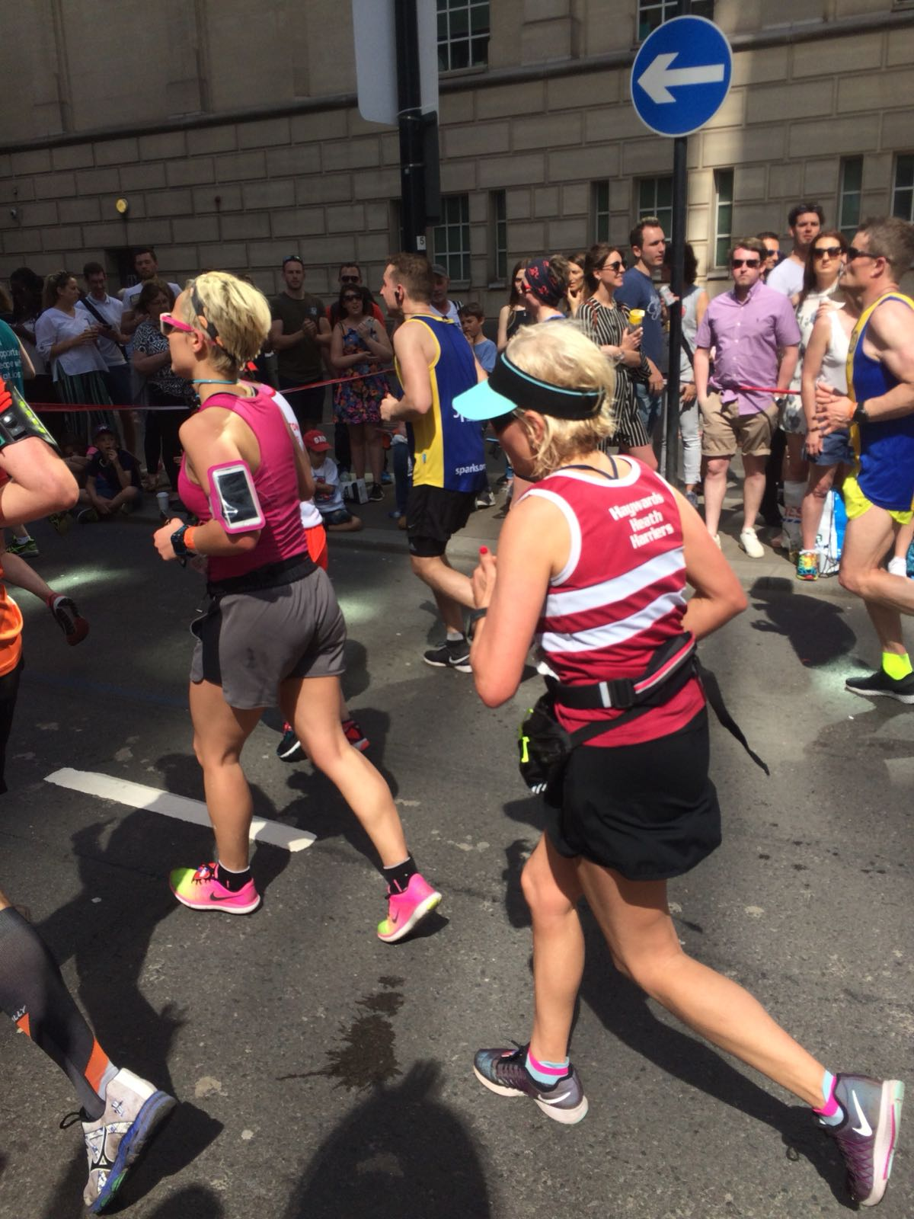

**Sarah Banks in the sweltering heat in the London Marathon.**

The previous weekend, a huge number of people in Sussex took part in one of the many parkruns that are held in the county. A combination of Marathon season and good weather brought out over 4000 runners just in the Sussex parkrun. As the running revolution is taking place, people wanting to look after their health and well-being are taking to running. Running has so many benefits: from fitness, nutrition, relieving stress, shedding unnecessary weight.

Bevendean parkrun 34

Brighton & Hove Park parkrun 454

Bognor parkrun 289

Chichester parkrun 261

Clair parkrun 152

East Grinstead parkrun

Eastbourne parkrun 329

Hastings parkrun 333

Horsham parkrun 345

Hove Prom parkrun 391

Peacehaven parkrun 144

Preston Park parkrun 531

Tilgate parkrun 620

Worthing parkrun. 467