MIDDY REPORT 11.06.17

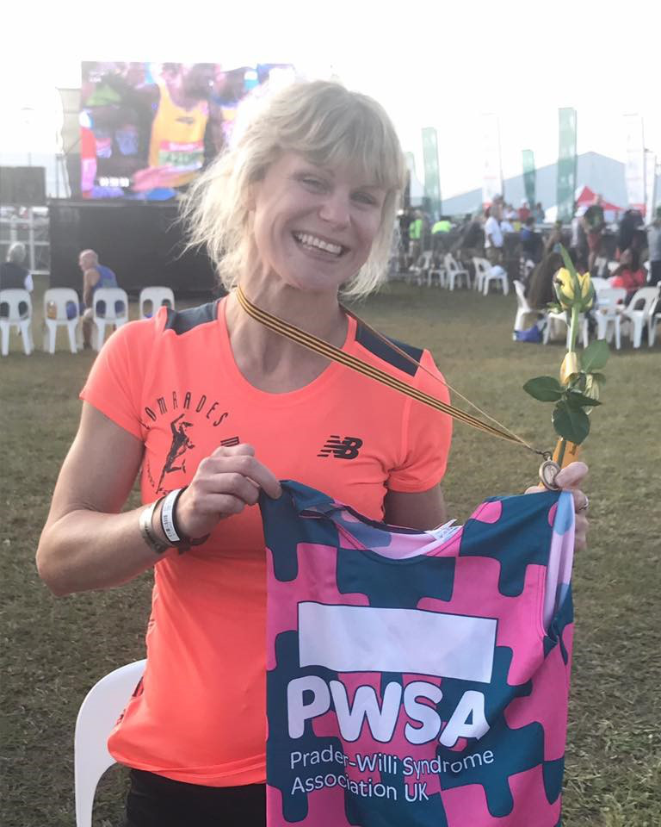

Last weekend (4th June), Haywards Heath Harrier, Kim Lo competed in one of the toughest and one of the most famous of endurance challenges in the world: she took part in the COMRADES MARATHON which is held in South Africa. The race is a point to point over 54 miles. This year the marathon was the ‘uphill’ event from the sea-level at Durban, with the ‘up’ of 1000 metres altitude to Pietermaritzburg. The run was “hilly and hot” and Kim finished the race in an amazing time of 9 hours 6 minutes 49 seconds.

Kim was raising money for the charity Prader-Willi Syndrome Association UK (PWSA) because her ‘little nephew’ has been diagnosed with it. If you would like to help Kim raise finance then please go to the link below.

<https://www.justgiving.com/fundraising/leggingitforlovebugs>

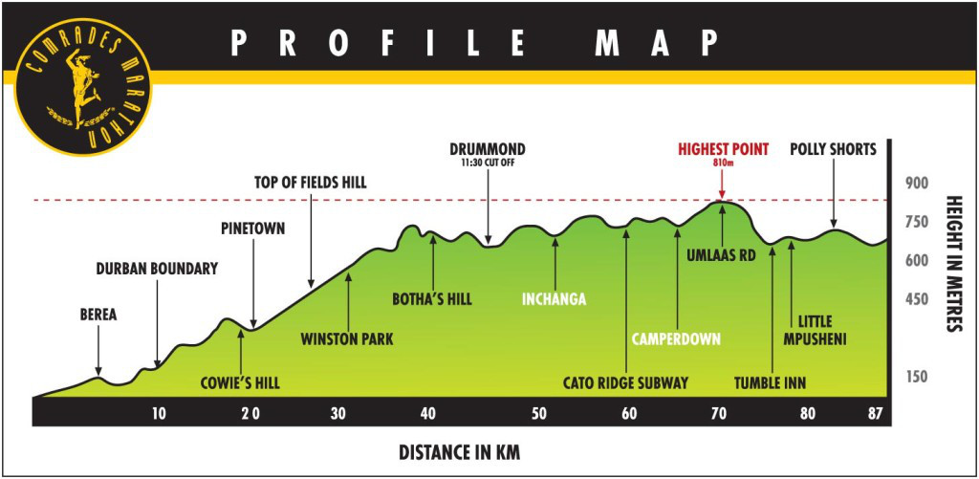

ONE OF THE TOUGHEST MARATHONS IN THE WORLD….

She also took part on the Saturday 3rd June in one of the biggest parkruns in the world at North Beach parkrun in Durban with over 2,081 runners taking part and was the 2nd female runner home in 21:12!

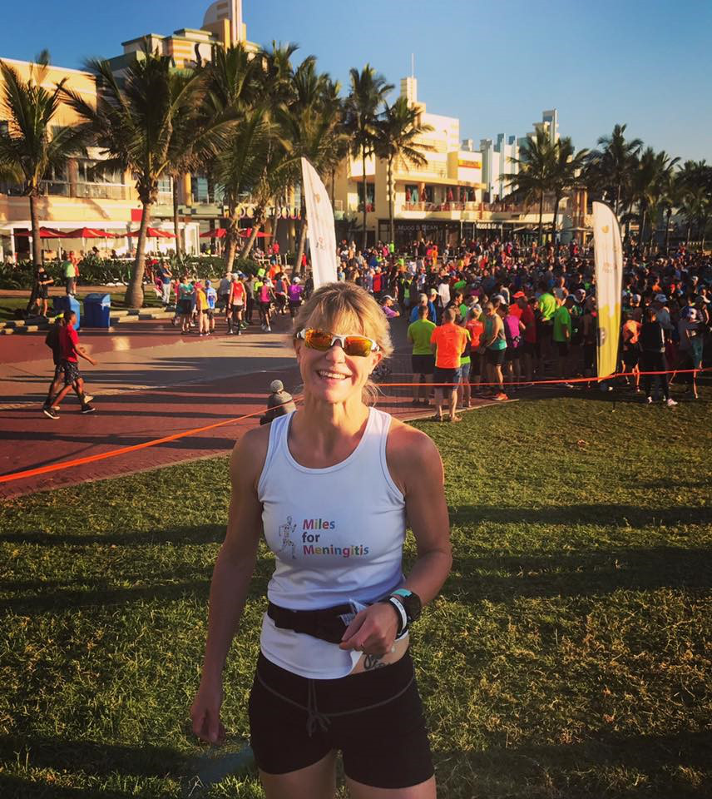

PHOTO OF KIM LO AT THE START OF THE DURBAN PARKRUN

Both Michael Burke and Phil Payne were in action again this weekend after their Stockholm Marathon endeavours last week. This week both men competed in the South Downs Way 100 miles race which follows the South Downs from Winchester to Eastbourne. Their results were as follows: Michael Burke 27hrs 07mins 18 secs and Phil Payne in a time of 27hrs 07mins17 secs.

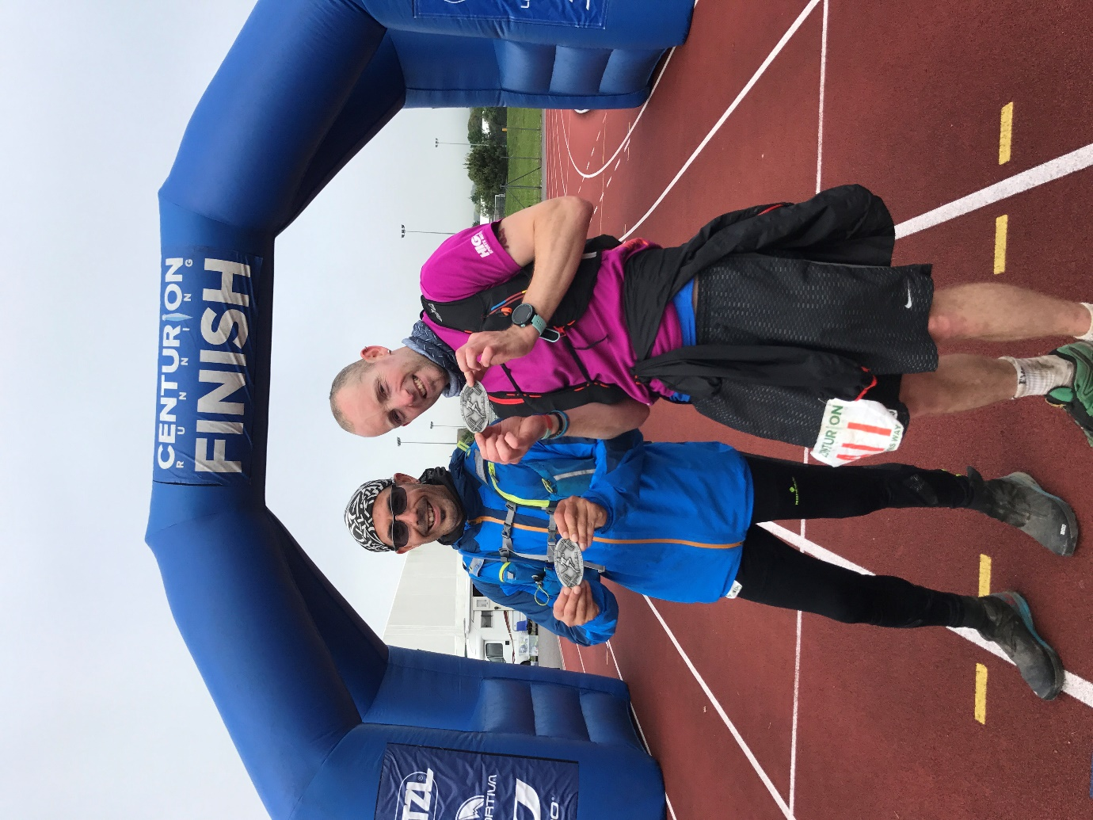

PHOTO OF MICHAEL BURKE (LEFT), AND PHIL PAYNE AT THE FINISH LINE IN EASTBORNE.

At the Sussex School Athletics Championships as K2 on Saturday, 2 young Harriers took park and did very well. There results were as follows:

Darja Knotkova-Hanley 4th Intermediate Girls 3000m 12:12.9.

Adam ran 2:10.28 4th Junior Boys 800m.

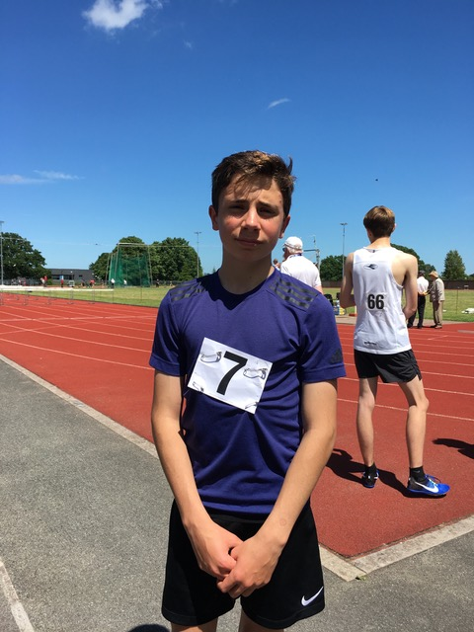

PHOTO OF ADAM DRAY WITH A NEW PB (PERSONAL BEST)

On Sunday was the 5km West Sussex Fun Run League race at Hove Park. Russ Mullen was the first Haywards Heath Harrier home and led the race from start to finish winning in a scintillating 15:45. He was backed up with other Harriers: 23rd Julian Boyer 19:02, 29th Barry Tullett 19:12, 51st Richard Cole 20:08, 90th Darja Knotkova-Hanley 21:38, 99th Bryan Tiller 21:50, 101st Mark Armitage 21:54, 111th Robert Coomber 22:09, 163rd Graham Kenward 23:37, 222nd Marion Hemsworth 25:22, 248th David Harbage 26:22, 279th Michelle Holdstock 28:07, 320th Linda Tullett 30:39, 369th Jenny Denyer 37:31.

Haywards Heath Harriers results at parkruns last Saturday were as follows:

Hove parkrun – Phil Hardaway 17:38.

Horsham parkrun – Michelle Holdstock 29:36, Justine Tanner 29:44, Jenny Denyer 44:36.

Tilgate parkrun – Toby Wiles 22:48.

Clair parkrun – Tom Mullen 19:35, Paul Cousins 19:57, Alex Todd 20:16 (PB), Barry Tullett 21:03, Robert Coomber 21:17, Simeon Cousins 22:12, Marcus Kimmins 22:24, Carl Bicknell 23:12, Carole Walters 23:17, Louis Henry 24:15, Ewan Kemsley 24:38, Liam Banham-Rayward 24:39, Mark Sykes 27:04, Sarah Banks 27:25 (50th parkrun!) Dominic Roberjot 29:32, Katherine Buckeridge 30:00, Bryan Tiller 30:24, Maureen Rea 32:01, Marion Hemsworth 33:58.

Preston Park parkrun – Jamie Gibson 17:16, Ben Gibson 17:45, Ben Duncan 18:07, Oli Gibson 18:57, Ben Adams 19:25, Peter Cobbett 27:42.

Hove Prom parkrun – Russ Mullen 15:53 (PB), James Bennett 19:54. Emma Navesey 21:08.

Worthing parkrun – Amy Mitchell 21:48 (PB).